VILLAGE OF COPENHAGEN BOARD OF TRUSTEES
REGULAR MEETING MINUTES
January 12,2022 6:30 PM
@Village Hall

Mayor Mark Souva
Trustee Benjamin Snyder
Trustee Gerald Shambo
Trustee Kim Vogt
Trustee Shareef Stokely

Attendance
In Attendance: CLERK: Lori Wheeler Trustees: Mayor Mark Souva, Trustee Gerald Snyder, Trustee Kim Vogt, Trustee Shareef Stokely Via Zoom: Trustee Ben Shambo
DPW: David Potocki and Rich Ross
Audience: Scott Alexander and Pat Mahar
Via Zoom: Mickey Deitrich, CVFD Chief TJ Williams
Meeting called To Order
Pledge of Allegiance then Meeting was called to order at 6:30 p.m. by Mayor Mark Souva.
Minutes
A motion was made by Trustee Vogt and was seconded by Trustee Stokely to approve the December 8, 2021, Regular Meeting Minutes and December 30,2021 Special Meeting Minutes
Vote taken:
Trustee Stokely – Aye
Trustee Snyder – Aye
Trustee Vogt – Aye
Trustee Shambo – Aye
Mayor Souva – Aye
All Ayes- Motion Carried

Trustee Shambo asked if the DPW was picking up Christmas trees that people were putting on the curb. DPW said they were, and Trustee Shambo suggested that the Village advertise that better if they were going to pick them up.
Trustee Shambo also thanked the DPW for picking up garbage in below zero temperatures that week.

DPW Report
DPW REPORT FOR JANUARY 2022
- took trash cans back over to fire hall
- replaced fire hydrant whip over at fire hall
- Ben Shambo water & sewer hookup is all done
- Christmas tree is down at village hall- snowblowed all sidewalks around village
- read all of village meter readings around village
- read all of town of Denmark meter readings
- picked up any Christmas trees from around village that were put out
- took water and sewer samples to converse labs for the month
- all of Christmas light and banners are down for the season
- had Nortrack come out and looked at loader had a light on they had to do a manually do a regen on loader all fixed
- boiler down at Stoddard water plant is now working
- went around village to check on meters that weren’t reading
- V-plow is on F-450 now just in case if need to use it
- ware is shut off at Devere Rumble lavender shop
- found curb-stop at Anthony Petrus
- lowered cutting edge on village snowblower
- water leak at bus garage is all fixed
- did some plowing and snow removal
Property Maintenance Report- Terry McKeever 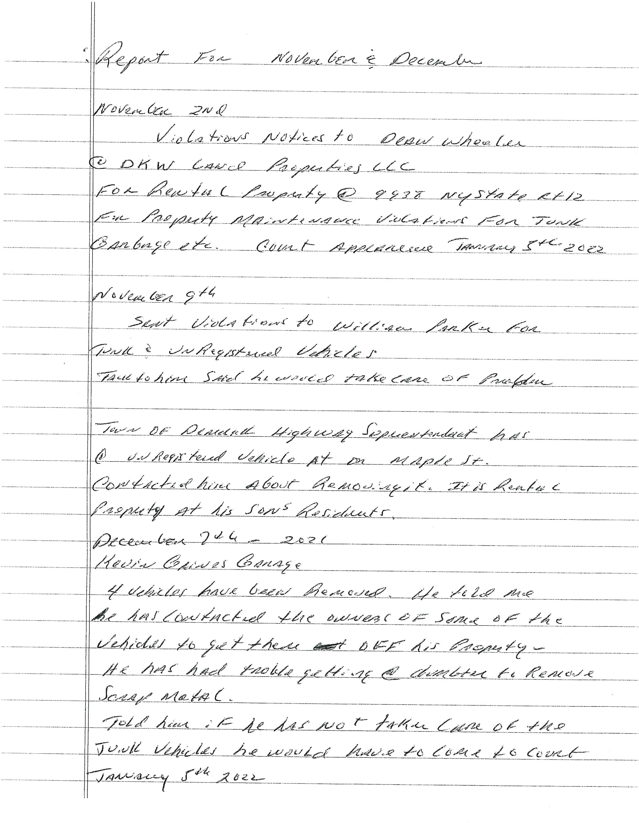

Copenhagen Volunteer Fire Department
- The Board was given a copy of CVFD minutes to review.

- Chief TJ Williams joined the meeting via zoom. He thanked the DPW for keeping the Fire Hall driveway cleaned out.

Chief Williams also informed the Board that the Copenhagen Volunteer Fire Department is remedying the problems with the Violation notice that they received about training amongst other things.
Mayor Souva will follow up with them as they fix their problems. Mayor Souva is aware that the CVFD is putting policies in place for the future.

Correspondence

- Pat Mahar stated that the form he received from the Property Maintenance Officer, Terry McKeever, for the pickup truck in his back yard was wrong. Mr. Mahar said the Terry McKeever called him and asked him to remove the vehicle but never gave him the proper procedures. Mr. Mahar received a violation ticket, and his address was wrong. Mr. Mahar also stated that the Denmark Court can not hear the case because he works for the Town of Denmark and County will throw it out because of the errors. Mr. Mahar believes that Mr. McKeever is wasting Village of Copenhagen money and is not pleased with how Mr. McKeever called him.
- Email from Kathy Hanchek
Mrs. Hanchek was on the 150th Anniversary Committee and believes that the Village Board of Trustees did not have all the facts before they gave the Copenhagen CARES Collaborative Committee the funds that were in the Community Day Fund in the Village budget, in the amount of $4,507. Mrs. Hanchek stated that in her email. She feels they were blindsided because no one talked to them about the money before giving it to the other committee.
Mayor Souva allowed Mrs. Hanchek to speak to the Board via zoom.
She said that they would have formed a committee (EIN number and bank account) had they known that the Village Board was going to give the money away.
She agreed that there were no minutes of the 150th meetings to be found in the Village Hall. The Village Board of Trustees had no way of knowing through minutes that people from the 150th Anniversary Committee wanted to use that money for future events.
Mrs. Hanchek said she would like the money to be given to them. However, Mayor Souva stated that the money was already gone, there was no way to get it back.

New Business
- Discussion was held about the boiler at the Stoddard Road water plant. The boiler stopped working and one HVAC contractor changed the blower motor, and another changed the sensors and cleaned it. However, the boiler needs to be replaced, all of this was a temporary fix. The Village can use ARPA funds to replace the boiler.
- Mayor Souva informed the Board that RACOG started a Zoning Board of Appeals. RACOG would like the Village of Copenhagen to join it with an annual fee. Discussion was held as the Village does not have a zoning board. The Village only controls multifamily homes, businesses, and trailers. The Board does not think that the Village would have to use a ZBA enough to warrant paying a yearly fee. Suggestion was made to talk to the Town of Denmark to see if the Village could use their ZBA on an as needed basis.
- Trustee Shambo maid an announcement that he will not be running for reelection again in March. He thanked everyone and they thanked him for his 6 years of service.

Old Business
- Matt Cooper sent an update on the Waste Water and the Water projects:
Memo To: Village of Copenhagen Board

From: Matt Cooper
Date: January 12, 2022
Project No.: 2110.001/2110.003

Subject: Board Update:
- Wastewater Treatment Facility Disinfection & Improvements Project
- Water Supply Project

- Wastewater Treatment Facility Disinfection & Improvements Project:

  - Preliminary Engineering Report
    - Revised PER submitted to NYSDEC & EFC-Approved 1/27/21
    - Project Budget: $635,000
    - User Rate Increase: $34 per year

  - Funding
    - Engineering Planning Grant (EPG) - $22,900 awarded for study.
      - 50% Disbursed at beginning of study.
      - 50% Disbursed at completion of study - 12/10/20
    - Water Quality Improvement Project (WQIP)
      - $353,400 grant Awarded - December 2021
      - Covers 80% construction costs and inspection
    - Clean Water State Revolving Fund (CWSRF)
      - $281,600 loan pending - awaiting loan closing with EFC

  - Permits
    - DEC has issued the new SPDES permit to include disinfection.
    - Time extension for disinfection deadline for plans & specs requested.
      - Extension granted - deadline November 1, 2021

  - Schedule
    - Design: Design Drawings & Specs Submitted to DEC - December 2021
    - DEC Compliance
      - Submit Engineering Plans & Specifications - November 1, 2021
      - Begin Construction - May 1, 2022
      - Begin Operation of Disinfection - May 1, 2023
    - Submit WQIP Application -July 2021
    - EFC Loan Closing - awaiting EFC to schedule closing

  - Action Items
  - None at this time

Water Supply Project:
solve··
Preliminary Engineering Report - Woodbattle WTP Rehabilitation
- Submitted to NYSDOH & EFC - May 2020
- Project Budget: $1,101,000

  - Funding
- Water Infrastructure Improvements Act (WIIA)
  - 60% grant of total project cost
  - Applications due November 21-Application Submitted, awaiting announcements
  - SEQR and Bond Resolution are completed
- Drinking Water State Revolving Fund (DWSRF)
  - Low interest loan for costs not covered by grant

  - Permits
- Woodbattle wells are already included in Village's water supply permit
- DEC has renewed the SPDES permit for the Woodbattle WTP lagoon

  - Schedule - Tasks
- Emergency work to the Woodbattle WTP completed - November 2020
- DOH inspection found WTP to be in compliance - November 2020
- Complete record drawings of emergency work - January 2021
- Submit WIIA Grant Application - November 2021
- Submit DWSRF Financing Application - Dependent on WIIA grant success

- Action Items
  - None at this time

- Clerk Wheeler updated the Board with the progress of the Payroll and Accounting Software. She informed them that she started using the Payroll Software and is using the Accounting Software but will take some time to input old data.
- Powis Contracting, Inc snow removal bill from February 29, 2020, was discussed and voted on, as they gave the Village certified payroll.
Resolution 64-2022
Trustee Vogt offered a motion for a resolution and Trustee Stokely seconded the motion to pay the Powis Contracting bill dated February 29, 2020 in the amount of $6,380.
Vote taken:
Trustee Stokely– Aye
Trustee Snyder – No
Trustee Vogt– Aye
Trustee Shambo (Via Zoom) – Aye
Mayor Souva – obstained
3 Ayes, 1-No - Motion Carried
Resolution 65-2022
Trustee Vogt offered a motion for a resolution and Trustee Stokely seconded the motion to pay the Powis Contracting bill in the amount of $6,380 out of the contingency fund (A1990.4)
Vote taken:
Trustee Stokely– Aye
Trustee Snyder – No
Trustee Vogt– Aye
Trustee Shambo (Via Zoom) – Aye
Mayor Souva – obstained
3 Ayes, 1-No - Motion Carried
- Copenhagen Central School no longer needs parking limits in front of the school.
- Rich Ross informed the Board that the plow has to be off the F250 in order to get the bumper fixed and was going to wait for weather to subside to get it fixed.
- Audit-need 3 quotes
- Zoom TV-Trustee Vogt suggested that the Village check with Councilman Fred Wadsworth at the Town of Denmark about what he is doing at the Town to see if the Village could do the same.
- Village Hall Air Conditioning-Furnace installed 11/16/21-Hyde Stone needs to come back in Spring to finish AC
- Paving Loud and Grove Streets-edge of streets-County was waiting for new edger-Spring
- Waiting for National Grid for the ANCA audit of Village Energy use. -need to have National Grid online accounts.
- Mill Street Culvert- rocks have been removed. Waiting to do culvert. Keep an eye on water-Spring
- LED Lighting- some of the streetlights have been changed on Cataract Street and Mechanic Street. After all the streetlights are installed, the company will come back to install the controls.
- Trustee Vogt informed the Board that the Earth Planters that were ordered are in and the DPW is coordinating pick up of them.
- Walk Audit-Mickey Dietrich will keep the Board updated on projects that BOCES classes are doing for the Village of Copenhagen, hopefully benches and picnic tables that the Village ordered through the Façade and Landscape Grant will be done by Spring.
- Discussion was held on possibly using some of the ARPA funds to repair the Gazebo.

- Bandwagon Building- Trustee Shambo informed the Board that the insulation was installed, and the door should be installed sometime in February. Trustee Shambo does not expect any more updates until after door is installed.

- No Updates for the Maple Ave drainage project.

- Washington Street drainage project-tabled until Spring

- Trustee Vogt informed the Board that all the Board needed to do to be able to put moving the Village elections from March at the Village Hall to November at the General Election located at the Town of Denmark on the ballot so the people could vote on it was to do a resolution to do so.

Resolution 66-2022
Trustee Vogt offered a motion for a resolution and Trustee Stokely seconded the motion to add moving the Village of Copenhagen Elections in March to the General Election located at the Town of Denmark in November on the March 2022 ballot for the people to vote.
Vote taken:
Trustee Stokely– Aye
Trustee Snyder – Aye
Trustee Vogt– Aye
Trustee Shambo (Via Zoom) – Aye
Mayor Souva -Aye
All Ayes - Motion Carried

- Discussion was held about the Snow Removal and Equipment needs bid. About how bids they are advertised, and Trustee Snyder wants to know if the Board can void the contract with Powis Contracting, Inc because there was only one bidder.
Trustee Snyder made a motion that was seconded by Mayor Souva to consult the Village lawyer to inquire if the Village of Copenhagen could void the Snow Removal and Equipment needs contract with Powis Contracting, Inc.
Vote taken:
Trustee Stokely– No
Trustee Vogt– No
Trustee Shambo (Via Zoom) – No
With 3 No’s – Motion Not Carried

Open Forum
Mayor Souva made the decision to not have Open Forum. Mayor Souva explained that if anyone would like to discuss anything that they would like to be part of the minutes to write a letter to the Board, it will have to go under correspondence. Open forum does not have to be recorded in the minutes.
The Open Meetings Law, Article 7 of the Public Officers Law (§§ 100-111)
PUBLIC PARTICIPATION
Although the OML requires that the public be allowed to attend meetings, it is silent with respect to public participation at meetings. Therefore, the public body (the trustees) may, at its discretion, allow the public to speak, but State law does not require that the public be allowed to do so. Whatever rule a public body imposes regarding public participation, the rule must be applied equitably, with all attendees, regardless of residence, being afforded the same opportunity to participate.
NYCOM Handbook for Village Officials (2021) • Chapter 6 • The Open Meetings Law
Approval for Claims and Bill Payment
Resolution 67-2022
The Board reviewed the bills, and a motion was made by Trustee Vogt and was seconded by Trustee Shambo (via zoom) to pay the bills that are listed on Abstract # 8 dated January 12, 2022.
Vote taken:
Trustee Stokely– Aye
Trustee Snyder – Aye
Trustee Vogt -Aye
Trustee Shambo (via Zoom) – Aye
Mayor Souva – Aye
All Ayes. Motion Carried

Account | Voucher | Amount
General | 152-169 | $ 9,026.58
Water | 81-93 | $ 5,291.97
Sewer | 59-69 | $ 1,953.04
Trust & Agency | 1 | $ 584.43

A motion was made by Trustee Shambo (via zoom) and seconded by Trustee Vogt to adjourn the meeting at 7:48 p.m.
Vote taken:
Trustee Stokely– Aye
Trustee Snyder – Aye
Trustee Vogt– Aye
Trustee Shambo (via zoom)– Aye
Mayor Souva – Aye
All Ayes. Motion Carried
Meeting adjourned.

Next Village of Copenhagen Board of Trustees Regular Meeting to be held February 9, 2022 at 6:30pm.

Mayor Clerk

