AT 18:30:00/6:30:00 MAYOR SOUVA CALLED THE MEETING TO ORDER, THOSE IN ATTENDANCE RECITED THE PLEDGE OF ALLEGIANCE.

PRESENT WHERE: MAYOR MARK SOUVA

TRUSTEES: SHAREEF STOKELY, KIM VOGT, KERRY COLTON, PATTY BATES

CLERK: KIMBERLY AUGUSTINE

DPW: SUPERINTENDENT RICHARD ROSS

GUESTS: FRANK FAZIO, KATE FAZIO, KRISTLE HINOLA, MATT COOPER (LEFT 18:41:00/6:41), LOUIE ALEXANDER, BILL ST. LOUIS, JUDY ST. LOUIS (18:48:00, 6:48) GAIL ALEXANDER (19:05:00,7:05)

BARTON & LOGUIDICE UPDATE: MATT COOPER

- WASTEWATER PROJECT 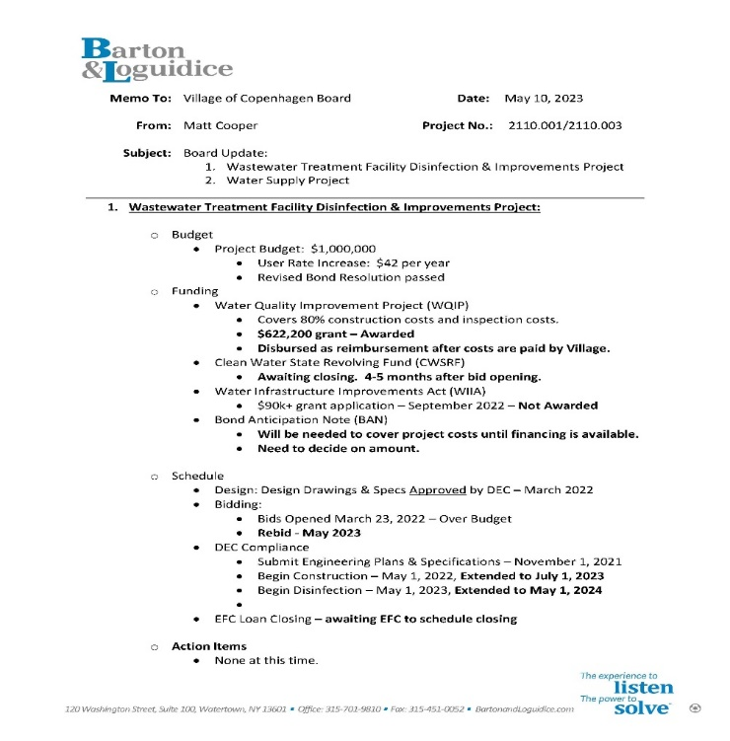
BIGGEST CONCERN IS THE HOW THE PROJECT WILL BE FUNDED. M. COOPER RECCOMMENDED A COLABLE BOND ANTICIPATION NOTE.

- WATER SUPPLY PROJECT
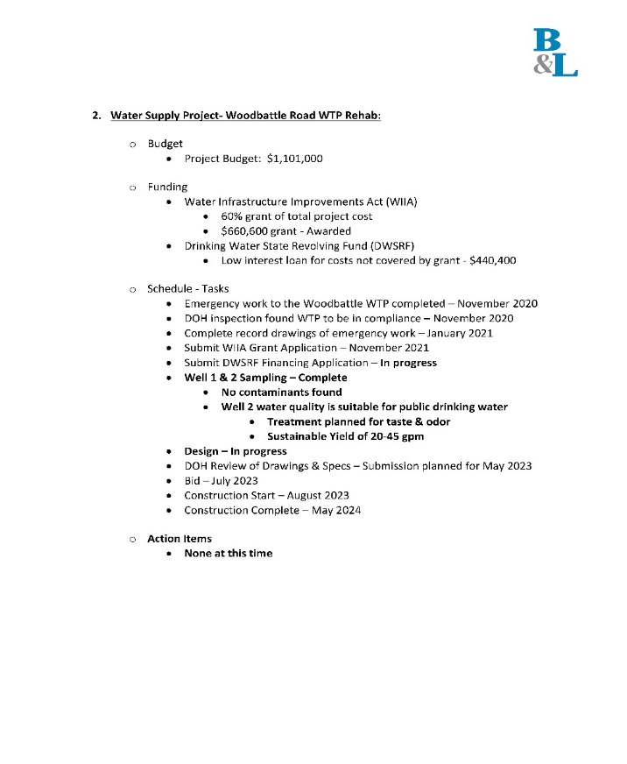
- TESTING HAS CONCLUDED AT WOODBATTLE. NO CONTAMINANTS FOUND. WELL 2 WATER QUALITY IS SUITABLE FOR PUBLIC DRINKING WATER. THERE IS A TREATMENT PLANNED FOR TASTE & ODOR. IT GAVE A SUSTAINABLE YEILD OF 20-45 GALLONS PER MINUTE.

MATT COOPER LEFT AT 18:41:00/6:30

RACOG UPDATE:
-A DISCUSSION WAS ALSO HAD, DO WE WANT TO BUY OUR OWN AS A VILLAGE OR USE THE ONE
RACOG IS BUYING; FROM TIME TO TIME? DUE TO STRICT DEPARTMENT OF TRANSPORTAION
RULES, FOR NOW WE WILL BE BORROWING FROM RACOG.

DPW UPDATE:
DPW Report For May 2023

- Found and uncovered manhole covers on Maple Ave., Grove St., Mechanic St., and Stoddard St
- Flagged for the Town of Denmark as they swept the Village Dtreets
- Found another two manholes in front of Heberts Farm
- Turned water on at both Cemeteries
- Moved flowerpots and placed them in front of over head door at Sewer Plant so they can be picked up
- Moved benches over in front of Generator at Sewer Plant
- Swept sidewalk in front of Band Wagon
- Took Storz connector off old fire hydrant and put it on thenew one that was replaced on Cataract Street
- Still gathering more information on four water accounts
- Changed winter wipers to summer ones on F-250 and F-450
- Turned water on at 10089 Grove St.
- Turned water on at Rumbles seasonable business
- Fixed lawn out back of shop
- Fixed lawn at Stoddard Water Plant, High Street Lift Station and Sewer Plant
- Moved both plows inside Sewer Plant along with the portable Generator
- Ordered reagents and buffer solutions for Waste Plants daily testing
- Turned water off at William Martains house on Rt.12 backing plate was broke and leaking water
- Took sweeper off lawn mower and put on mower deck
- Picked up 55 gal. drum to use to transfer diesel fuel from Woodbattle Water Plant to Village Garage skid tank
- Measured out where new 1,000 gallon propane tank is to be placed at Village Garage
- Turned water off at Casie Allens trailer so he can remodel his bathroom
- Sent monthly Water Report to Health Department
- Took monthly Water and Sewer samples to Converse Labs
- Found Main Water Valves in front of Gary Parker’s house and Devere Rumbles house
- Cleaned brush and dirt from around manhole behind Cottage Inn and Old Town Garage
- Mowed and weed eated Band Stand

COPENHAGEN CARES UPDATE: NO UPDATES.

FIRE DEPARTMENT:

RUTLAND- NO UPDATES.
COPENHAGEN FD INC.- NO FURTHER PROGRESS IN REGARDS ON GOING COURT HEARINGS.

NEW BUSINESS

-ERIC FLEMING SUBMITTED AN APPLICATION FOR A SEWER.
A DISCUSSION WAS HAD, DOES HE NEED TO BE CHARGED AN EXTRA EDU OR DOES NOT NEED TO. THE BOARD HAS TO LOOK INTO THE EDU LAW.

-A MOTION WAS MADE BY TRUSTEE VOGT AND SECONDED BY TRUSTEE BATES, TO
ACCEPT ERIC FLEMINGS SEWER APPLICATION. A DECISION WILL BE MADE JUNE
14TH MEETING, AS TO AN EXTRA EDU BEING CHARGED.

TRUSTEE STOKELY AYE
TRUSTEE VOGT AYE
TRUSTEE COLTON AYE
TRUSTEE BATES AYE
MAYOR SOUVA AYE
ALL AYES, MOTION CARRIED

-CONSIDERATION FOR HOLIDAY & TIME OFF CHANGES.
DPW WOULD LIKE TO WORK HALF DAYS GOOD FRIDAY AND JUNETEENTH. CHANGE MARTIN LUTHER KING TO A FLOATING HOLIDAY; OR ATLEAST MOVE IT TO THE FRIDAY AFTER THANKSGIVING. SUPERVISOR ROSS FEELS IT WILL SAVE THE VILLAGE MONEY, BECAUSE THEY STILL NEED TO COME ON THOSE FEDERAL HOLIDAYS TO DO WATER/SEWER PLANT CHECKS. THIS WAY IF THE THEY WORK HALF DAYS, IT WON’T BE CONSIDERED OVERTIME.

DPW WOULD ALSO LIKE TO CHANGE THE WAY VACATION, SICK-LEAVE, AND PERSONNEL TIME IS USED & CALCULATED. INSTEAD OF 4-HOUR BLOCKS, THEY WOULD LIKE IT TO BE CHANGED TO HOURLY. RESAON BEHIND THIS IS IT WOULD CUT DOWN ON EMPLOYEE ABSENTISM BY NOT HAVING TO USE 4 HOURS AT A TIME; INSTEAD SAID EMPLOYEE COULD ONLY TAKE A HOUR OR TWO.

A MOTION WAS MADE BY TRUSTEE VOGT AND SECONDED BY TRUSTEE STOKELY TO ACCEPT THESE SUGGESTED CHANGES. MOVING FORWARD THIS WILL BE HOW IT IS DONE.

TRUSTEE STOKELY AYE
TRUSTEE VOGT AYE
TRUSTEE COLTON AYE
TRUSTEE BATES AYE
MAYOR SOUVA AYE
ALL AYES, MOTION CARRIED

-INFORMATIONAL: LEWIS COUNTY’S NEW WIND FARM: OPPORTUNITY TO PROVIDE
COMMUNITY FUNDING?

27 TURBINES, 8 YEARS OF WORK AND ENOUGH ENERGY TO POWER 30,000 HOMES. THE NUMBER THREE ENERGY CENTER IN LOWVILLE, NEW YORK IS OFFICIALLY ON THE GRID AS OF MAY 4TH. THEY CURRENTLY SUPPLY ENERGY TO EVERY LIGHT BULB IN LEWIS COUNTY. ON TOP OF TAX REVENUE, INVENERGY ESTABLISHED A $6 MILLION COMMUNITY SUPPORT FUND THROUGH NUMBER THREE, WHICH CAN BE USED THROUGHOUT LEWIS COUNTY OVER THE NEXT 30 YEARS; IT CAN HELP SMALL BUSINESS, NOT-FOR-PROFIT, AND EVEN MUNICIPALITIES.

-TRUSTEE VOGT WOULD LIKE THE VILLAGE TO PAY FOR THE THREE PLANTERS THAT
WERE VANDALIZED LAST YEAR. THEY ARE $159 EACH, WITH $58 SHIPPING AND
HANDLING. IT WILL BE COMING OUT ACCOUNT A8810.4; COMMUNITY
BEAUTIFICATION- TREES FLOWERS ETC…

-A MOTION WAS MADE BY TRUSTEE VOGT AND SECONDED BY TRUSTEE BATES TO PAY
EARTH PLANTERS $535, FOR THREE NEW PLANTERS IN THE VILLAGE.

TRUSTEE STOKELY AYE
TRUSTEE VOGT AYE
TRUSTEE COLTON AYE
TRUSTEE BATES AYE
MAYOR SOUVA AYE
ALL AYES, MOTION CARRIED

APPLICATIONS RECEIVED FOR MEMORIAL PARK:
-JUNE 3, 2023- SHARI SIMMONS SIP N’ PAINT
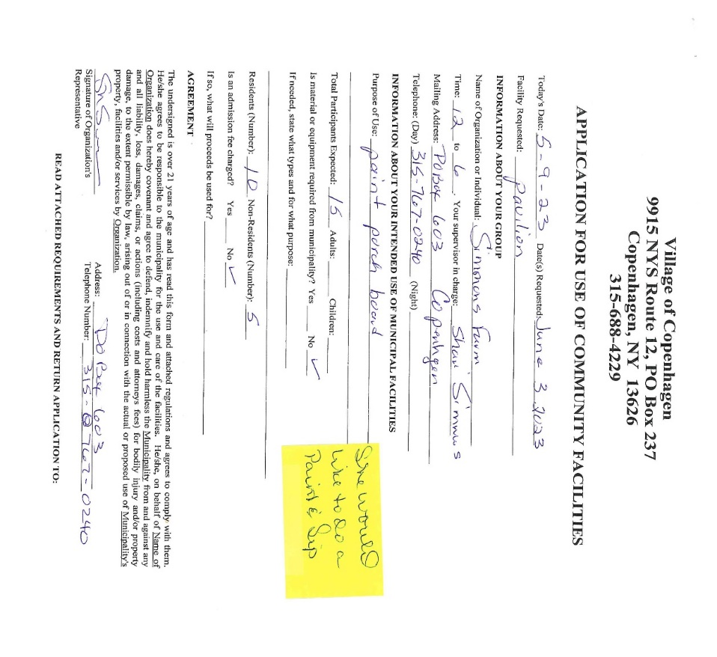
-A MOTION WAS MADE BY TRUSTEE BATES AND SECONDED BY TRUSTEE STOKELY TO
ACCEPT APPLICATION FOR JUNE 3RD, 2023. LET IT BE KNOWN THAT APPLICANTS
HAVE BEEN TOLD THAT THEY HAVE TO PARK ON THE STREET, AND NO ALCOHOL.

TRUSTEE STOKELY AYE
TRUSTEE VOGT AYE
TRUSTEE COLTON AYE
TRUSTEE BATES AYE
MAYOR SOUVA AYE
ALL AYES, MOTION CARRIED

-JUNE 4, 2023- JOYCE SULLIVAN/ NNY GARDENING GROUP
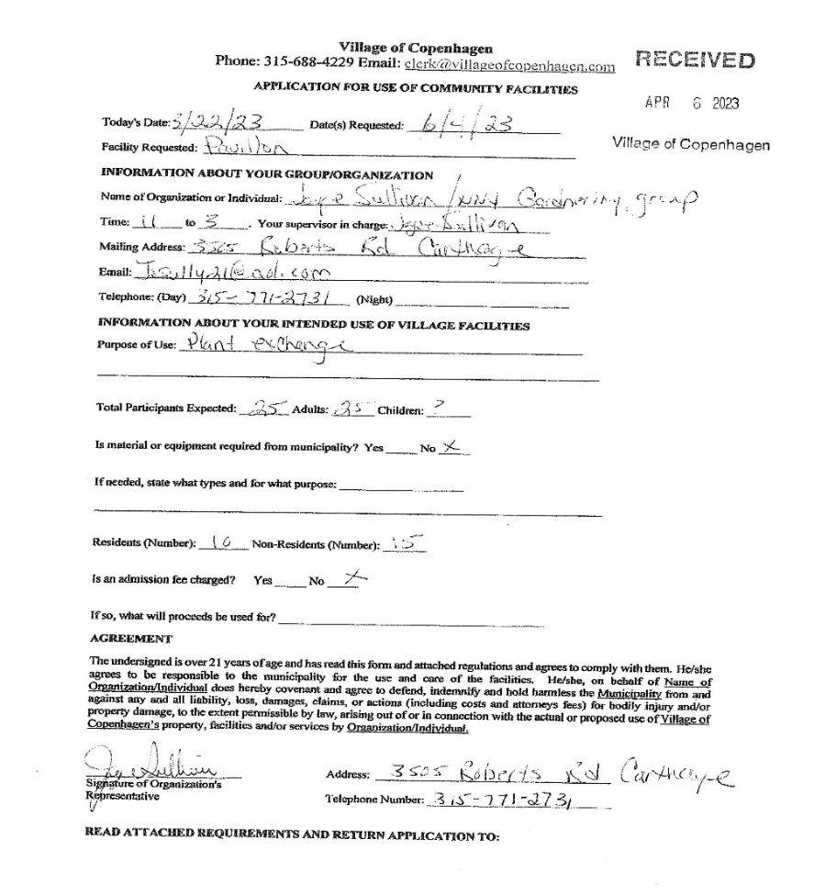

-A MOTION WAS MADE BY TRUSTEE BATES AND SECONDED BY TRUSTEE STOKELY
TO ACCEPT APPLICATION FOR JUNE 3RD, 2023. LET IT BE KNOWN THAT
APPLICANTS HAVE BEEN TOLD THAT THEY HAVE TO PARK ON THE STREET, AND
NO ALCOHOL.

TRUSTEE STOKELY AYE
TRUSTEE VOGT AYE
TRUSTEE COLTON AYE
TRUSTEE BATES AYE
MAYOR SOUVA AYE
ALL AYES, MOTION CARRIED

-A MOTION FOR RESOLUTION WAS MADE BY TRUSTEE BATES AND SECONDED BY
TRUSTEE COLTON, TO ACCEPT KATE FAZIO/COPENHAGEN CENTRAL SCHOOL
APPLICATION FOR MAY 18TH/ MAY 25TH.

TRUSTEE STOKELY AYE
TRUSTEE VOGT AYE
TRUSTEE COLTON AYE
TRUSTEE BATES AYE
MAYOR SOUVA AYE
ALL AYES, MOTION CARRIED

-VILLAGE EMERGENCY CALL SYSTEM- INTERALLY AND EXTERNALLY
THE BOARD WILL BE LOOKING AT A MASS NOTIFICATION SYSTEM, TO ALERT OUR VILLAGERS IN CASE OF AN EMERGENCY. ALSO WILL BE WORKING ON AN INTERNAL EMERGENCY SYSTEM WITHIN THOSE ELECTED & APPOINTED

OLD BUSINESS

-THE NEW MEMORIAL PARK/TED SIMMONS PAVILION & GARDEN SIGN HAS BEEN
ORDERED. ETA IS TRACKING TO BE AROUND THE END OF MAY EARLY JUNE.
CLERK AUGUSTINE AND SUPERINDENT ROSS WILL BE WORKING WITH COMPANIES TO GET A DESIGN FOR A FLOWER BOX ONCE IT ARRIVES.

-AN ACKNOWLEDGEMENT AND RULES SIGN ARE CURRENTLY BEING DESIGNED FOR
THE PARK.

-2021 AUDS ARE OFFICIALLY DONE.

-THE SIDEWALK LAW HAS BEEN DRAWN UP, AND IS GOING TO BE SENT TO LAWYER
SOON.

-RE-BIDS ARE CURRENTLY OPEN FOR WASTEWATER TREATMENT FACILITY PROJECT
UNTIL 14:00:00/2:00 P.M. 5.18.23. AT WHICH TIME WILL BE PUBLICALLY OPENED
AND READ.

- REQUEST FOR QUOTES WENT OUT TO FIRMS, IN RELATION TO THE FEASIBILITY STUDY
TO CONNECT TO WEST CARTHAGE’S WATER. THE THREE QUOTES ARE DUE THE
22ND, AND WILL BE DISCUSSED AT THE PUBLIC SPECIAL MEETING MAY 24TH AT
18:00:00/6:00 P.M.

-LEWIS COUNTY SOIL & DRAINAGE-
TRUSTEE BATES MET WITH NICHELLE. OUR WATER SHED IS A LOT LARGER THAN
PREVIOUSLY THOUGHT. A FEW CONTRUBUTING FACTORS, BUT NOT ALL ARE:
- CHANGE IN ANNUAL RAINFALL
- NUMBER OF FORESTED AREAS
- AN INCREASE IN PAVED AREAS
- SIZES AND TYPES OF DRAINAGE MATERIALS THROUGHOUT THE VILLAGE
SOME SUGGESTED SOLUTIONS:
- DIG THE ENTIRE SYSTEM UP & REDO IT
- RETENTION AND SLOW RELEASE AT SOME POINT ABOVE THE DRAINAGE
- RAIN BARREL PROGRAM

SUPERINTEDENT ROSS IS CHECKING WITH DANC TO SEE IF WE CAN GET A CAMERA TO LOOK AT THE DRAINAGE THROUGHOUT THE VILLAGE.

NICHELLE IS LOOKING INTO AREAS OF FUNDING. THE TIMELINE TO START NEEDS TO BE AROUND JULY 2023, TO DETERMINE AWARDS BY DECEMBER 2023/JANUARY
2024.

-A LETTER WAS READ ALOUD FROM DEVERE & MARY RUMBLE, FROM HOPENHAGEN
FARMS. THEY RESPECTFULLY INFORMED THE BOARD AND GUESTS, THE LAVENDAR
FESTIVAL WILL BE JULY 8TH OF THIS YEAR.
- THE PROPER PERMITS WERE FILLED WITH LEWIS COUNTY
- THERE WILL BE NO PARKING BARRELS ALONG THE STREET
- RUTLAND FIRE DEPARTMENT HAS AGREED TO BE ONSITE FOR THE FESTIVAL

-TRUSTEES WERE PRESENTED WITH AUDITED APRIL FINANCIALS, AND THEY WERE
ACCEPTED.

-TRUSTEES WERE PRESENTED WITH MAY FINANCIALS.

-A MOTION WAS MADE BY TRUSTEE BATES AND SECONDED BY TRUSTEE STOKELY TO
PAY THE BILLS.

TRUSTEE STOKELY AYE
TRUSTEE VOGT AYE
TRUSTEE COLTON AYE
TRUSTEE BATES AYE
MAYOR SOUVA AYE
ALL AYES, MOTION CARRIED

-AT 19:55:00/7:55 P.M. MOTION WAS MADE BY TRUSTEE BATES AND SECONDED BY
TRUSTEE STOKELY TO ADJOURN THE MEETING.

TRUSTEE STOKELY AYE
TRUSTEE VOGT AYE
TRUSTEE COLTON AYE
TRUSTEE BATES AYE
MAYOR SOUVA AYE
ALL AYES, MOTION CARRIED

NEXT REGULAR BOARD MEETING WILL BE HELD JUNE 14, 2023, @ 18:30:00/6:00.

MAYOR SOUVA CLERK AUGUSTINE

