PLEDGE OF ALLEGIANCE
APPROVAL OF DECEMBER MEETING MINUTES

UPDATES
RACOG
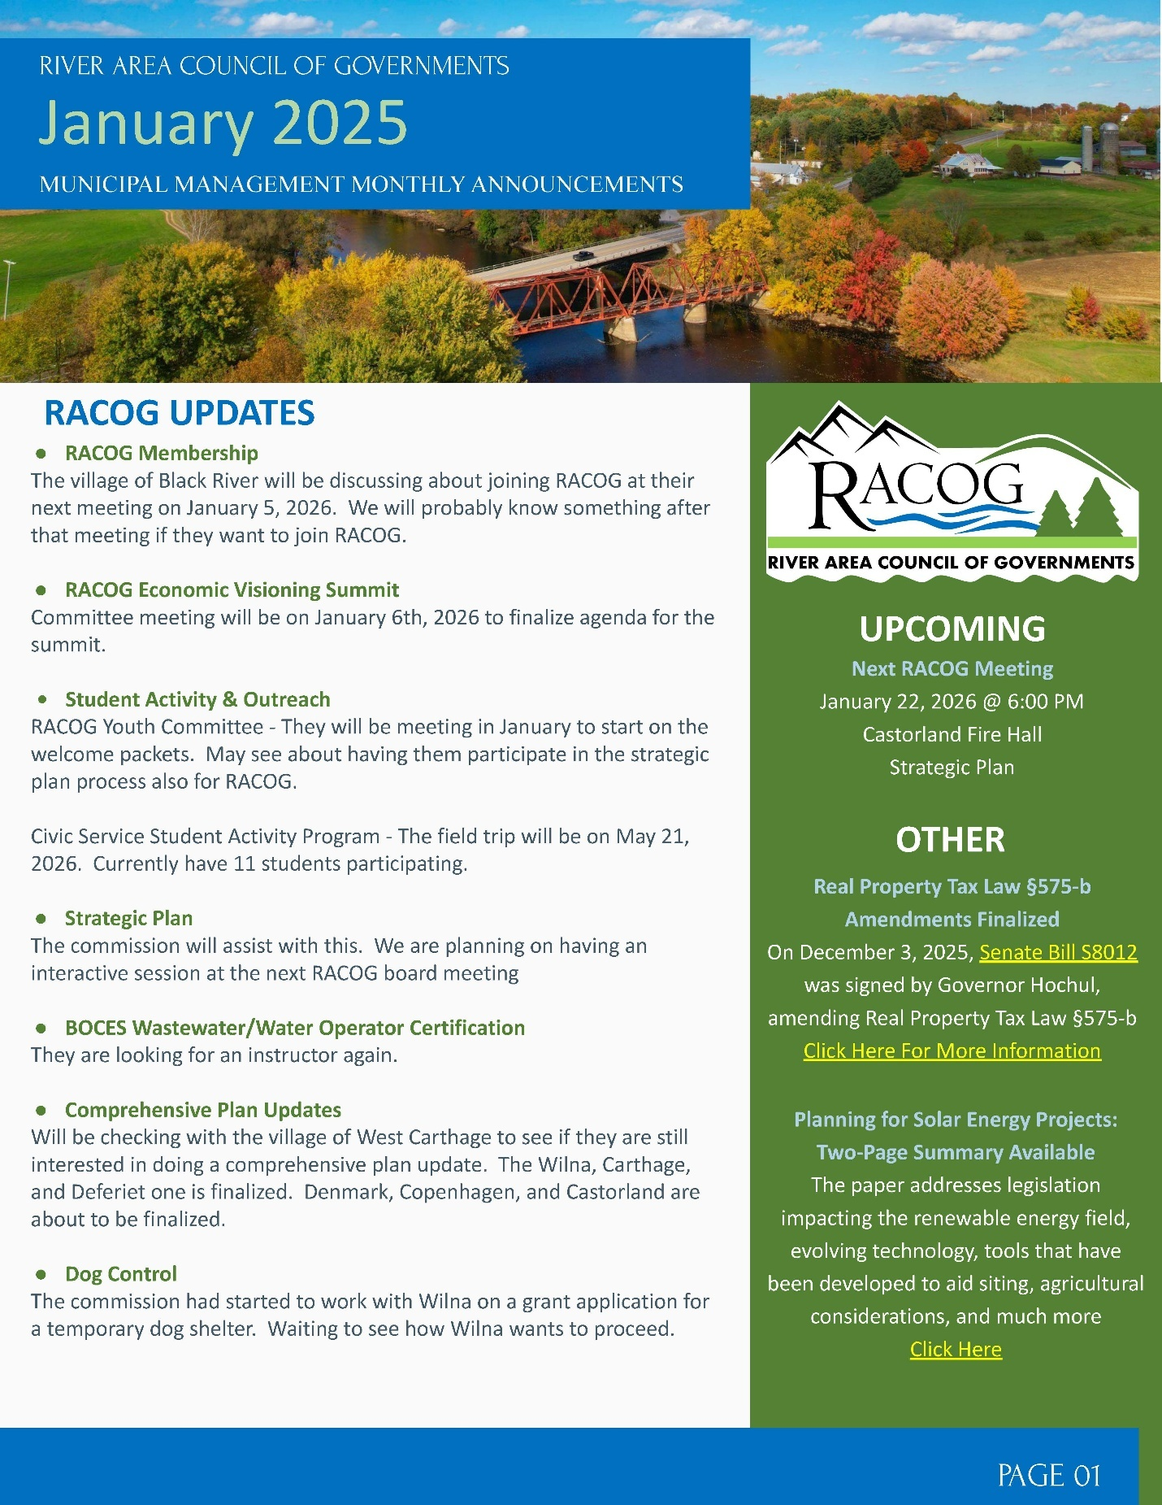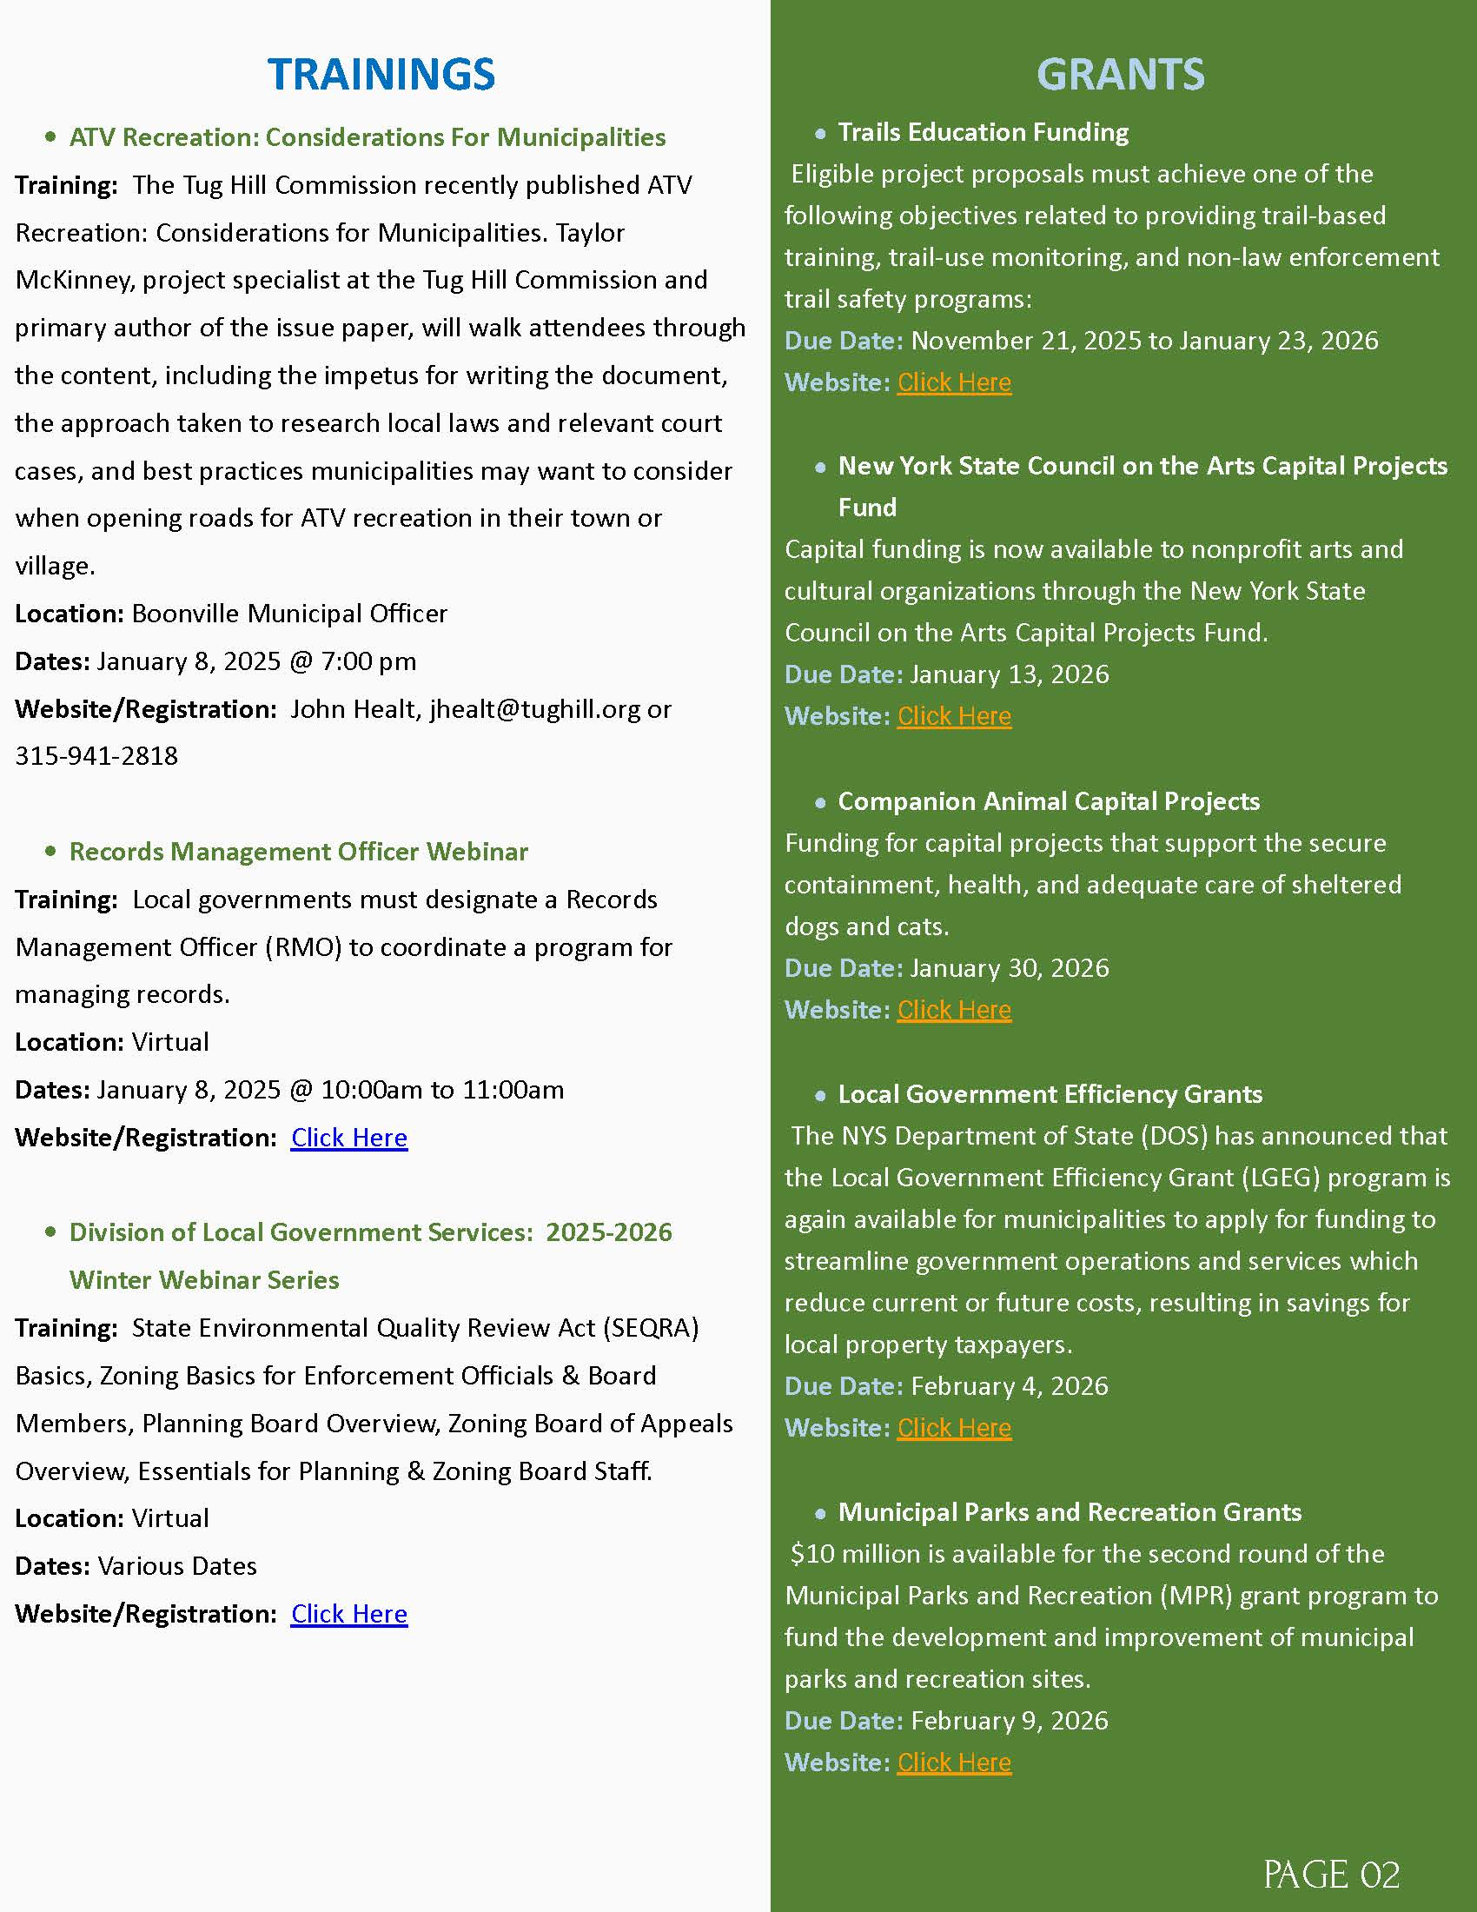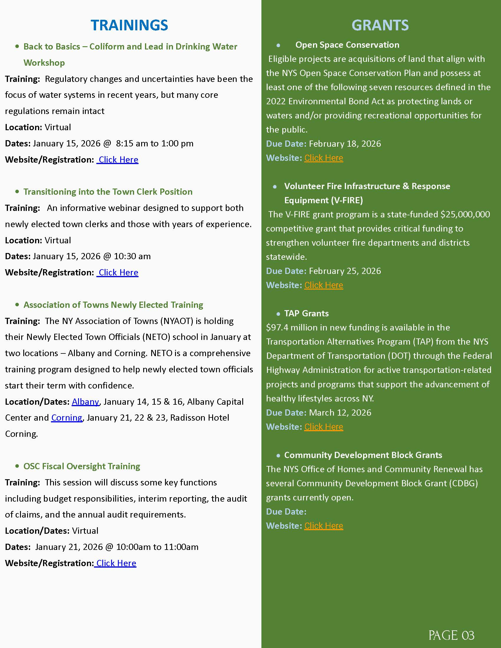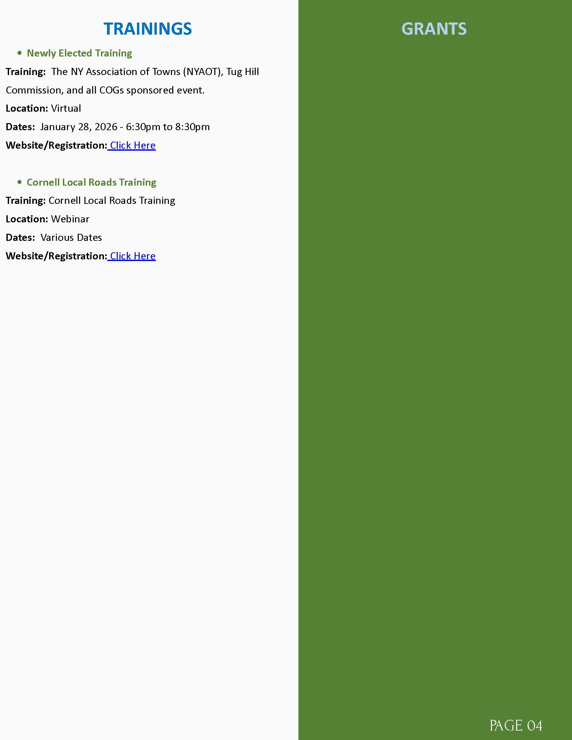
DPW
- Snowblowed sidewalks from church to Dollar General
- Moved snow from old white house to old red brick building next to post office
- Moved snow from Powis building to wanda bushes apartment building
- Moved snow from down next to old red brick building on Maple Ave
- Moved snow from over next to dry hydrant
- Put out Hydrant barrels on main drag
- Turned off water at Devere Rumbles Lavender shop
- Changed out air hose ends on air line and fire truck
- Kubota went to whites because of water got in the fuel filters
- Placed two of the barrels up to school
- Took water and sewer samples to Convers labs for the month
- Had Siewarts up to check on High life station pump # 1 all set
- Moved snow from hydrant on Cataract st.
- Replaced both knobs on snow blower shoot
- Changed out Jeff Snyders meter head
- Dropped off F-250 to have new tires put on
- Picked up F-250 from getting new tires put on
- Had Kloster up to check on blower #1 for the code it had
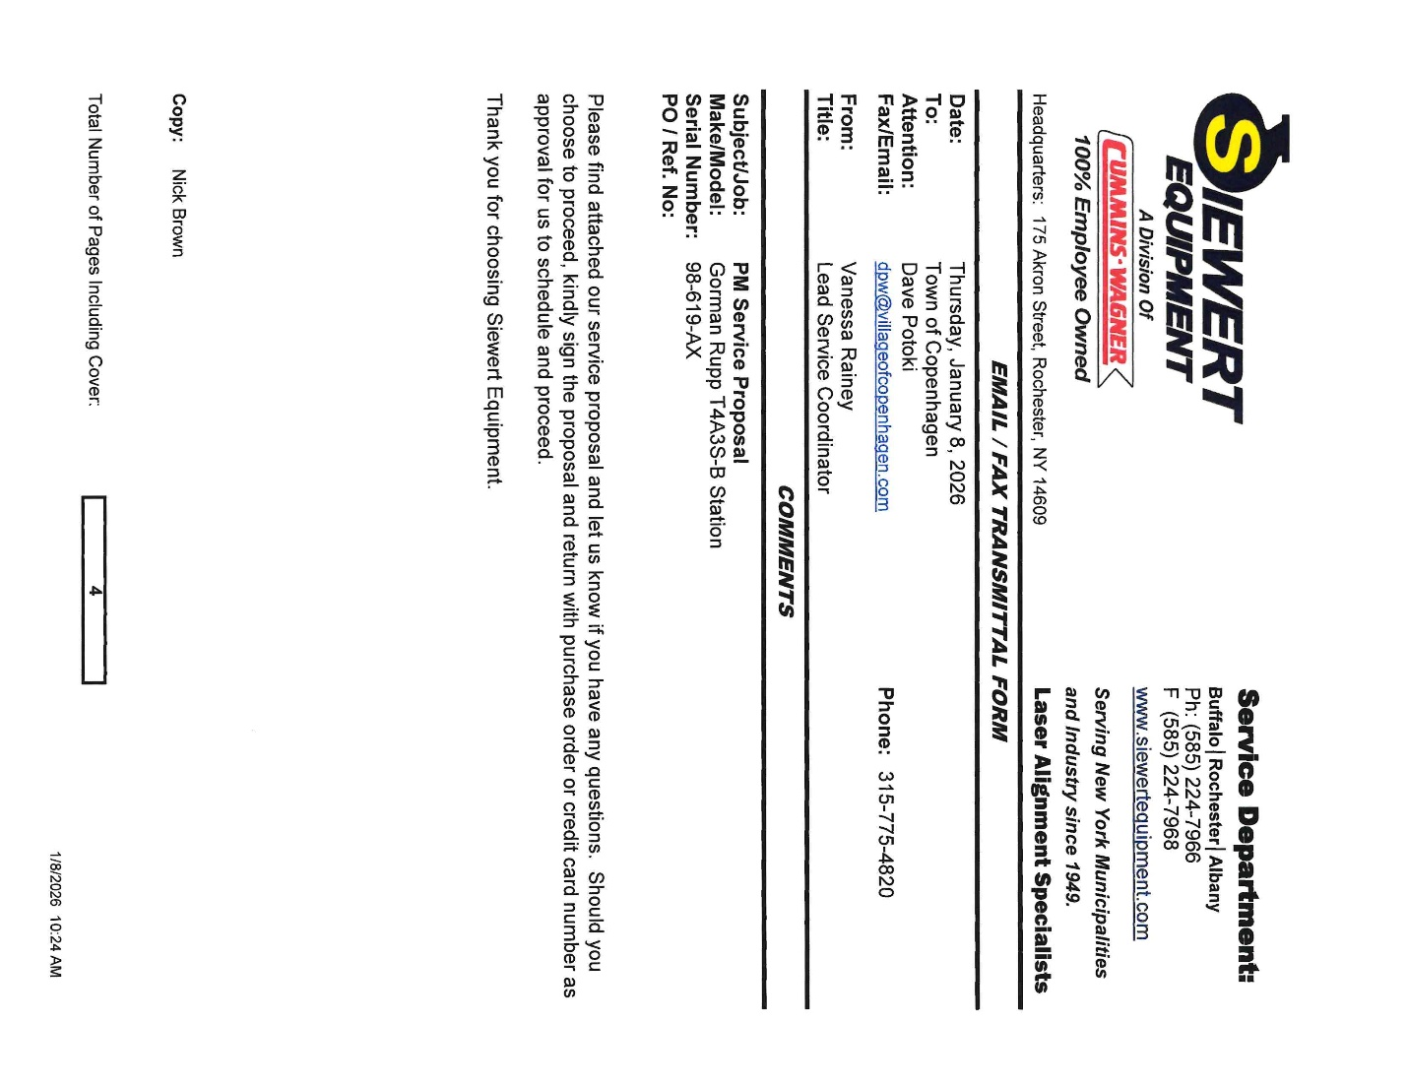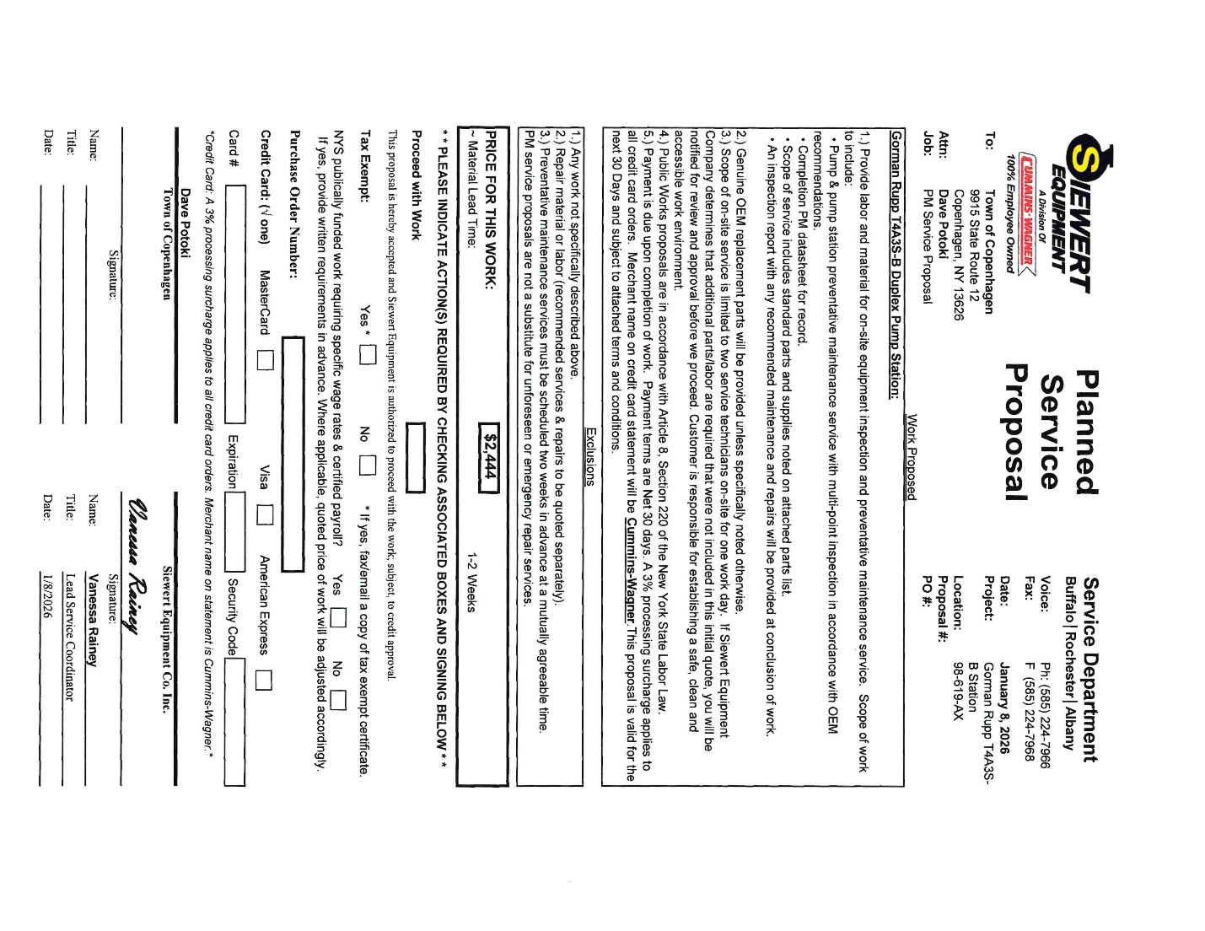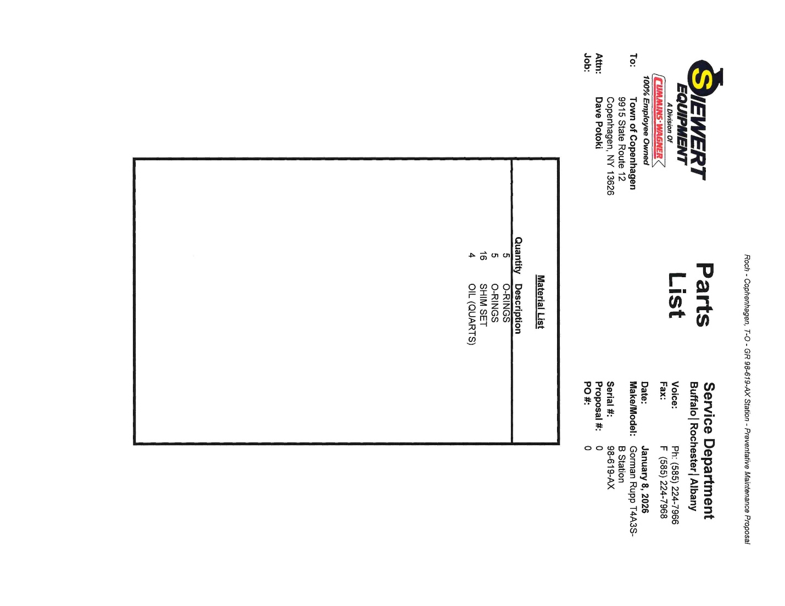

BCA
COPENHAGEN CARES
PROPERTY MAINTENANCE
FIRE DEPARTMENT
RUTLAND
COPENHAGEN FIRE DEPARTMENT INC
PUBLIC COMMENTS/INFORMATIONAL

OLD BUSINESS
SEWER USE LAW-LAWYERS
ANCA
SHARED SERVICES WITH CASTORLAND:
IMA WATER & SEWER
GARBAGE TRUCK
LEWIS COUNTY DRAINAGE
WOODBATTLE WATER PLANT- WATERMAN DEBRIS
LIGHT POLE BEHIND BUSH/GAINES APT BUILDINGS
CROSSWALK SIGN MISSING-MECHANIC
PARKING ON SIDEWALKS-LOUD
DOWNTOWN REVITILIZATION

SPRING
CATARACT ST HYDRANT- GIVE POWIS HYDRANT
NEW BUSINESS OFFICES TO BE FILLED FOR 1.2027
OPEN FORUM
FINANCIALS
TREASURER REPORT

MONTHLY ABTRACTS
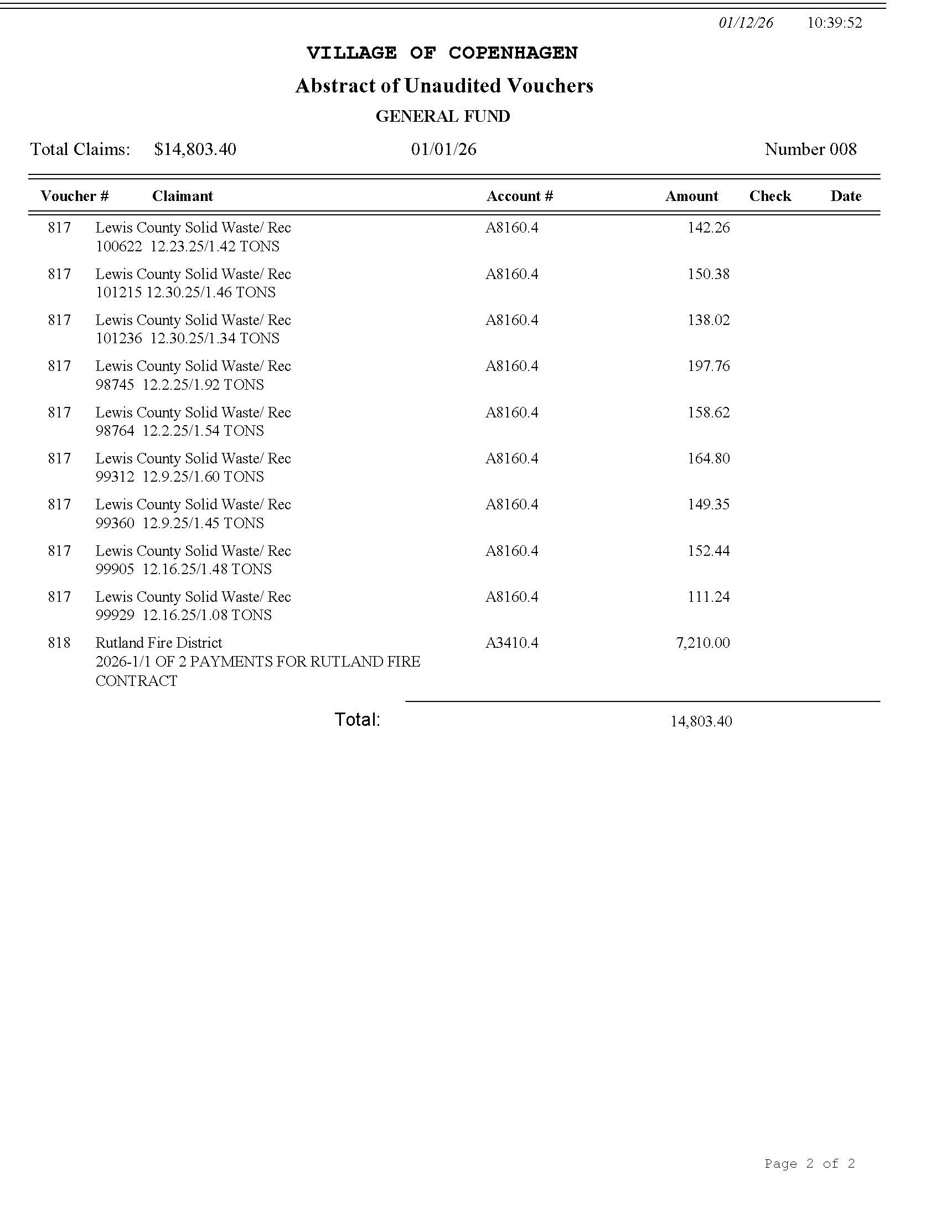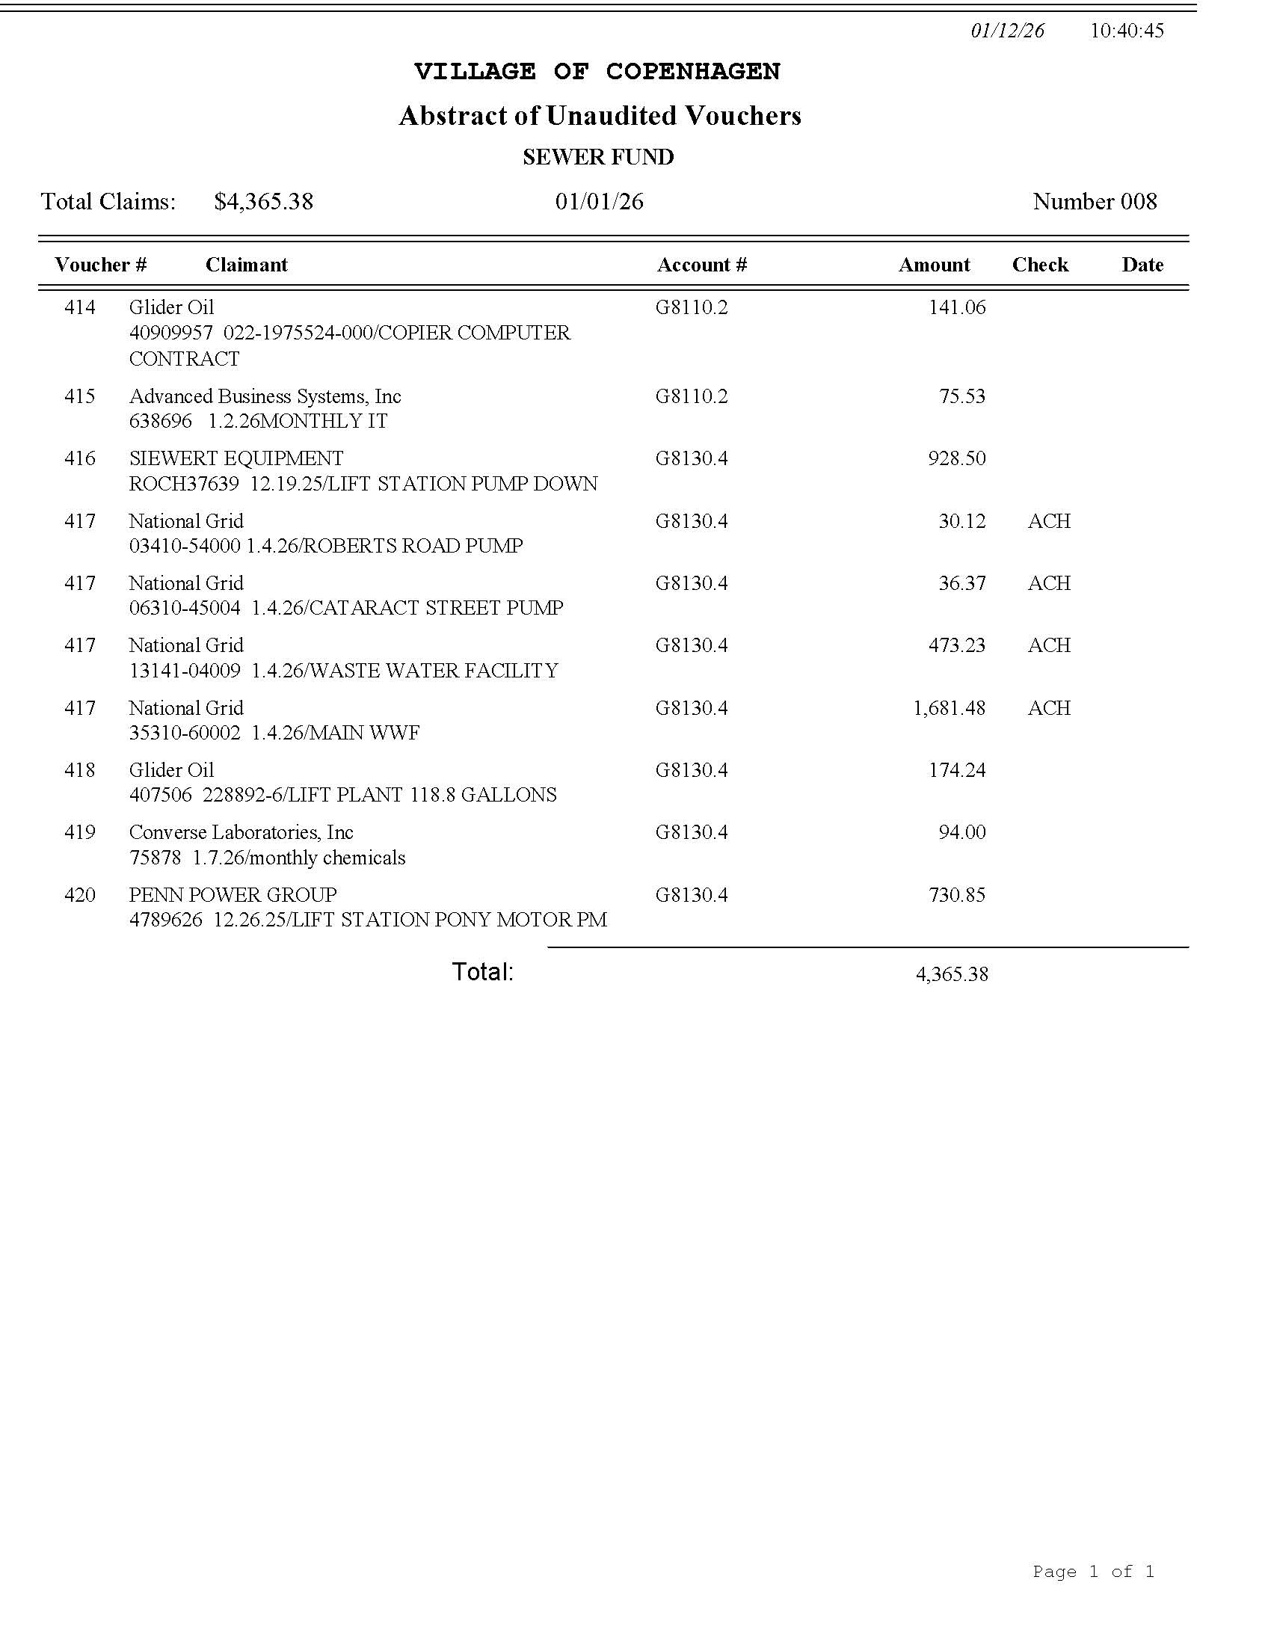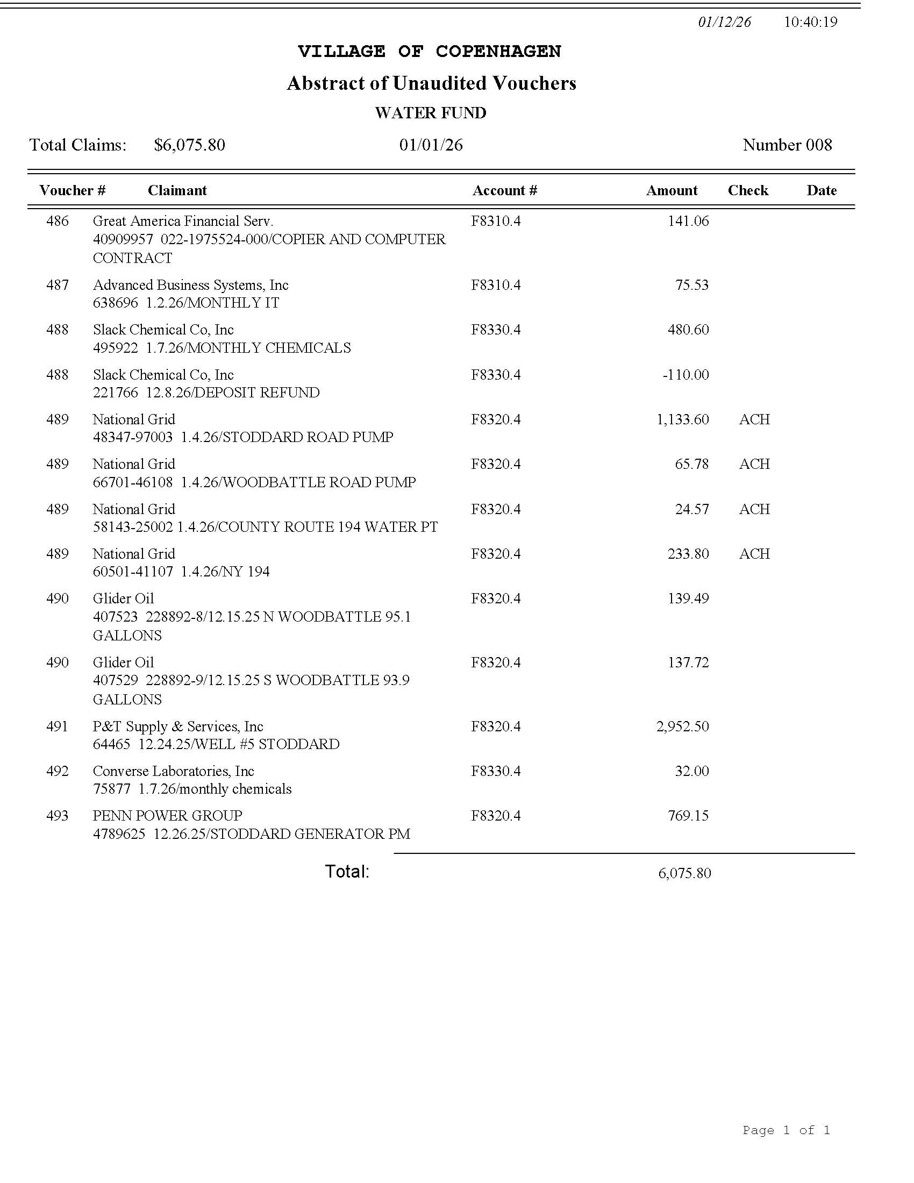
PAY BILLS

ADJOURNMENT
NEXT MEETING FEBRUARY 11TH
SEE YOU THEN!

