At 18:30:00/6:30:00 MAYOR SOUVA CALLED THE MEETING TO ORDER, THOSE IN
ATTENDANCE RECITED THE PLEDGE OF ALLEGIANCE.

PRESENT WERE: MAYOR MARK SOUVA

TRUSTEES: KIM VOGT, PATTY BATES, DIANE MAHAR, SCOTT ALEXANDER

CLERK: KIMBERLY AUGUSTINE

ABSENT: SUPERINTENDENT RICH ROSS

GUEST: GAIL ALEXANDER, MICKET DIETRICH, MIKE ALTERI, GERALD CARTER

APPROVAL OF DECEMBER MEETING MINUTES
A MOTION WAS MADE BY TRUSTEE BATES AND SECONDED BY TRUSTEE ALEXANDER, TO APPROVE DECEMBER 2025 MEETING MINUTES.
TRUSTEE VOGT AYE
TRUSTEE BATES AYE
TRUSTEE MAHAR AYE
TRUSTEE ALEXANDER AYE
MAYOR SOUVA AYE
ALL PRESENT IN FAVOR, MOTION CARRIED.
APPROVED JANUARY 14, 2026

UPDATES
RACOG

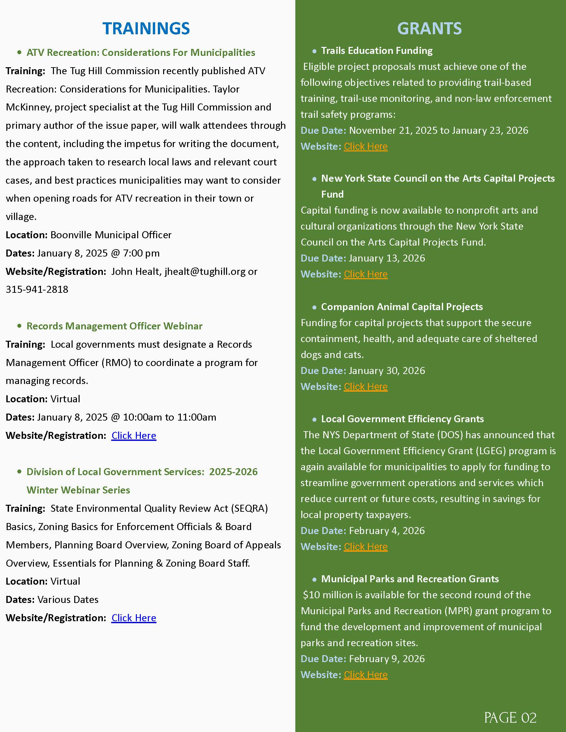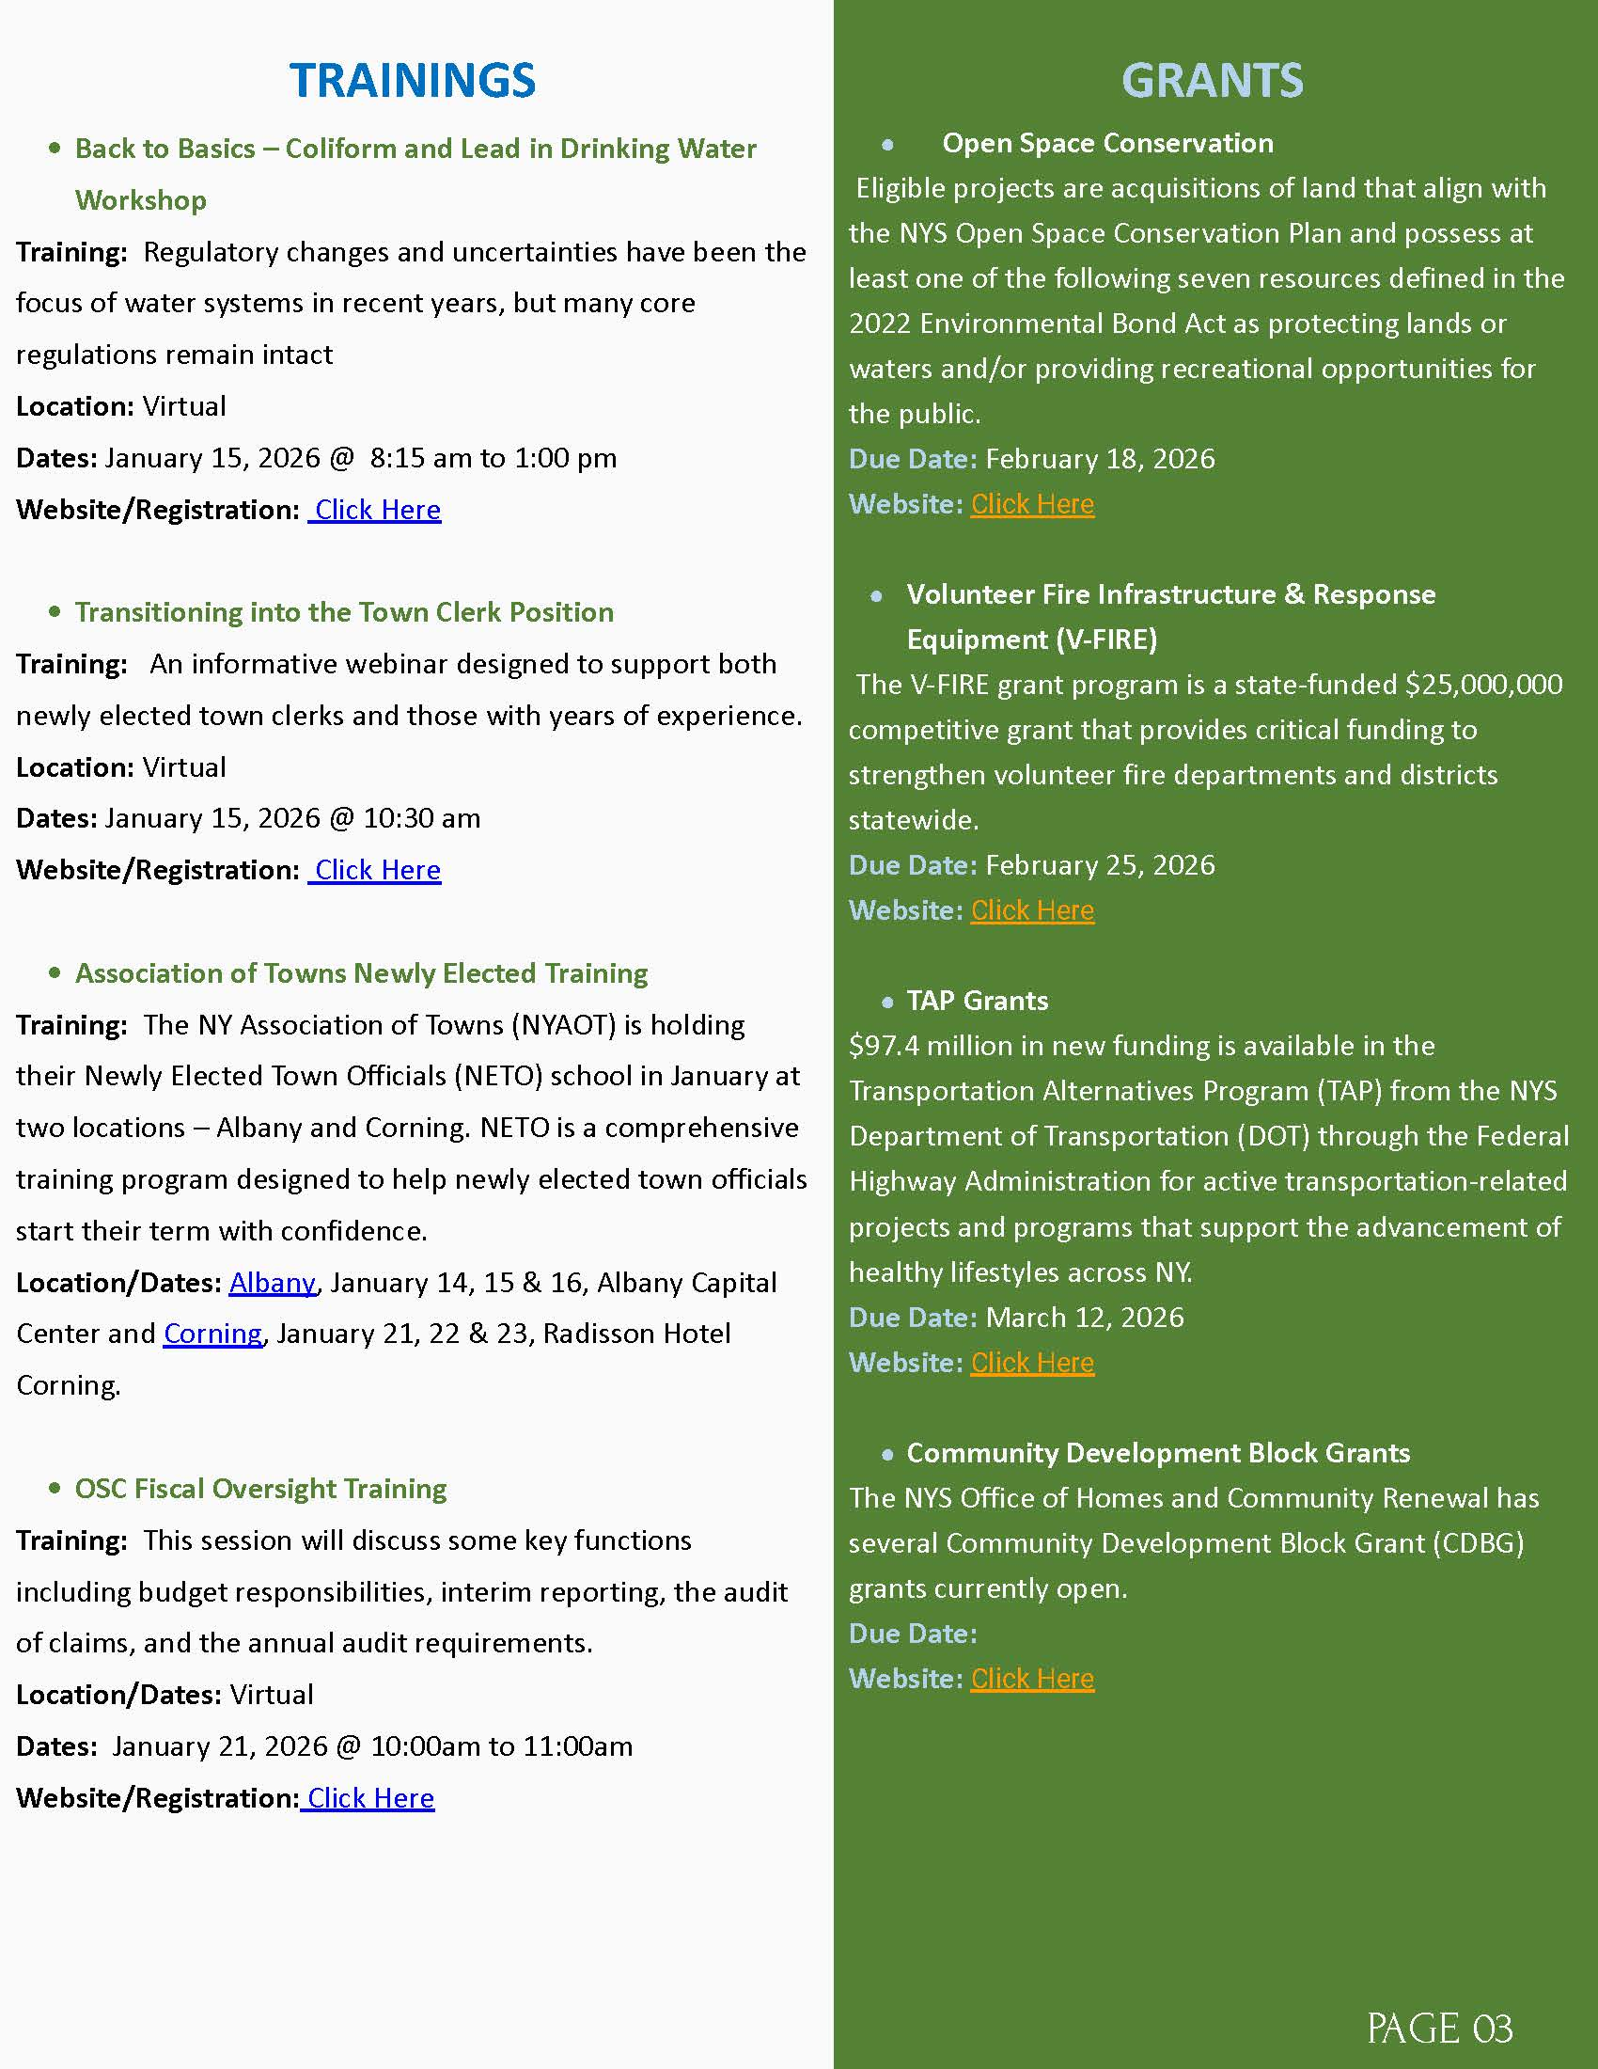

DPW
- Snowblowed sidewalks from church to Dollar General
- Moved snow from old white house to old red brick building next to post office
- Moved snow from Powis building to wanda bushes apartment building
- Moved snow from down next to old red brick building on Maple Ave
- Moved snow from over next to dry hydrant
- Put out Hydrant barrels on main drag
- Turned off water at Devere Rumbles Lavender shop
- Changed out air hose ends on air line and fire truck
- Kubota went to whites because of water got in the fuel filters
- Placed two of the barrels up to school
- Took water and sewer samples to Convers labs for the month
- Had Siewarts up to check on High life station pump # 1 all set
- Moved snow from hydrant on Cataract st.
- Replaced both knobs on snow blower shoot
- Changed out Jeff Snyders meter head
- Dropped off F-250 to have new tires put on
- Picked up F-250 from getting new tires put on
- Had Kloster up to check on blower #1 for the code it had
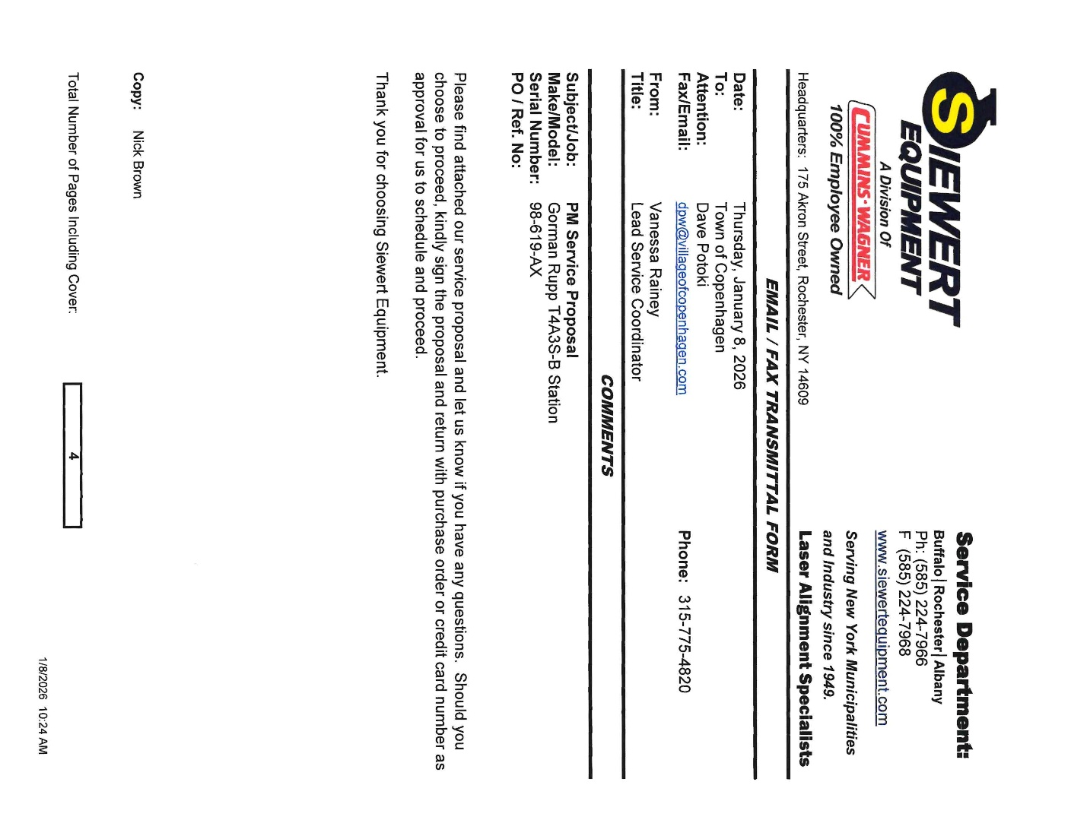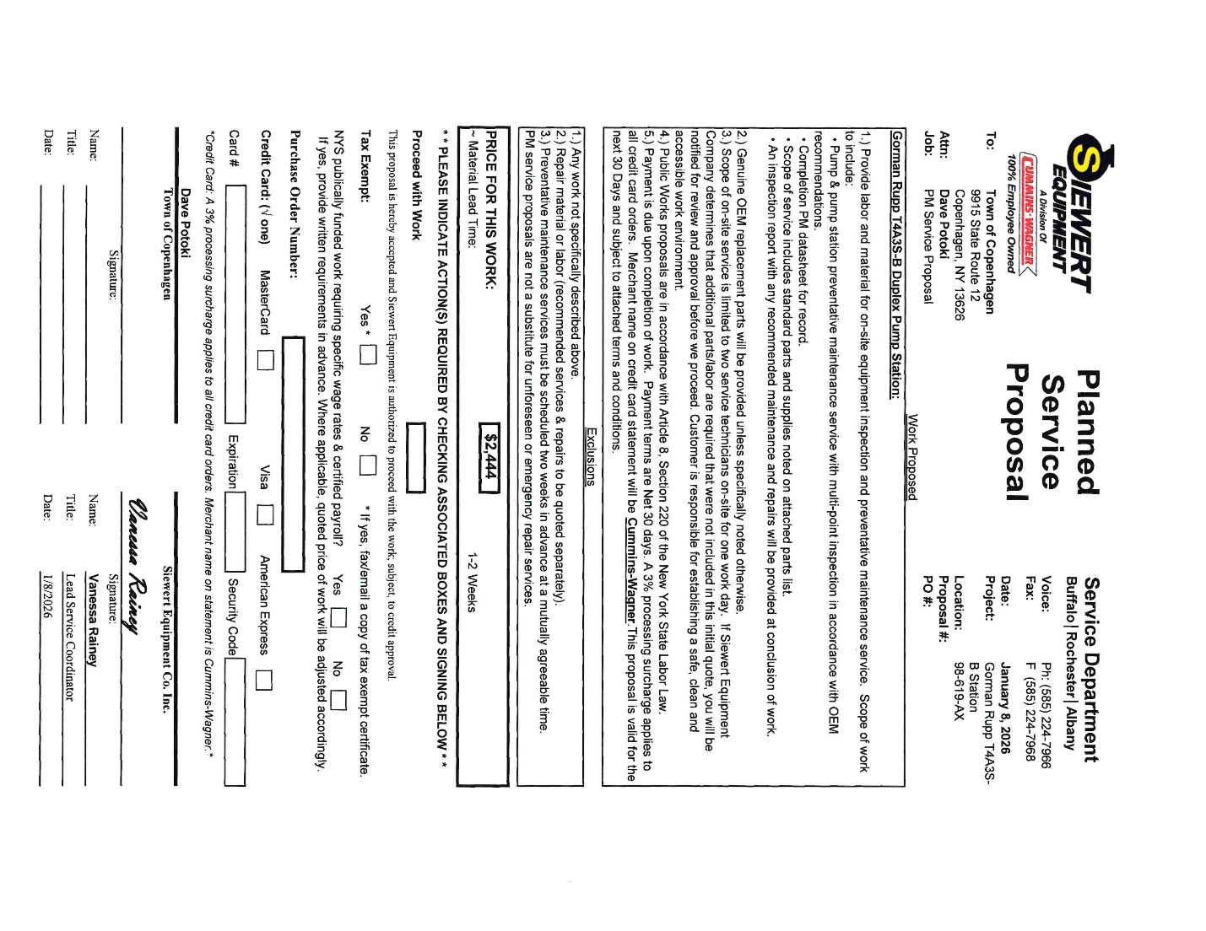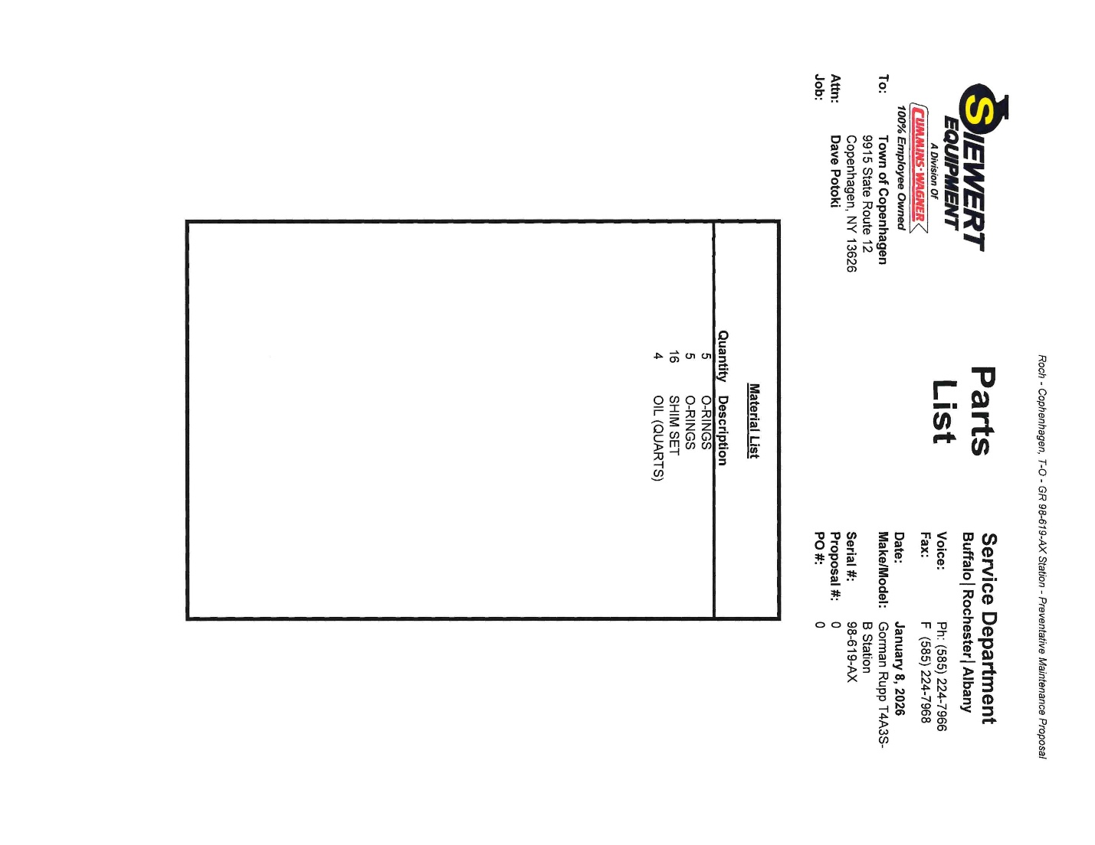

RESOLUTION 16-2026

SERVICE PUMPS
A MOTION FOR RESOLUTION WAS MADE BY TRUSTEE VOGT AND SECONDED BY TRUSTEE ALEXANDER, TO SERVICE PUMPS AT $2444.00.
TRUSTEE VOGT AYE
TRUSTEE BATES AYE
TRUSTEE MAHAR AYE
TRUSTEE ALEXANDER AYE
MAYOR SOUVA AYE
ALL PRESENT IN FAVOR, MOTION CARRIED.
RESOLUTION 16-2026 APPROVED JANUARY 14, 2026

BCA

RESOLUTION 17-2026

ENGINEER AGREEMENT & NYSRF DOCUMENT
A MOTION FOR RESOLUTION WAS MADE BY TRUSTEE BATES AND SECONDED BY TRUSTEE MAHAR, TO GIVE MAYOR SOUVA THE POWER TO SIGN THESE DOCUMENTS.
TRUSTEE VOGT AYE
TRUSTEE BATES AYE
TRUSTEE MAHAR AYE
TRUSTEE ALEXANDER AYE
MAYOR SOUVA AYE
ALL PRESENT IN FAVOR, MOTION CARRIED.
RESOLUTION 17-2026 APPROVED JANUARY 14, 2026

COPENHAGEN CARES
NO UPDATES

PROPERTY MAINTENANCE
NO UPDATES

FIRE DEPARTMENT
RUTLAND
NO UPDATES
COPENHAGEN FIRE DEPARTMENT INC.
NEW JUDGE ASSIGN TO CASE: RAMZINGER

PUBLIC COMMENTS/INFORMATIONAL
NONE

OLD BUSINESS
SEWER USE LAW-LAWYERS
NO UPDATE
ANCA
NO UPDATE

SHARED SERVICES WITH CASTORLAND:
IMA WATER & SEWER
GARBAGE TRUCK
NO UPDATE

LED LIGHTING BEHIND GAINES/BUSH-MUNCY
NO UPDATE

CROSSWALK SIGN MISSING-MECHANIC
PARKING ON SIDEWALKS-LOUD
SUPERINTENDENT ROSS WILL WORKING TOGETHER RO MONNET AND LEWIS COUNTY, TO GET THESE AREAS TAKEN CARE OF

DOWNTOWN REVITILIZATION
NO UPDATE

DCC COMPRHENSIVE PLAN

RESOLUTION 18-2026
A MOTION FOR RESOLUTION WAS MADE BY TRUSTEE BATES AND SECONDED BY TRUSTEE MAHAR,

WHEREAS, THE COPENHAGEN VILLAGE BOARD CHARGED THE DEMARK, COPENHAGEN, AND CASTORLAND (DCC) COMPREHENSIVE PLAN COMMITTEE WITH THE DEVELOPMENT OF A COMPREHENSIVE PLAN; AND THE DCC COMPREHENSIVE PLAN COMMITTEE DEVELOPED SUCH PLAN; HELD A PUBLIC HEARING ON SUCH PLAN AUGUST 21, 2025; AND RECCOMMENDED SUCH PLAN TO THE VILLAGE BOARD,

WHEREAS, THE COPENHAGEN VILLAGE BOARD SUBMITTED THE PLAN TO LEWIS COUNTY PLANNING BOARD FOR REVIEW UNDER GENERAL MUNICIPAL LAW SECTION 239M; THE LEWIS COUNTY PLANNING BOARD APPROVED THE PLAN WITH MODIFICATIONS; AND THE COPENHAGEN VILLAGE BOARD INCORPORATED THE MODIFICATIONS SUGGESTED BY THE LEWIS COUNTY PLANNING BOARD INTO THE PLAN,

WHEREAS, THE COPENHAGEN VILLAGE BOARD HELD A PUBLIC HEARING ON THE PLAN DECEMBER 15, 2025,

WHEREAS, THE COPENHAGEN VILLAGE BOARD ESTABLISHED ITSELF AS LEAD AGENCY UNDER THE STATE ENVIROMENTAL QUALITY REVIEW ACT, AND DECLARED THAT THE PLAN WILL NOT HAVE A SIGNIFICANT NEGATIVE EFFECT ON THE ENVIROMENT,

THERFORE, BE IT RESOLVED THAT, PURSUANT TO THE VILLAGE LAW SECTION 7-722, THE COPENHAGEN VILLAGE BOARD HEREBY ADOPTS THE TOWN OF DENMARK AND THE VILLAGES OF COPENHAGEN AND CASTORLAND COMPREHENSIVE PLAN.

TRUSTEE VOGT AYE
TRUSTEE BATES AYE
TRUSTEE MAHAR AYE
TRUSTEE ALEXANDER AYE
MAYOR SOUVA AYE
ALL PRESENT IN FAVOR, MOTION CARRIED.
RESOLUTION 19-2026 APPROVED JANUARY 14, 2026

TRUSTEE VOGT AYE
TRUSTEE BATES AYE
TRUSTEE MAHAR AYE
TRUSTEE ALEXANDER AYE
MAYOR SOUVA AYE
ALL PRESENT IN FAVOR, MOTION CARRIED.
RESOLUTION 18-2026 APPROVED JANUARY 14, 2026

SPRING
CATARACT ST HYDRANT- GIVE TO POWIS
LEWIS COUNTY DRAINAGE
WOODBATTLE WATER PLANT- WATERMAN DEBRIS- WAITING FOR FROST TO KILL GRASS TO GET IT OUT

NEW BUSINESS
OFFICES TO BE FILLED FOR 1.1.27
TRUSTEE KIM VOGT
TRUSTEE SCOTT ALEXANDER

OPEN FORUM

FINANCIALS
TREASURER REPORT

MONTHLY ABSTRACTS
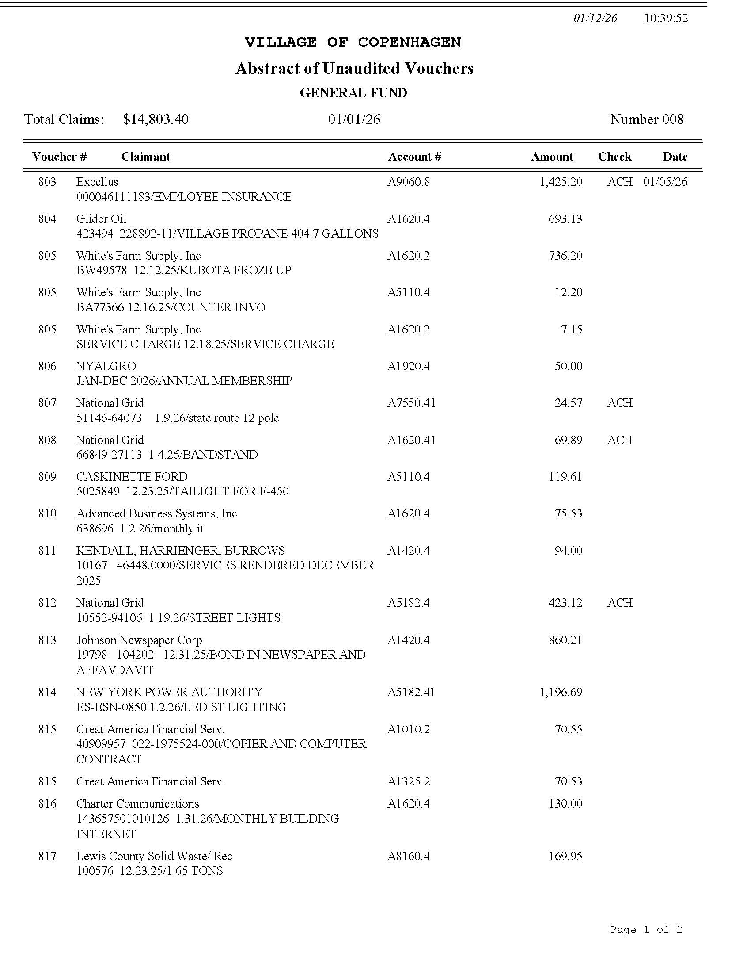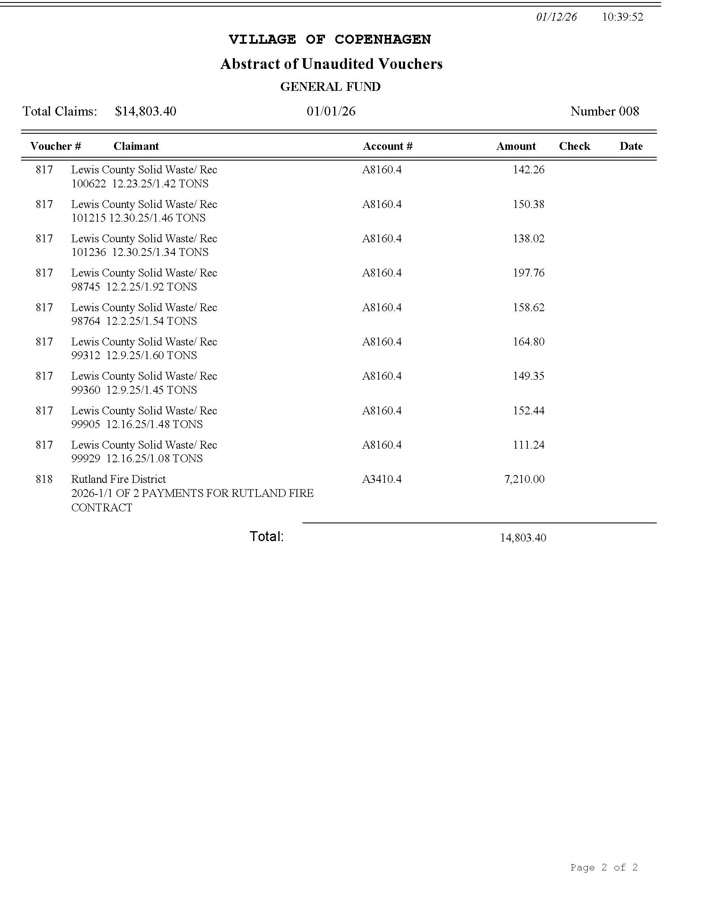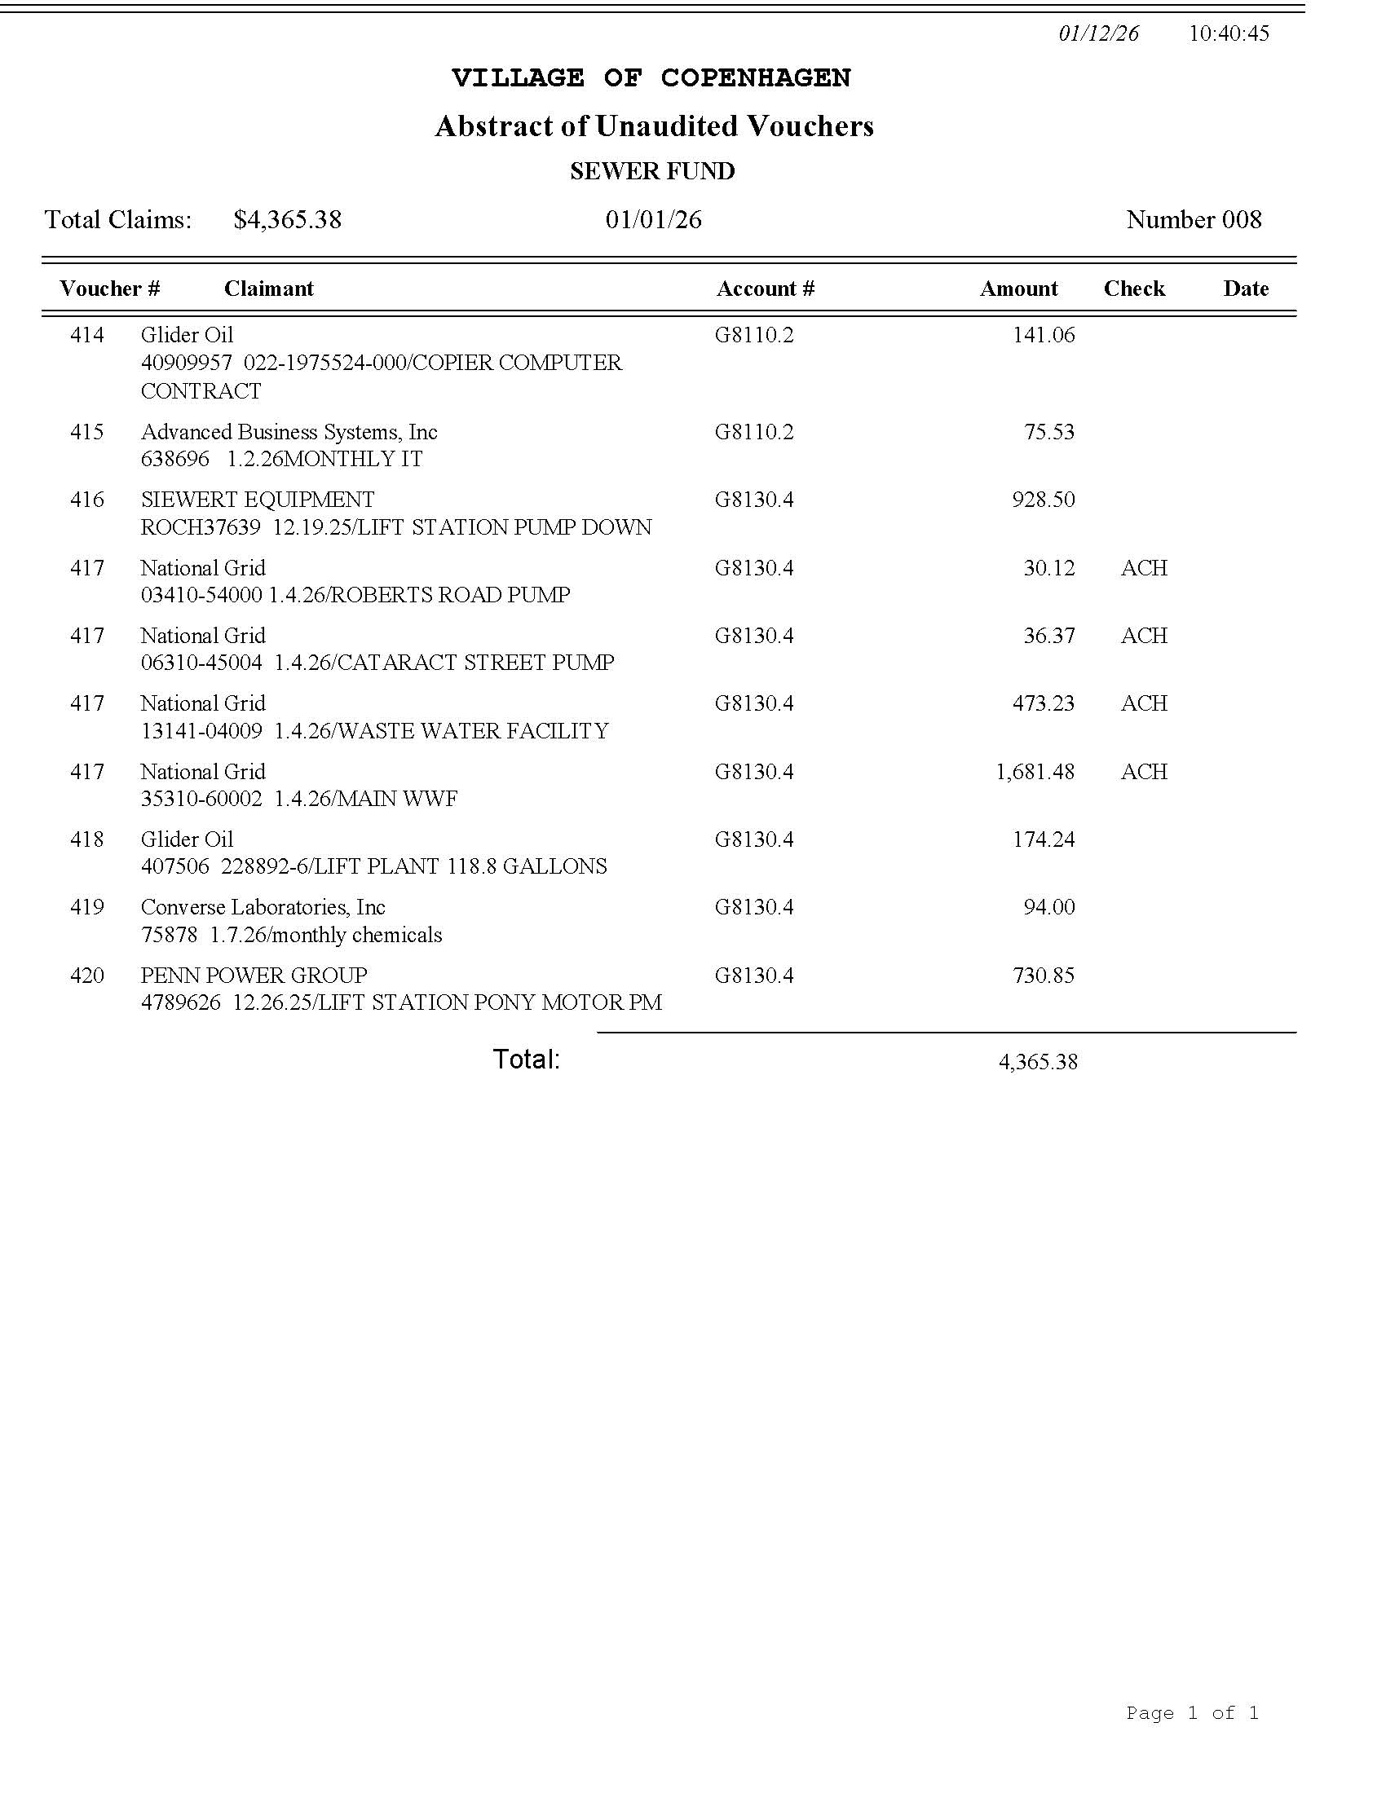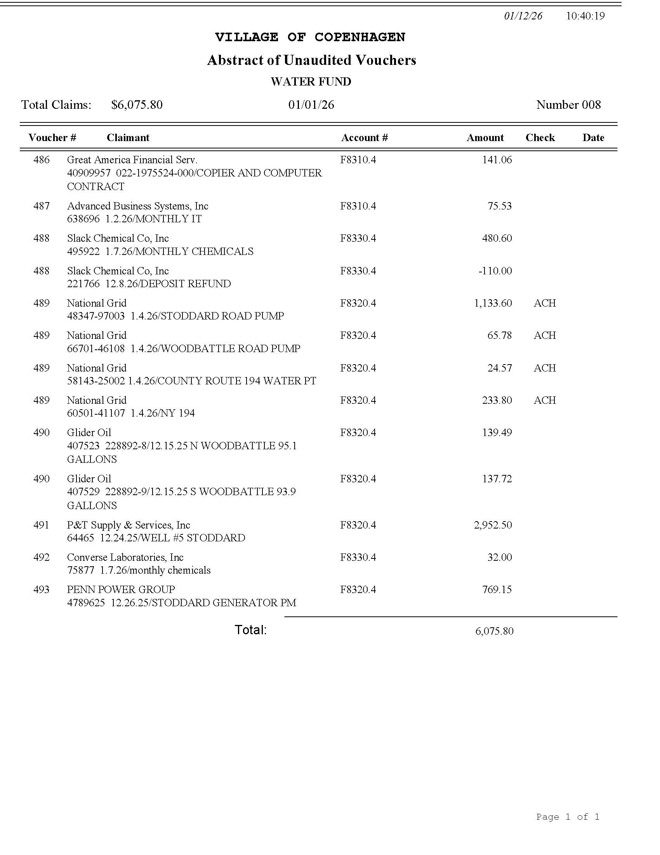

PAY BILLS

RESOLUTION 19-2026
A MOTION FOR RESOLUTION WAS MADE BY TRUSTEE MAHAR AND SECONDED BY TRUSTEE BATES, TO PAY JANUARY 2026 BILLS.
TRUSTEE VOGT AYE
TRUSTEE BATES AYE
TRUSTEE MAHAR AYE
TRUSTEE ALEXANDER AYE
MAYOR SOUVA AYE
ALL PRESENT IN FAVOR, MOTION CARRIED.
RESOLUTION 19-2026 APPROVED JANUARY 14, 2026

ADJOURNMENT

A MOTION WAS MADE BY TRUSTEE BATES AND SECONDED BY TRUSTEE ALEXANDER, TO ADJOURN JANUARY 14, 2026 BOARD MEETING.
TRUSTEE VOGT AYE
TRUSTEE BATES AYE
TRUSTEE MAHAR AYE
TRUSTEE ALEXANDER AYE
MAYOR SOUVA AYE
ALL PRESENT IN FAVOR, MOTION CARRIED.
APPROVED JANUARY 14, 2026
MEETING ENDED AT 19:17/7:17 PM

NEXT MEETING FEBRUARY 11TH
SEE YOU THEN!

DATE KIMBERLY AUGUSTINE- CLERK

