At 18:30:00/6:30:00 DEPUTY MAYOR VOGT CALLED THE MEETING TO ORDER, THOSE IN ATTENDANCE RECITED THE PLEDGE OF ALLEGIANCE.

PRESENT WERE: DEPUTY MAYOR KIM VOGT

TRUSTEES: PATTY BATES, SCOTT ALEXANDER

CLERK: KIMBERLY AUGUSTINE

ABSENT: MAYOR MARK SOUVA, TRUSTEE DIANE MAHAR, SUPERINTENDENT RICH ROSS

GUEST: MICKEY DIETRICH, RACOG REPRESENATIVE

APPROVAL OF JANUARY ORGANIZATIONAL MEETING MINUTES
A MOTION WAS MADE BY TRUSTEE BATES AND SECONDED BY TRUSTEE ALEXANDER, TO APPROVE JANUARY 2026 ORGANIZATIONAL MEETING MINUTES.
DEPUTY MAYOR VOGT AYE
TRUSTEE BATES AYE
TRUSTEE MAHAR ABSENT
TRUSTEE ALEXANDER AYE
MAYOR SOUVA ABSENT
ALL PRESENT IN FAVOR, MOTION CARRIED.
APPROVED FEBRUARY 11, 2026

APPROVAL OF JANUARY MEETING MINUTES
A MOTION WAS MADE BY TRUSTEE ALEXANDER AND SECONDED BY TRUSTEE BATES, TO APPROVE JANUARY 2026 MEETING MINUTES.
DEPUTY MAYOR VOGT AYE
TRUSTEE BATES AYE
TRUSTEE MAHAR ABSENT
TRUSTEE ALEXANDER AYE
MAYOR SOUVA ABSENT
ALL PRESENT IN FAVOR, MOTION CARRIED.
APPROVED FEBRUARY 11, 2026

UPDATES
- RACOG
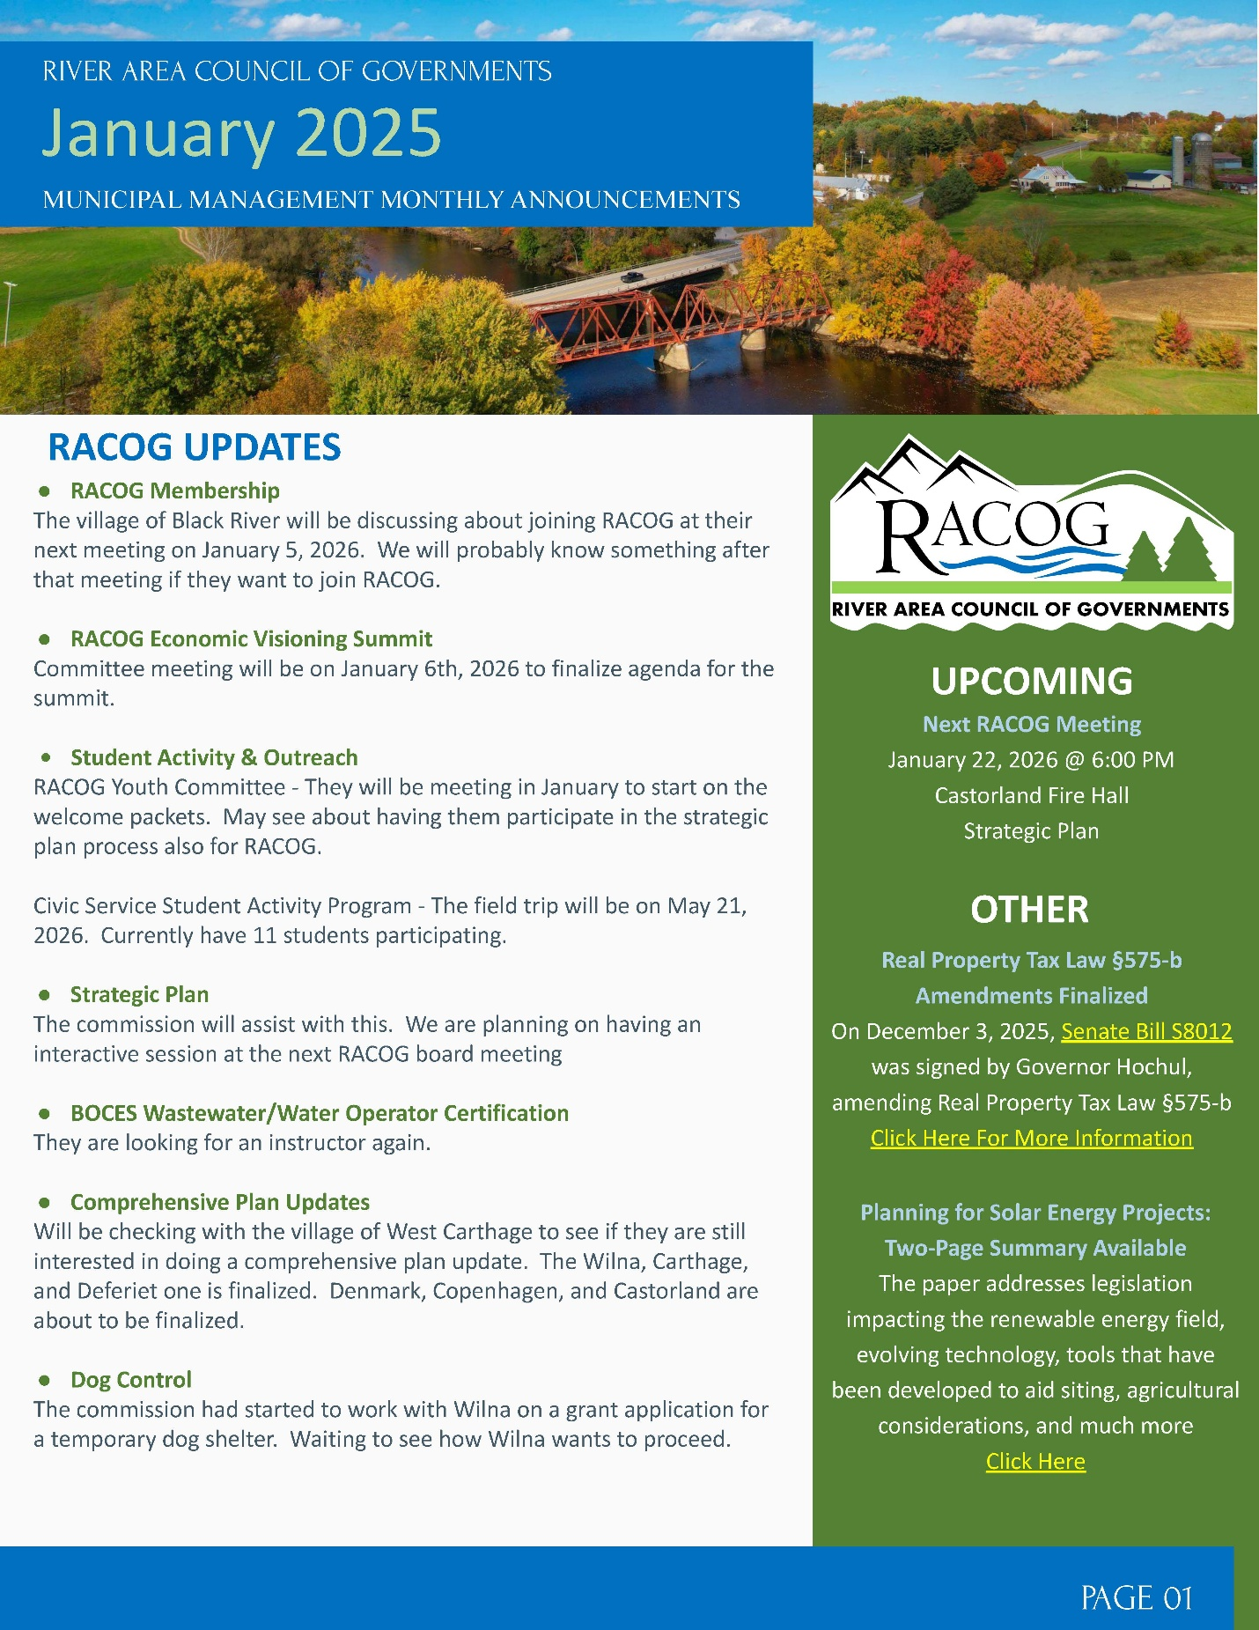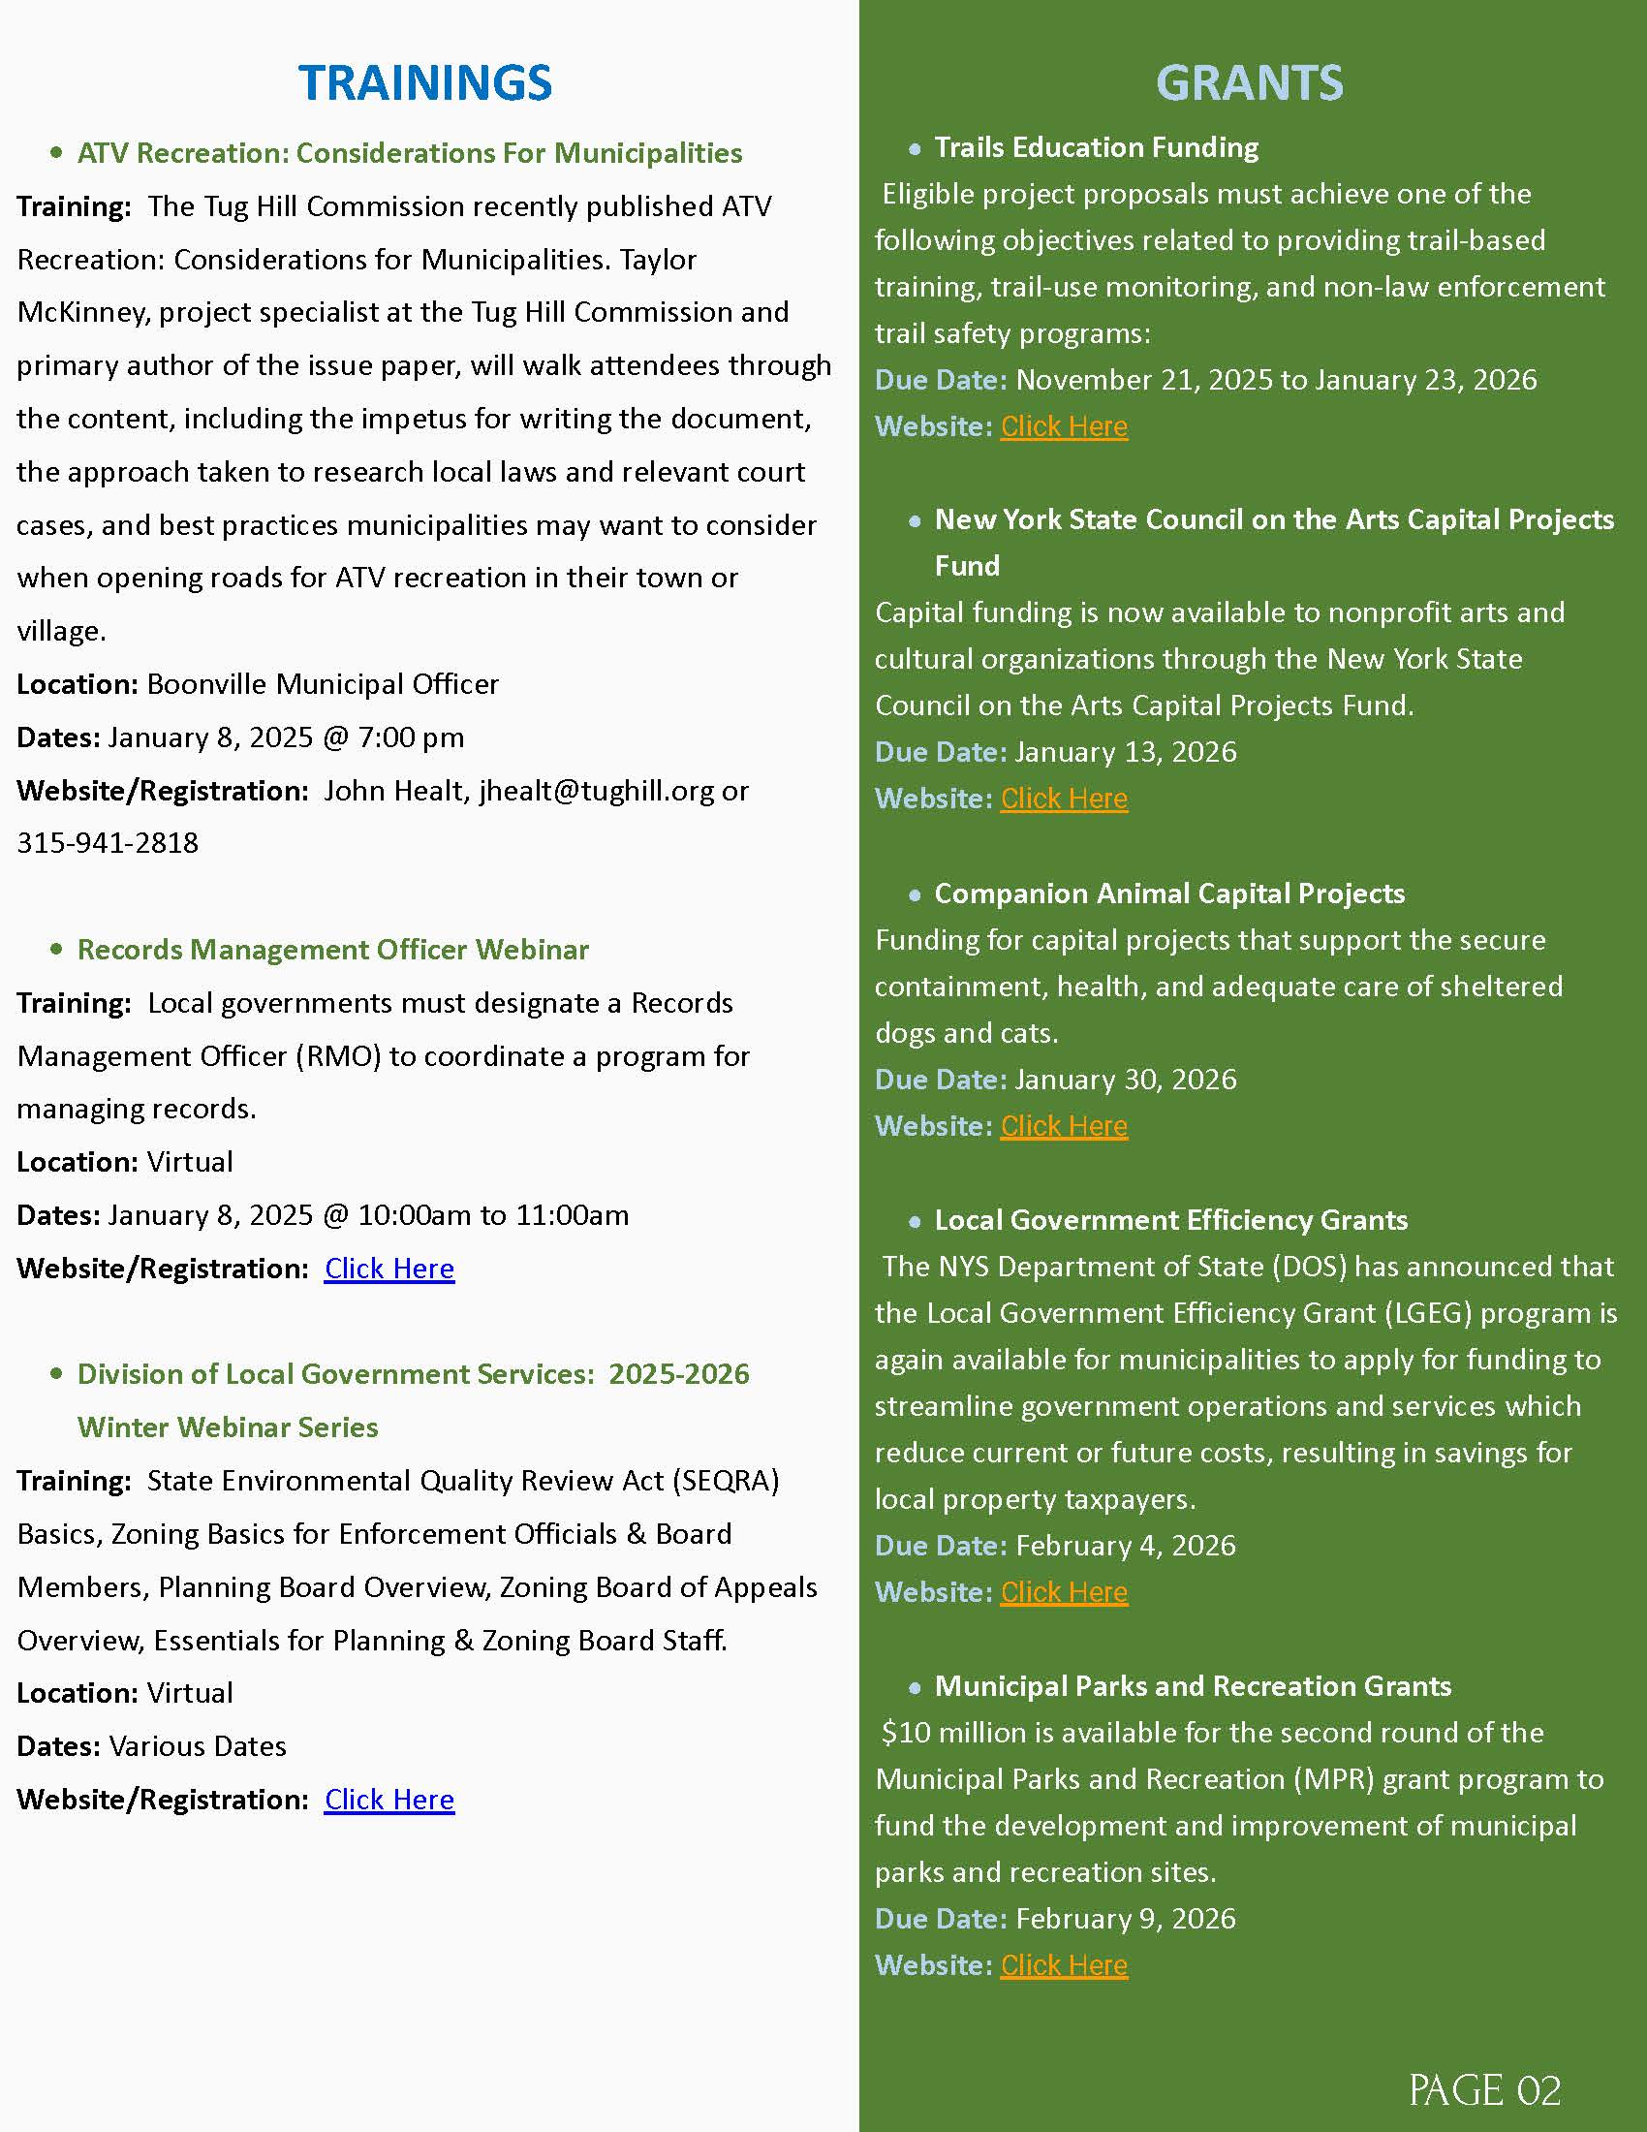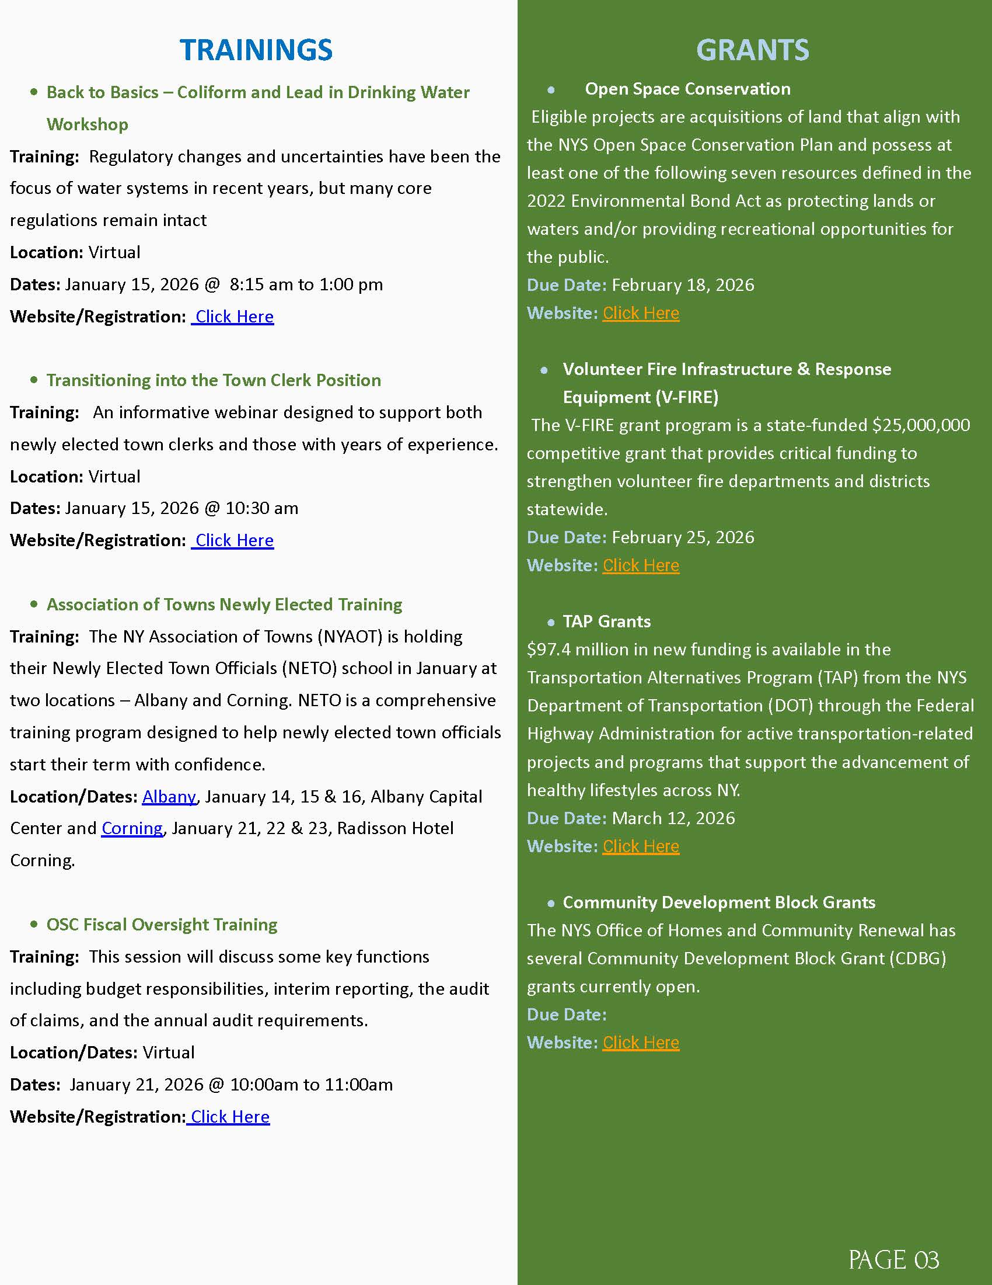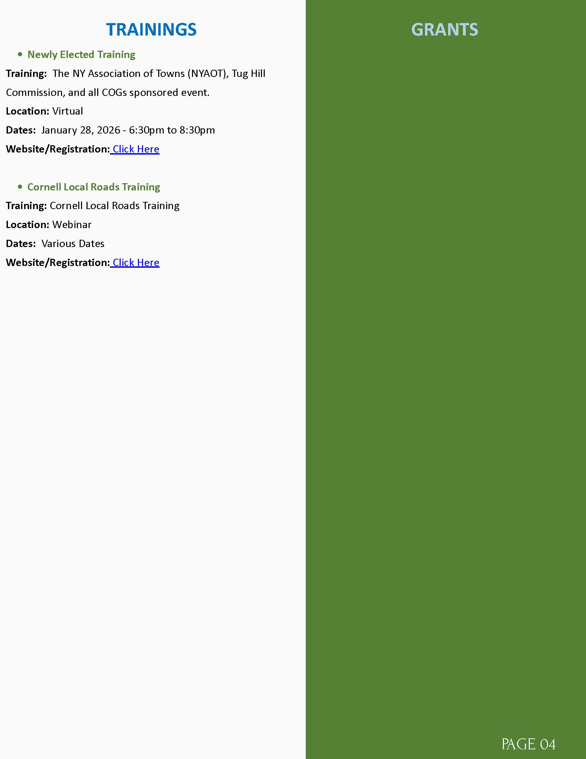

- DPW
- Fire inspection is all done for the month
- Dropped off F-450 for service
- F-450 is back from being serviced
- Took down snow flakes at bandstand and put them up to the sewer plant
- Sent water report to DOH for the month
- Took water and sewer samples to Converse for the month
- Had the loader serviced for the 1000 hour service and swapped cutting bar around
- Changed rear break light on F-250
- Moved snow from dry hydrant and red brick building on Maple Ave.
- Snow blowed out Woodbattle water plant and old water tower
- Snow blowed side walk to Dollar General, main drag, bandstand, bridge, village hall
- Moved snow from old white house to the post office on main drag
- Read village and Denmark’s meters
- Picked up more hypo for the month
- Pushed snow banks back down at Stoddard water plant
- Changed water meter head at Deryl and Alicia Deveau at 10119 Washington St

- BCA-NO UPDATE
- COPENHAGEN CARES- AMERICAN LEGION WILL BE PRESENTING A HUGE MEMORIAL DAY PARADE THIS YEAR. MORE DETAILS TO FOLLOW.
- PROPERTY MAINTENCE- NO UPDATE
- FIRE DEPARTMENT
  - RUTLAND FIRE DEPARTMENT- NO UPDATE
  - COPENHAGEN FIRE DEPARTMENT INC.- NO UPDATE

PUBLIC COMMENTS/INFORMATIONAL
- DEPARTMENT OF LABOR OFFICER GARRETT QUINN WILL BE COMING UP FOR MEETING WITH THE CLERK AND DPW SUPERINTENDENT. HE ENCOURAGED MAYOR AND TRUSTEES TO JOINED, IF THEY COULD. MEETING IS SCHELDULED FOR FEBRUARY 19TH. AT 9:30 AM.
- EMAIL FROM SARAH SHAMBO REGARDING VILLAGE DAYCARE OPPORTUNITY
“I am writing to bring an important community need and opportunity to your attention regarding child care availability in the Village of Copenhagen. As you may already be aware, the only licensed child care provider currently operating within the village, Erica Calloway, has made the decision to close her program. With her closure, families in Copenhagen will have no licensed child care options within the village, which creates a significant challenge for working parents and caregivers in our community. If you have not heard, New York State is moving forward with the first phase of the Governor’s push toward universal child care. This includes the release of $105 million in grant funding aimed at increasing access to quality child care by supporting the creation of new child care centers, as well as expansions or improvements to existing programs. These grants are specifically available to municipalities and nonprofit organizations, and unfortunately are not accessible to private or dependent child care providers.
I believe this presents a unique and timely opportunity for the Village of Copenhagen to consider establishing a small, community-based child care center. A program like this would directly address a growing local need, support working families, and strengthen the overall vitality of the village.
While I am not eligible to apply for these grants independently, I wanted to share this information because of its potential benefit to the community. If the village were interested in exploring this opportunity, I would welcome the chance to collaborate, share my experience, or assist in any way that may be helpful. That said, even if I am not directly involved, I strongly believe this is an opportunity worth considering for Copenhagen’s future.
I’ve attached a recent flyer that I received through OCFS to give you a little more details into the Grant.
Thank you for your time and for all you do to support our community. I would be happy to provide additional information or discuss this further if helpful.

Thank you,
Sarah Shambo
Owner/Provider Little Squirrels Child Care


OLD BUSINESS
- SEWER USE LAW-LAWYERS- NO UPDATE
- ANCA- NO UPDATE
- SHARED SERVICES WITH CASTORLAND
  - IMA WATER & SEWER- CASTORLAND HAVE REACHED OUT TO SURROUNDING TOWNS/VILLAGES, SINCE AN AGREEMENT CAN NOT BE SETTLED BETWEEN COPENHAGEN DPW AND CASTORLAND.
  - GARBAGE TRUCK- NO UPDATE
- LED LIGHTING BEHIND GAINES/BUSH-MUNCY- NO UPDATE
- LOUD STREET-OFFICER MONNET, SUPERINTENDENT ROSS, AND TRUSTEE MAHAR
- DOWNTOWN REVITILIZATION
LEWIS COUNTY PLANNING AND DOWNTOWN DEVELOPMENT- MAYOR AND TRUSTEES ARE HESITENT TO GO THIS PATH. THEY ARE STILL LOOKING INTO THE PROCESS.
SPRING
- CATARACT ST HYDRANT- GIVE TO POWIS
- LEWIS COUNTY DRAINAGE
- WOODBATTLE WATER PLANT- WATERMAN DEBRIS- WAITING FOR FROST TO KILL GRASS TO GET IT OUT

NEW BUSINESS

- TEXTMY.GOV
- 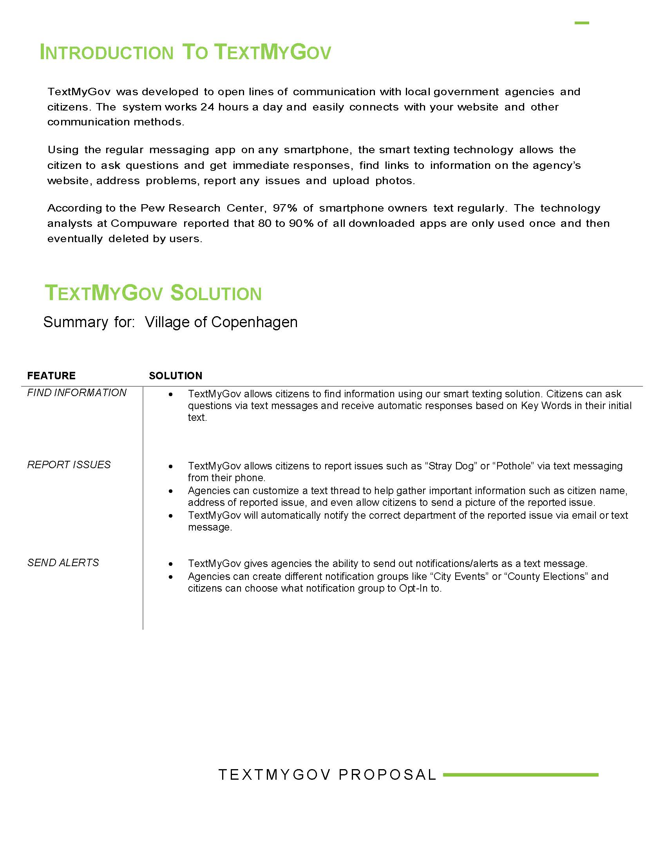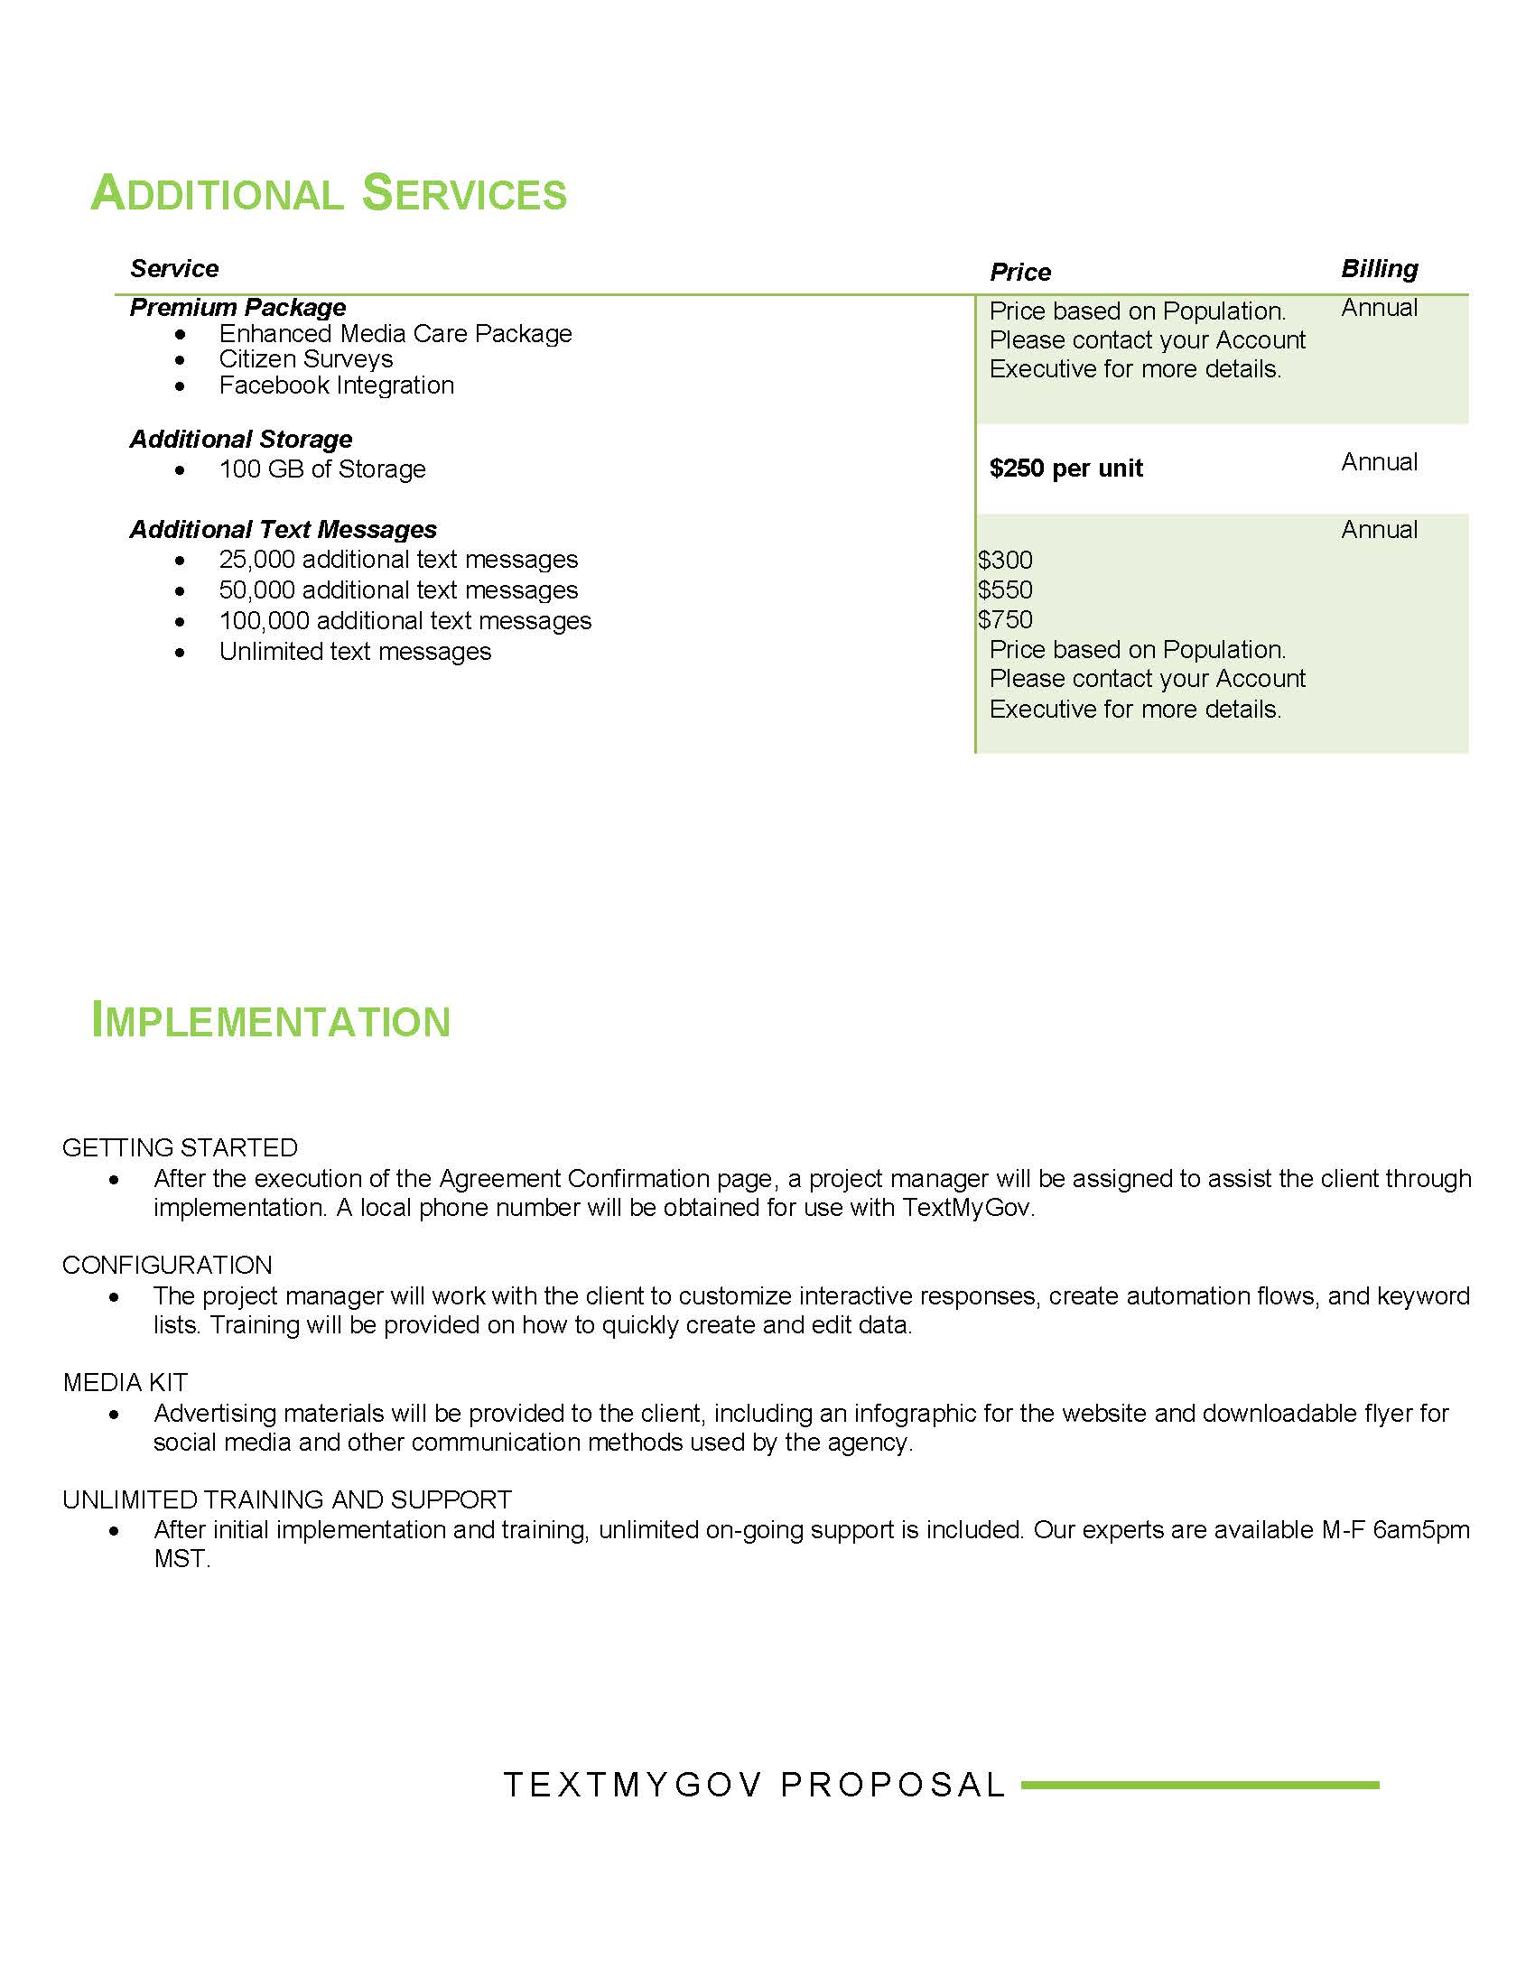

TRUSTEES ARE GOING TO ADD THIS TO BUDGET LIST.

- APPOINTMENTS
  - TERRY McKEEVER
RESOLUTION 20-2026
A MOTION FOR RESOLUTION WAS MADE BY TRUSTEE BATES AND SECONDED BY TRUSTEE ALEXANDER,
TO EXTEND PROPERTY MAINTENANCE OFFICER McKEEVER APPOINTMENT FROM JANUARY 1, 2026 TO DECEMBER 31, 2027.
DEPUTY MAYOR VOGT AYE
TRUSTEE BATES AYE
TRUSTEE MAHAR ABSENT
TRUSTEE ALEXANDER AYE
MAYOR SOUVA ABSENT
ALL PRESENT IN FAVOR, MOTION CARRIED.
RESOLUTION 20-2026 APPROVED FEBRUARY 11, 2026
  - RICHARD ROSS
RESOLUTION 21-2026
A MOTION FOR RESOLUTION WAS MADE BY TRUSTEE ALEXANDER AND SECONDED BY TRUSTEE BATES,
TO EXTEND DPW SUPERINTENDENT RICHARD ROSS APPOINTMENT FROM JANUARY 1, 2026 TO DECEMBER 31, 2027.
DEPUTY MAYOR VOGT AYE
TRUSTEE BATES AYE
TRUSTEE MAHAR ABSENT
TRUSTEE ALEXANDER AYE
MAYOR SOUVA ABSENT
ALL PRESENT IN FAVOR, MOTION CARRIED.
RESOLUTION 21-2026 APPROVED FEBRUARY 11, 2026

- 2026 BOUNDARY AND ANNEXATION SURVEY- THERE WILL BE NO BOUNDARY CHANGES TO THE VILLAGE OF COPENHAGEN.

- DPW LOG
THE BOARD OF TRUSTEES WOULD LIKE SEPERATE DAILY LOGS TO BE WRITTEN BY SUPERINTENDENT ROSS AND DPW LABORER POTOCKI.

RESOLUTION 22-2026
A MOTION FOR RESOLUTION WAS MADE BY TRUSTEE BATES AND SECONDED BY TRUSTEE ALEXANDER,
FOR DPW EMPLOYEES TO WRITE A DAILY LOG OF WHAT IS BEING DONE, DURING THEIR WORKING HOURS.
DEPUTY MAYOR VOGT AYE
TRUSTEE BATES AYE
TRUSTEE MAHAR ABSENT
TRUSTEE ALEXANDER AYE
MAYOR SOUVA ABSENT
ALL PRESENT IN FAVOR, MOTION CARRIED.
RESOLUTION 22-2026 APPROVED FEBRUARY 11, 2026

OPEN FORUM

FINANCIALS
- TREASURER REPORT
- MONTHLY ABSTRACTS
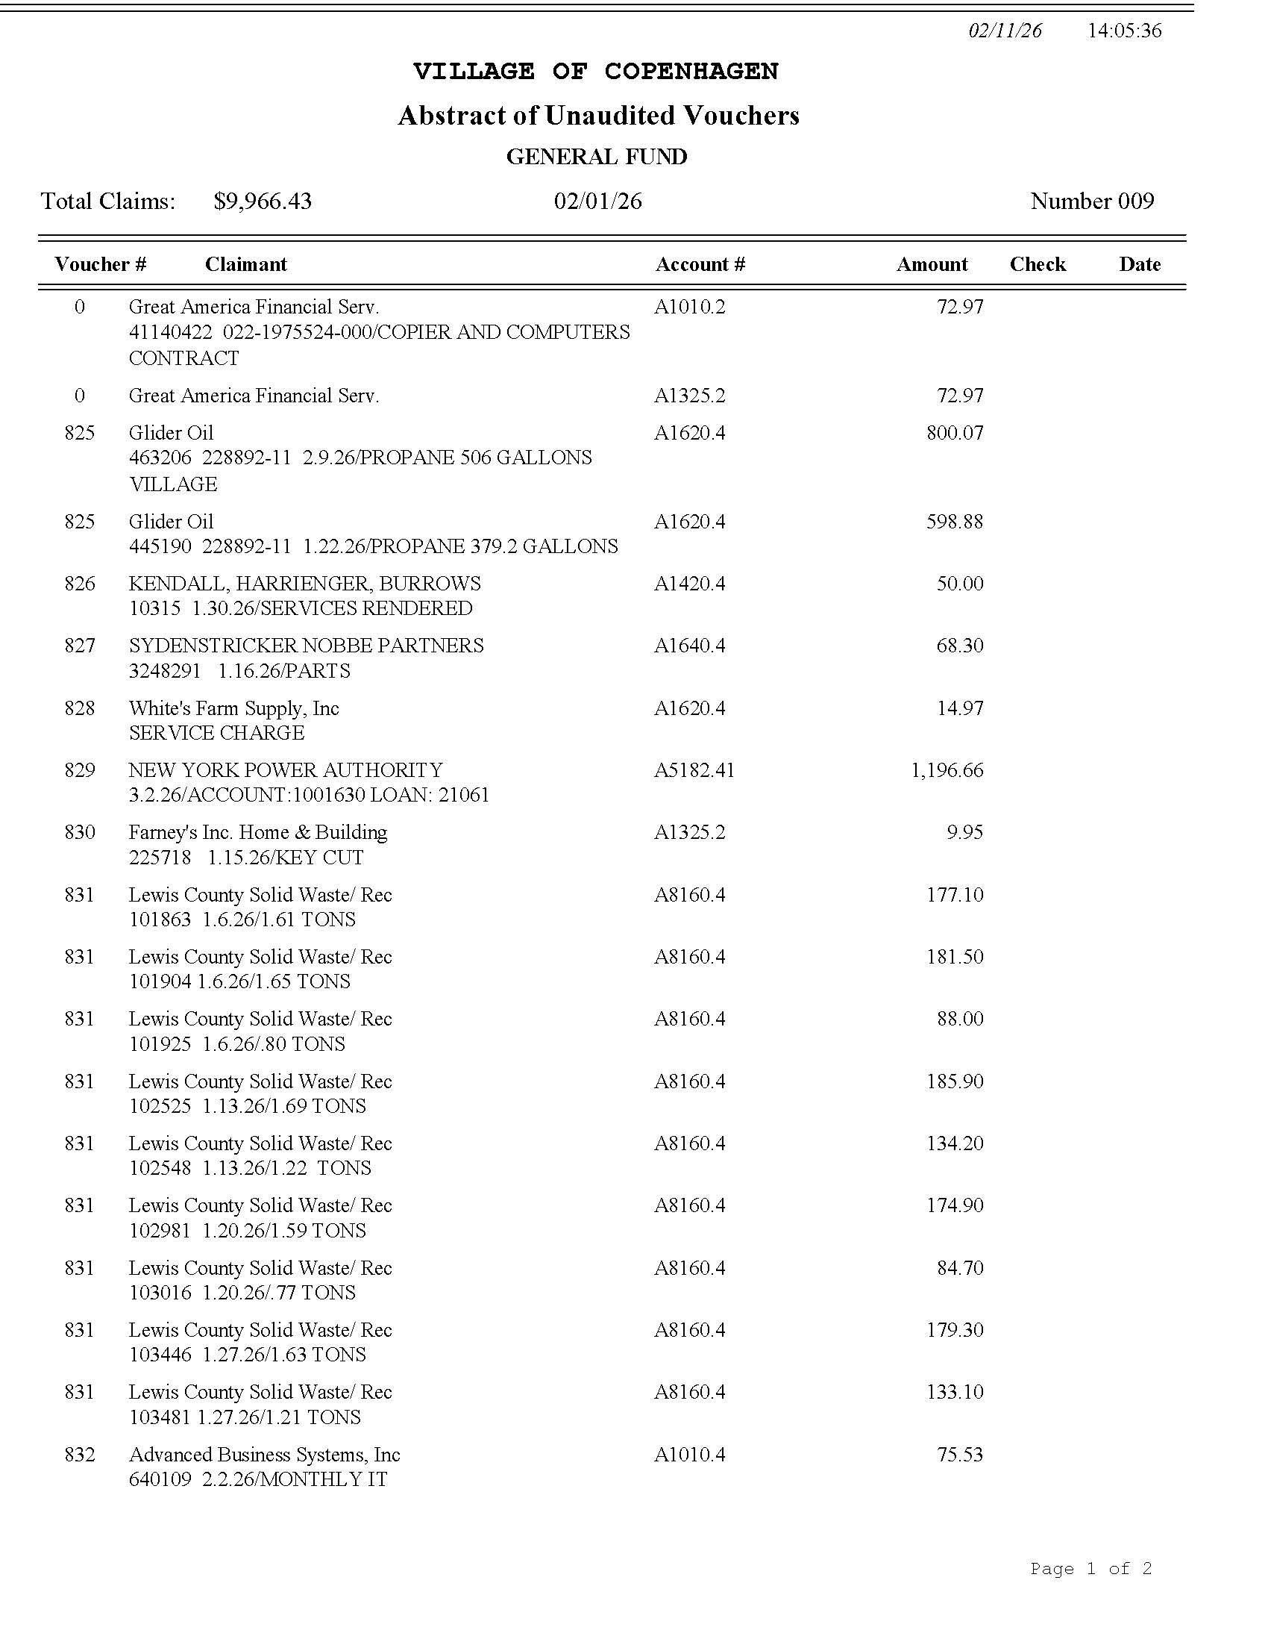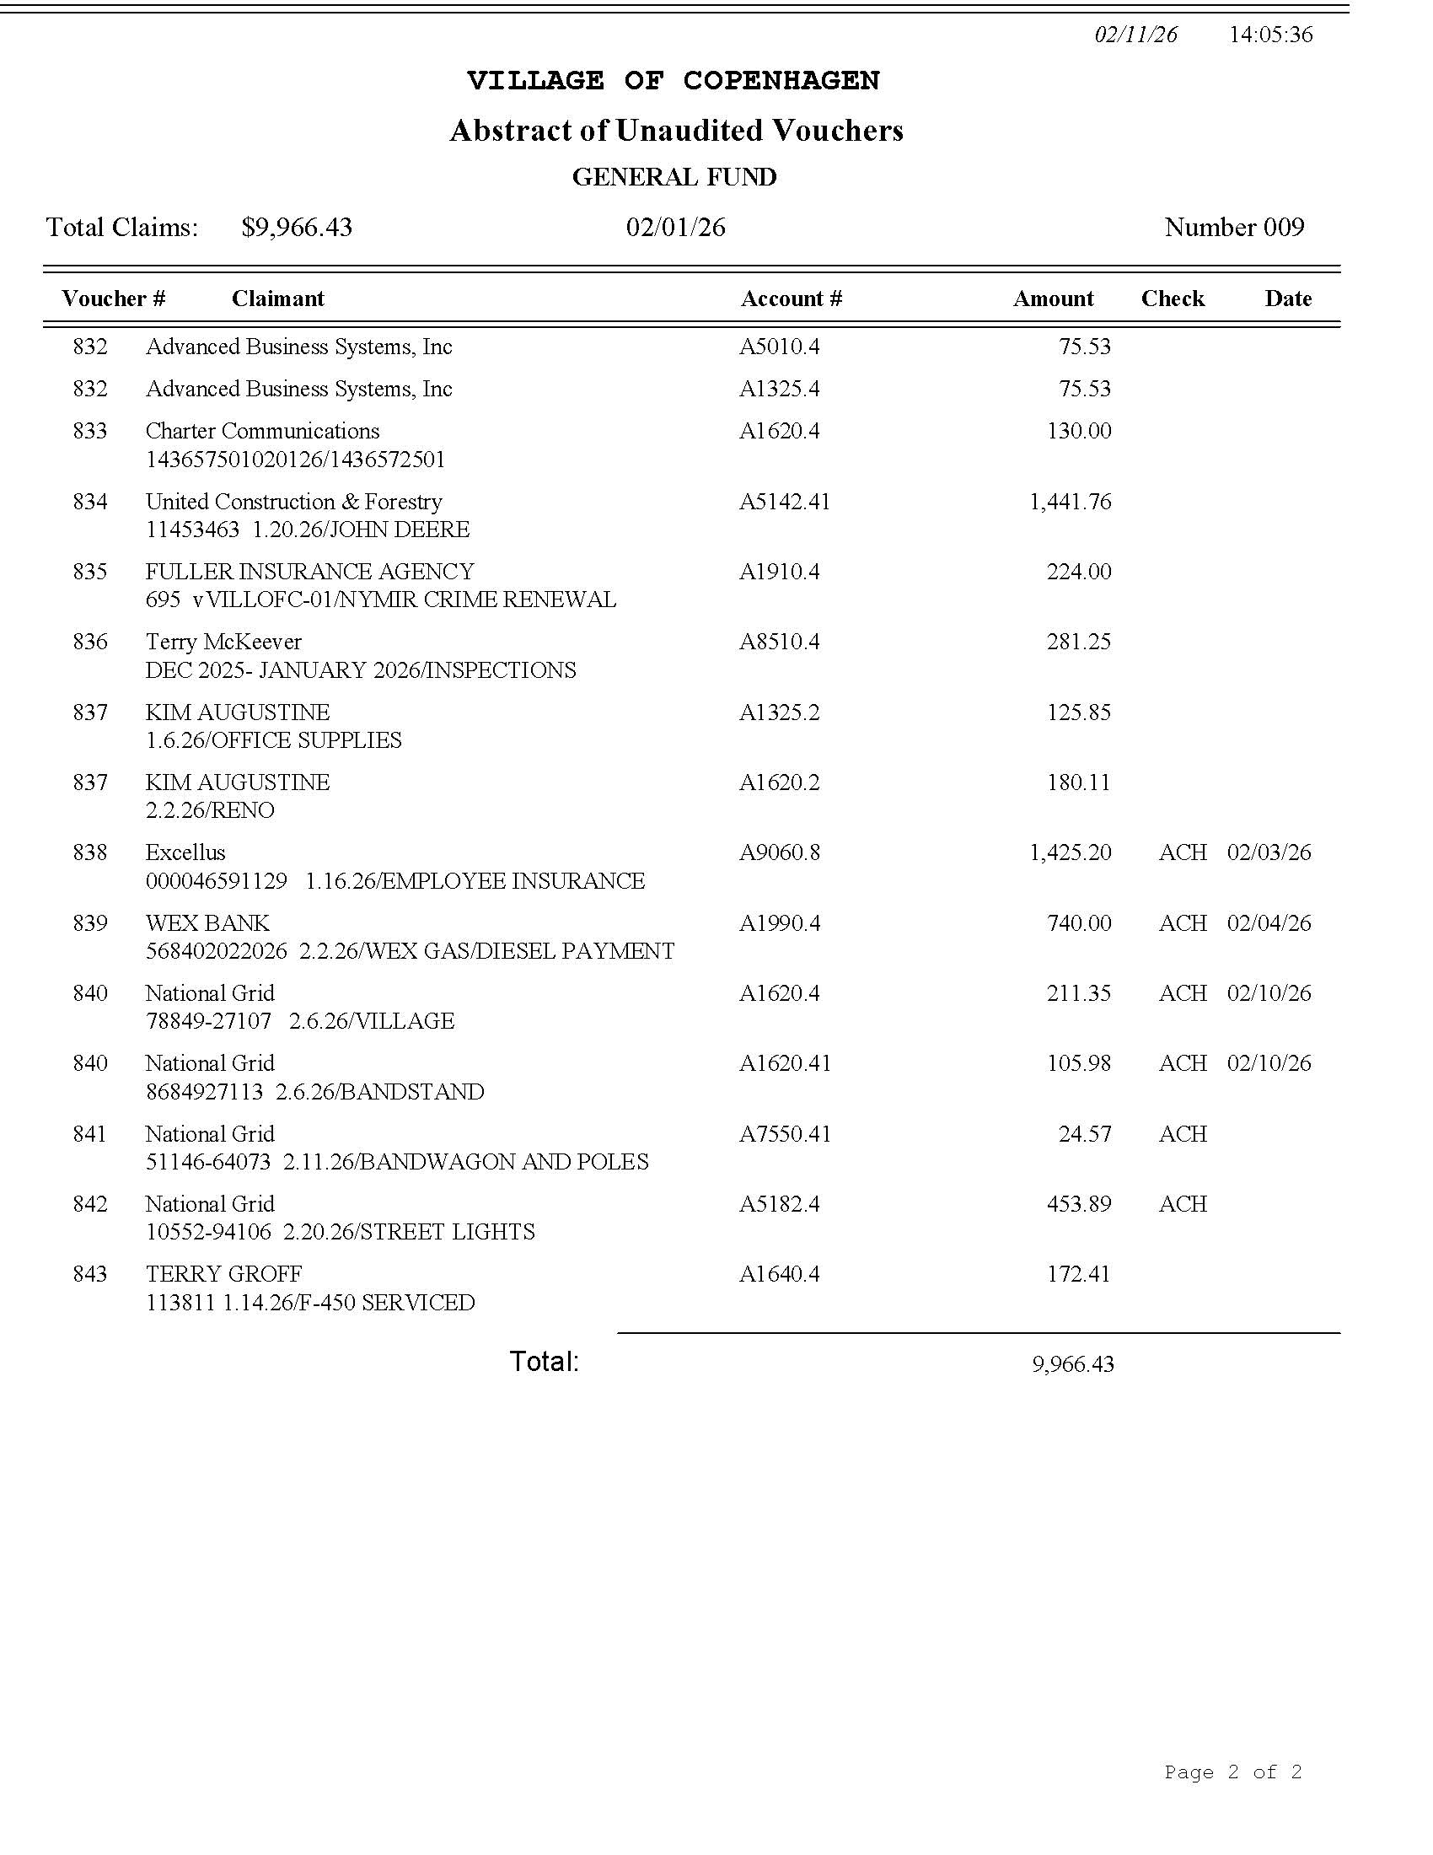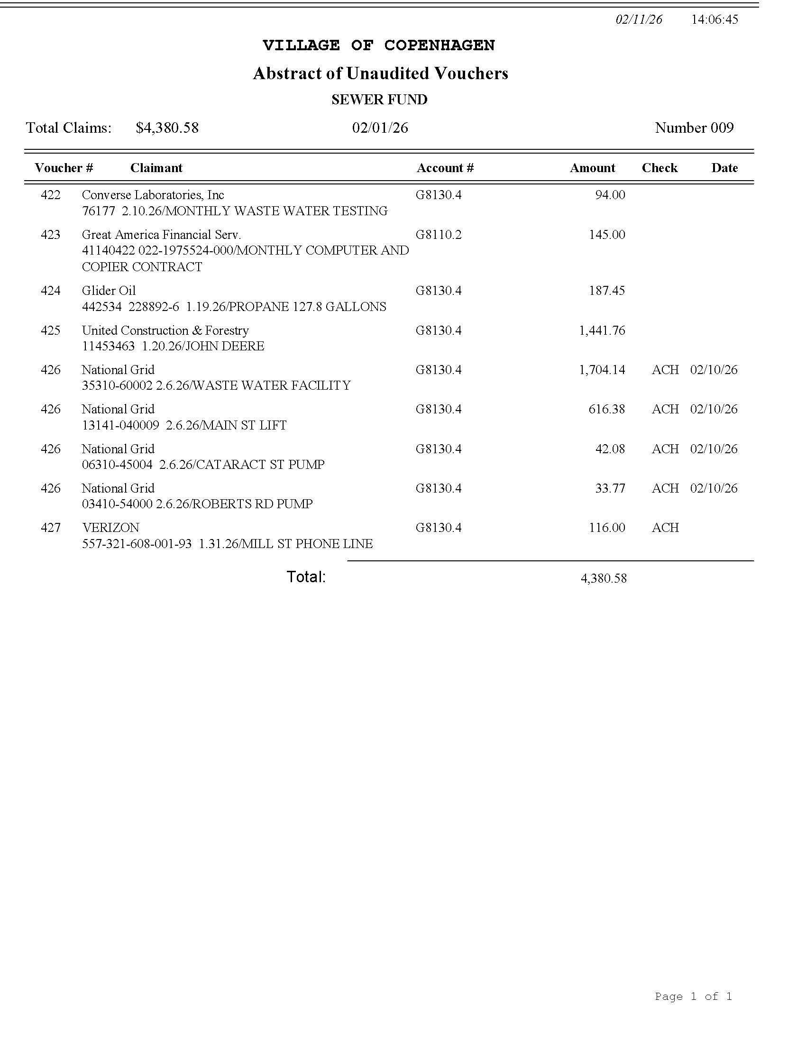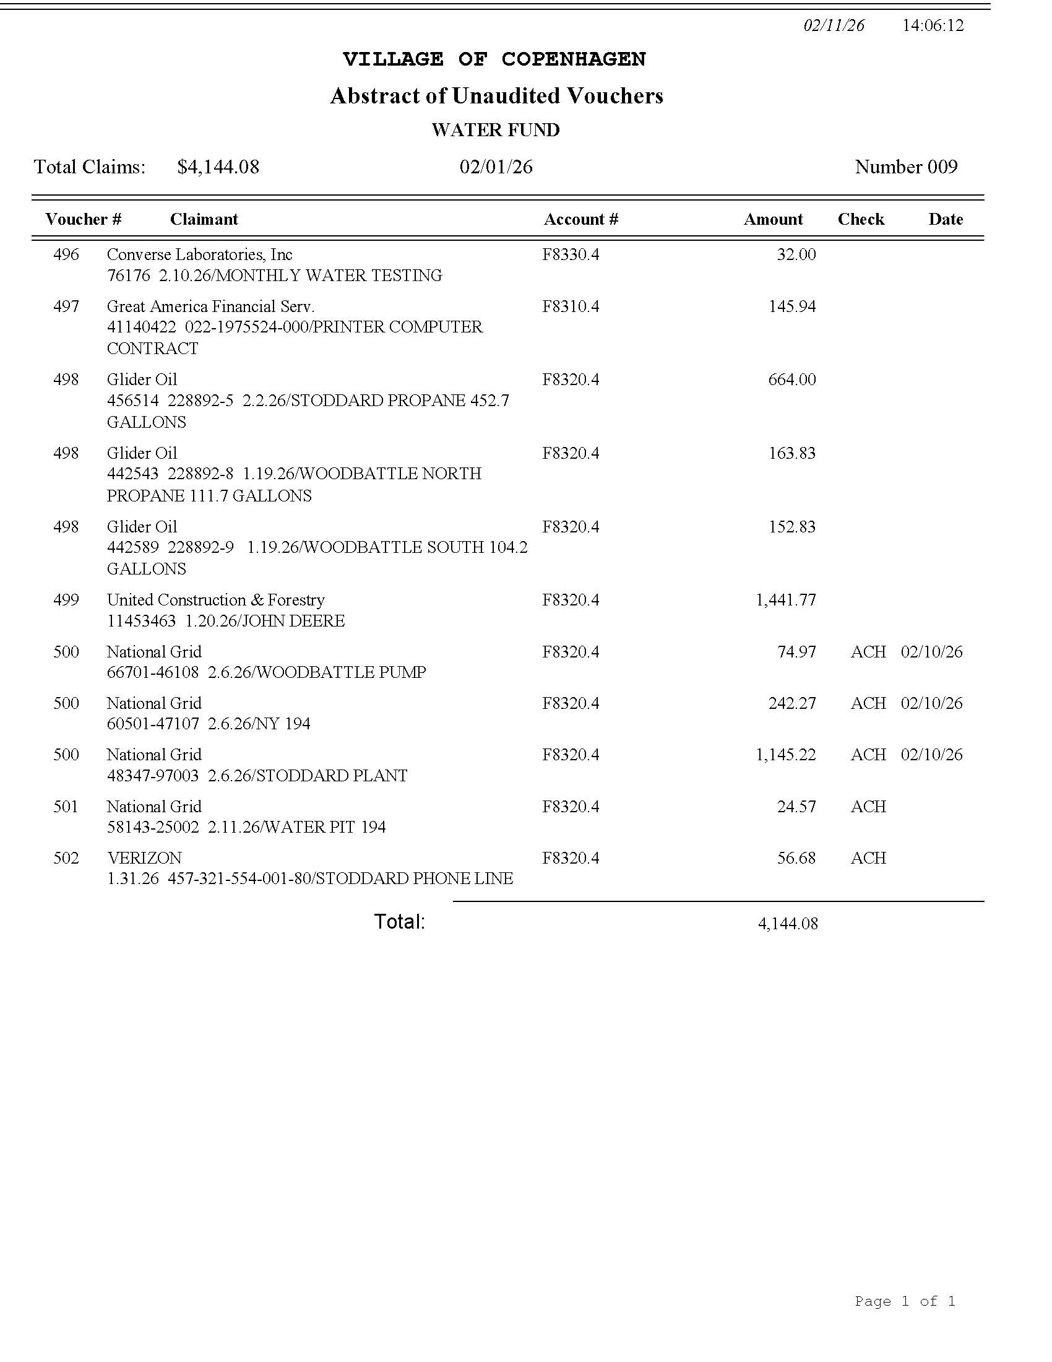

- PAY BILLS

RESOLUTION 23-2026
A MOTION FOR RESOLUTION WAS MADE BY TRUSTEE BATES AND SECONDED BY TRUSTEE ALEXANDER, TO PAY FEBRUARY 2026 BILLS.
DEPUTY MAYOR VOGT AYE
TRUSTEE BATES AYE
TRUSTEE MAHAR ABSENT
TRUSTEE ALEXANDER AYE
MAYOR SOUVA ABSENT
ALL PRESENT IN FAVOR, MOTION CARRIED.
RESOLUTION 23-2026 APPROVED FEBRUARY 11, 2026

- RESOLUTIONS TO TRANSFER FUNDS
  - A1920.4 MUNICIPAL DUES
  - A5110.41 STREET MAINTENANCE CONTRACTUAL
    - ACCOUNTS THAT NEED ATTENTION
      - A5110.4 STREET MAINTENANCE CONTRACTUAL
      - A5110.41 STREET MAINTENANCE GAS & DIESEL
      - F8320.4 SORSE SUPPLY POWER, CONTRACTUAL
      - G8130.4 SEWAGE TREATMENT CONTRACTUAL

RESOLUTION 24-2026
A MOTION FOR RESOLUTION WAS MADE BY TRUSTEE BATES AND SECONDED BY TRUSTEE ALEXANDER, TO TRANSFER $50 FROM GENERAL FUND A 1900.4 CONTINGENT ACCOUNT TO GENERAL FUND A 1920.4 MUNICIPAL DUES, TO ACCOUNT FOR DEFICIT OF -$50.
DEPUTY MAYOR VOGT AYE
TRUSTEE BATES AYE
TRUSTEE MAHAR ABSENT
TRUSTEE ALEXANDER AYE
MAYOR SOUVA ABSENT
ALL PRESENT IN FAVOR, MOTION CARRIED.
RESOLUTION 24-2026 APPROVED FEBRUARY 11, 2026

RESOLUTION 25-2026
A MOTION FOR RESOLUTION WAS MADE BY TRUSTEE BATES AND SECONDED BY TRUSTEE ALEXANDER, TO TRANSFER $5000 FROM GENERAL FUND A 1900.4 CONTINGENT ACCOUNT TO GENERAL FUND A 5110.4 STREET MAINTENANCE CONTRACTUAL, TO ACCOUNT FOR DEFICIT OF -$46.19 AND TO COVER FEBRUARY, MARCH, APRIL, AND MAY 2026. THE REASON THE CONTRACTUAL FUND WAS NOT PROPERLY BUDGETED, IS DUE TO UNEXPECTED HIKE IN ELECTRICITY COST FROM NATIONAL GRID.
DEPUTY MAYOR VOGT AYE
TRUSTEE BATES AYE
TRUSTEE MAHAR ABSENT
TRUSTEE ALEXANDER AYE
MAYOR SOUVA ABSENT
ALL PRESENT IN FAVOR, MOTION CARRIED.
RESOLUTION 25-2026 APPROVED FEBRUARY 11, 2026

ADJOURNMENT
A MOTION WAS MADE BY TRUSTEE BATES AND SECONDED BY DEPUTY MAYOR VOGT, TO ADJOURN FEBRUARY 11, 2026 BOARD MEETING.
DEPUTY MAYOR VOGT AYE
TRUSTEE BATES AYE
TRUSTEE MAHAR ABSENT
TRUSTEE ALEXANDER AYE
MAYOR SOUVA ABSENT
ALL PRESENT IN FAVOR, MOTION CARRIED.
APPROVED FEBRUARY 11, 2026
MEETING ENDED AT 19:17/7:17 PM

NEXT MEETING MARCH 11TH
SEE YOU THEN!

DATE CLERK-TREASURER

