PLEDGE OF ALLIEGANCE
APPROVAL OF JANUARY 2026 MEETING MINUTES

UPDATES
- RACOG
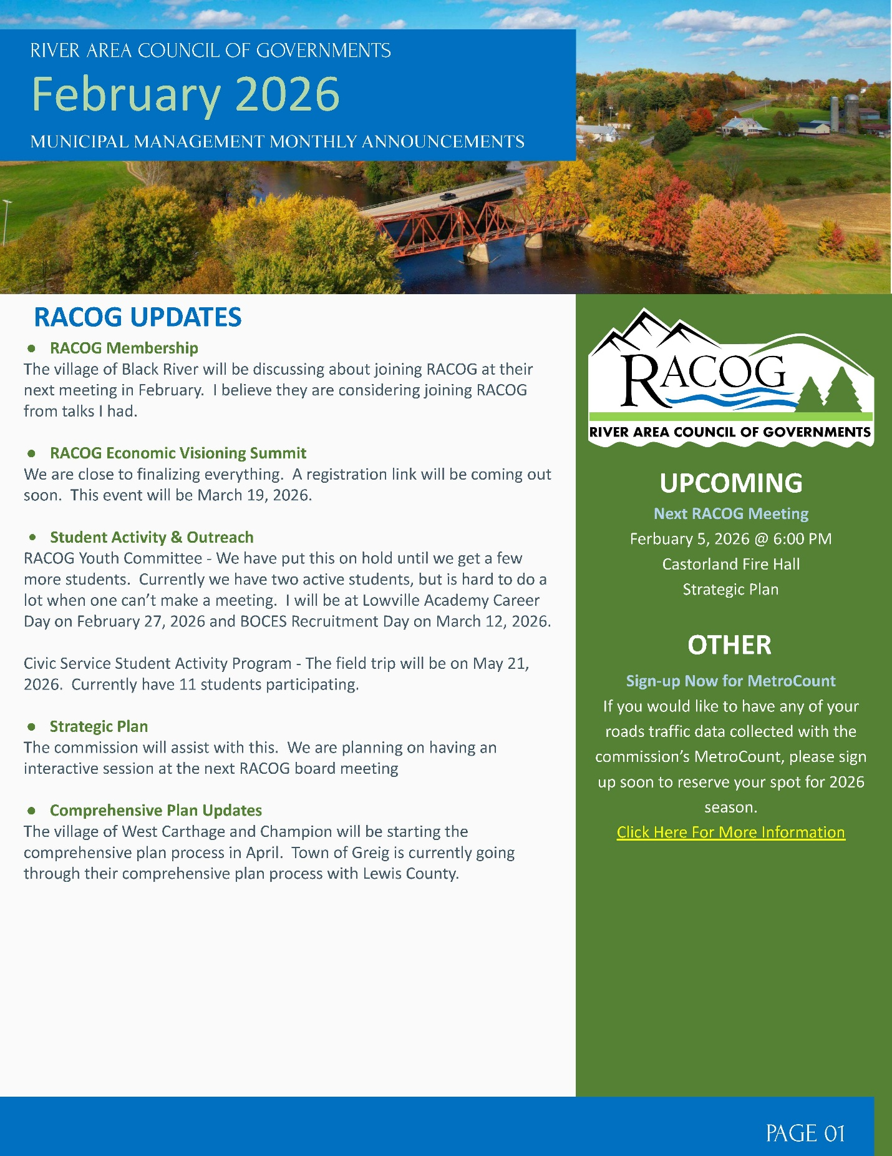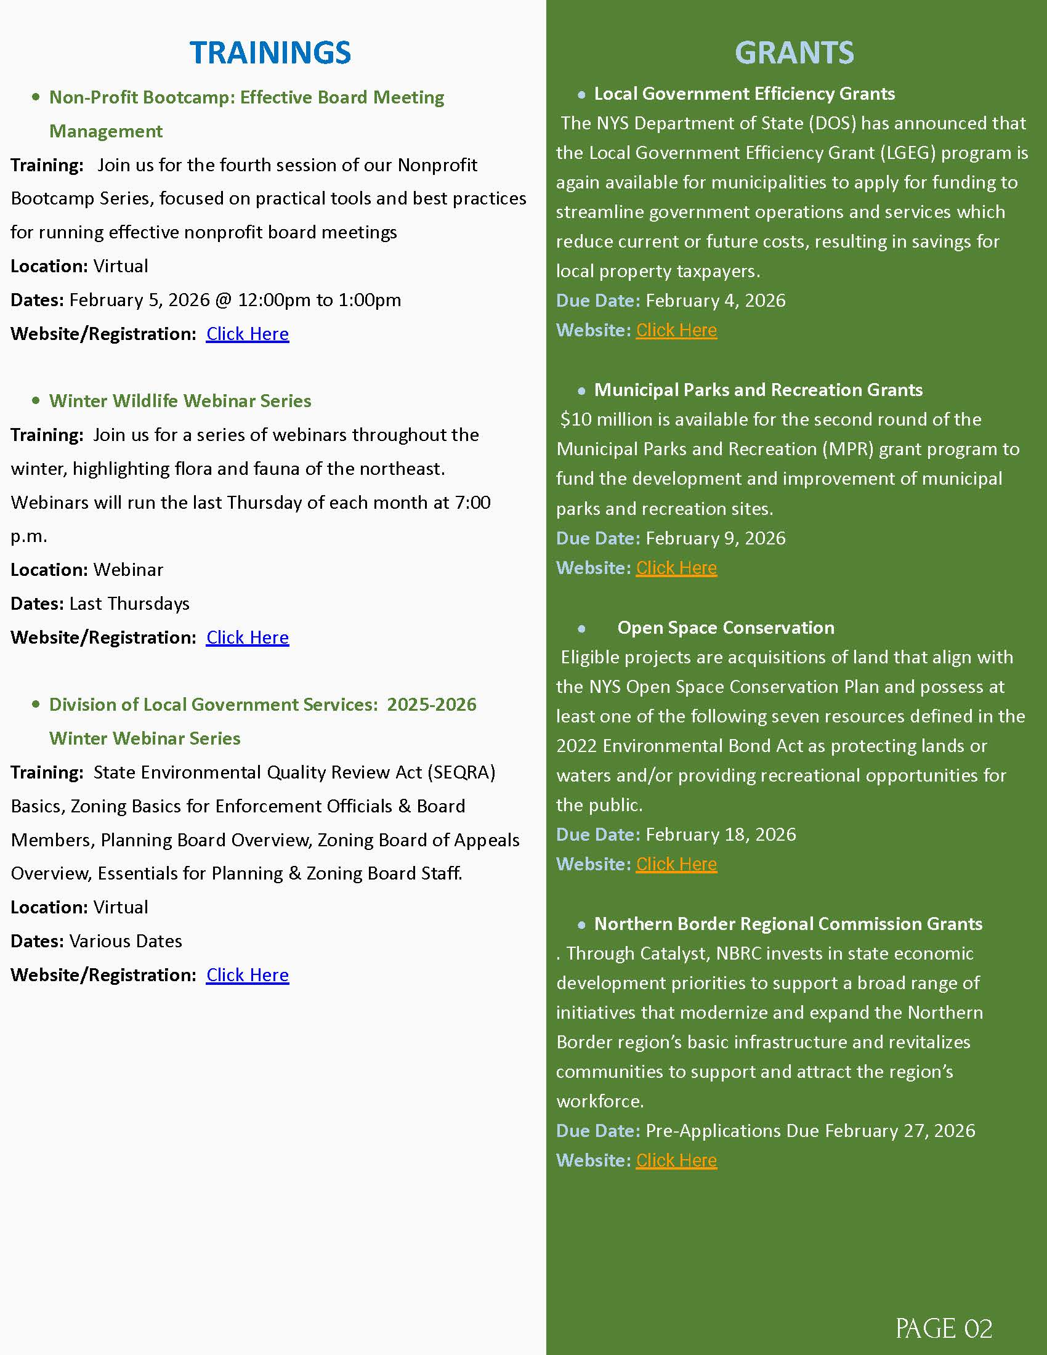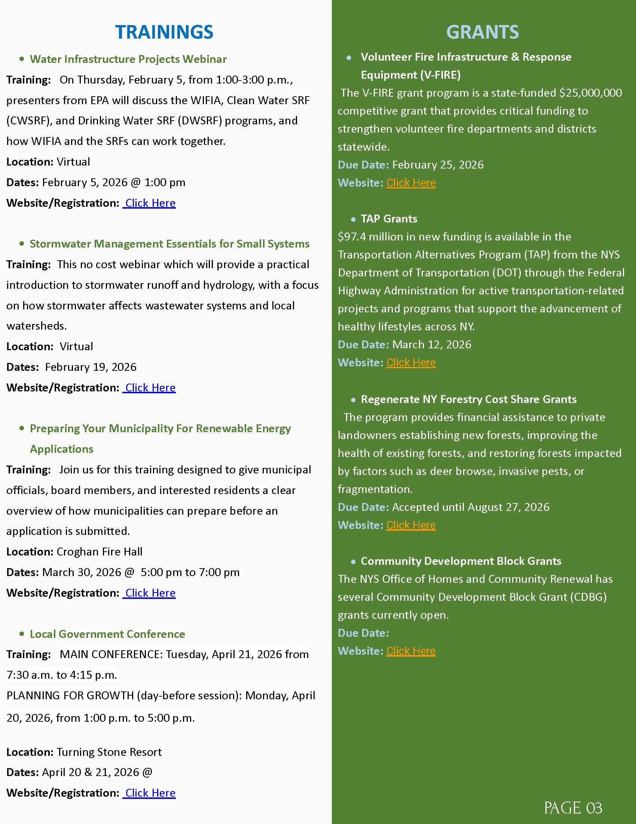
- DPW
- Fire inspection is all done for the month
- Dropped off F-450 for service
- F-450 is back from being serviced
- Took down snow flakes at bandstand and put them up to the sewer plant
- Sent water report to DOH for the month
- Took water and sewer samples to Converse for the month
- Had the loader serviced for the 1000 hour service and swapped cutting bar around
- Changed rear break light on F-250
- Moved snow from dry hydrant and red brick building on Maple Ave.
- Snow blowed out Woodbattle water plant and old water tower
- Snow blowed side walk to Dollar General, main drag, bandstand, bridge, village hall
- Moved snow from old white house to the post office on main drag
- Read village and Denmark’s meters
- Picked up more hypo for the month
- Pushed snow banks back down at Stoddard water plant
- Changed water meter head at Deryl and Alicia Deveau at 10119 Washington St

- BCA
- COPENHAGEN CARES
- PROPERTY MAINTENCE
- FIRE DEPARTMENT
  - RUTLAND FIRE DEPARTMENT
  - COPENHAGEN FIRE DEPARTMENT INC.

PUBLIC COMMENTS/INFORMATIONAL

OLD BUSINESS

- SEWER USE LAW-LAWYERS
- ANCA
- SHARED SERVICES WITH CASTORLAND:
  - IMA WATER & SEWER
  - GARBAGE TRUCK
- LED LIGHTING BEHIND GAINES/BUSH-MUNCY
- LOUD STREET-OFFICER MONNET & SUPERINTENDENT ROSS
- DOWNTOWN REVITILIZATION
  - LEWIS COUNTY PLANNING AND DOWNTOWN DEVELOPMENT
The Pro Housing Communities Program in New York aims to certify municipalities that actively support housing growth and address the housing shortage, enabling them to access key state funding opportunities.

Overview of the Program
The Pro Housing Communities Program was announced by Governor Kathy Hochul and is administered by the New York State Department of Homes and Community Renewal (HCR). It is designed to encourage municipalities to take proactive steps in addressing the housing crisis in New York State by streamlining processes and adopting policies that promote housing development.

Key Objectives
- Certification: Municipalities can apply for certification to demonstrate their commitment to housing growth. This certification is now a prerequisite for accessing certain discretionary funding programs, such as the Downtown Revitalization Initiative and the NY Forward program.

- Streamlining Permits: The program encourages local governments to streamline permitting processes for various types of housing, including multifamily, affordable, and supportive housing.

- Fair Housing Policies: Communities are urged to adopt policies that affirmatively further fair housing and incorporate regional housing needs into their planning decisions.

Application Process
- Letter of Intent: Municipalities interested in certification must submit a letter of intent to the program email (prohousing@hcr.ny.gov).
- Documentation: After submitting the letter, municipalities will receive a link to submit documentation, including zoning codes and housing permit approvals over the past five years.
- Certification Criteria: There are two pathways to certification:
- Demonstrating Housing Growth: Show evidence of a specific level of housing growth (e.g., 3% over three years).
Passing a ProHousing Resolution: If growth has been slow, municipalities can still achieve certification by passing a resolution committing to housing development.

Benefits of Certification
- Access to Funding: Certified municipalities can apply for various state funding programs, which can support infrastructure, redevelopment, and housing projects.
- Community Development: The program aims to enhance local economies by increasing the availability of housing, which is essential for maintaining economic growth in New York State.
SPRING
- CATARACT ST HYDRANT- GIVE TO POWIS
- LEWIS COUNTY DRAINAGE
- WOODBATTLE WATER PLANT- WATERMAN DEBRIS- WAITING FOR FROST TO KILL GRASS TO GET IT OUT

NEW BUSINESS
- TEXYMY.GOV
- APPOINTMENTS:
TERRY McKEEVER
RICHARD ROSS
- 2026 BOUNDARY AND ANNEXATION SURVEY

OPEN FORUM

FINANCIALS
- TREASURER REPORT
- MONTHLY ABSTRACTS
- PAY BILLS

ADJOURNMENT

NEXT MEETING MONTH DAY, 2026
SEE YOU THERE!

