PLEDGE OF ALLIEGANCE
APPROVAL OF FEBRUARY 2026 MEETING MINUTES

UPDATES
- RACOG
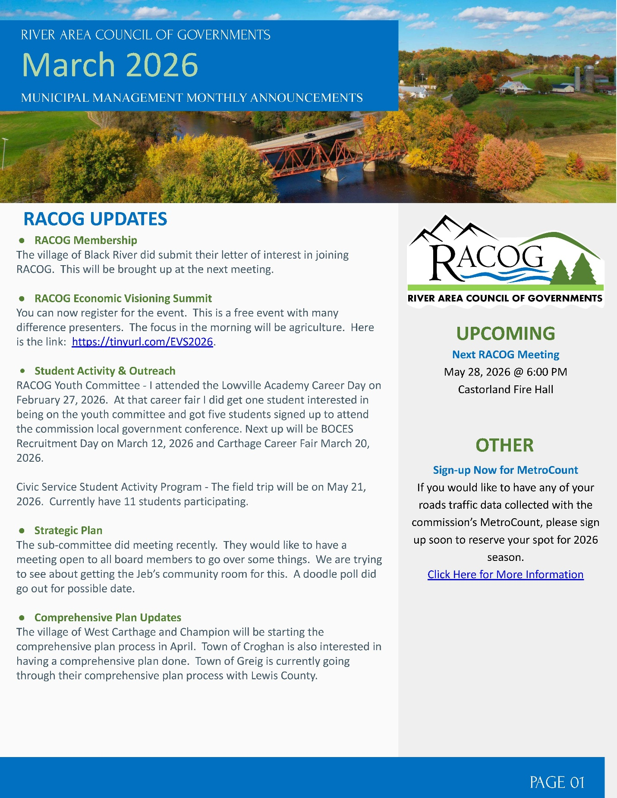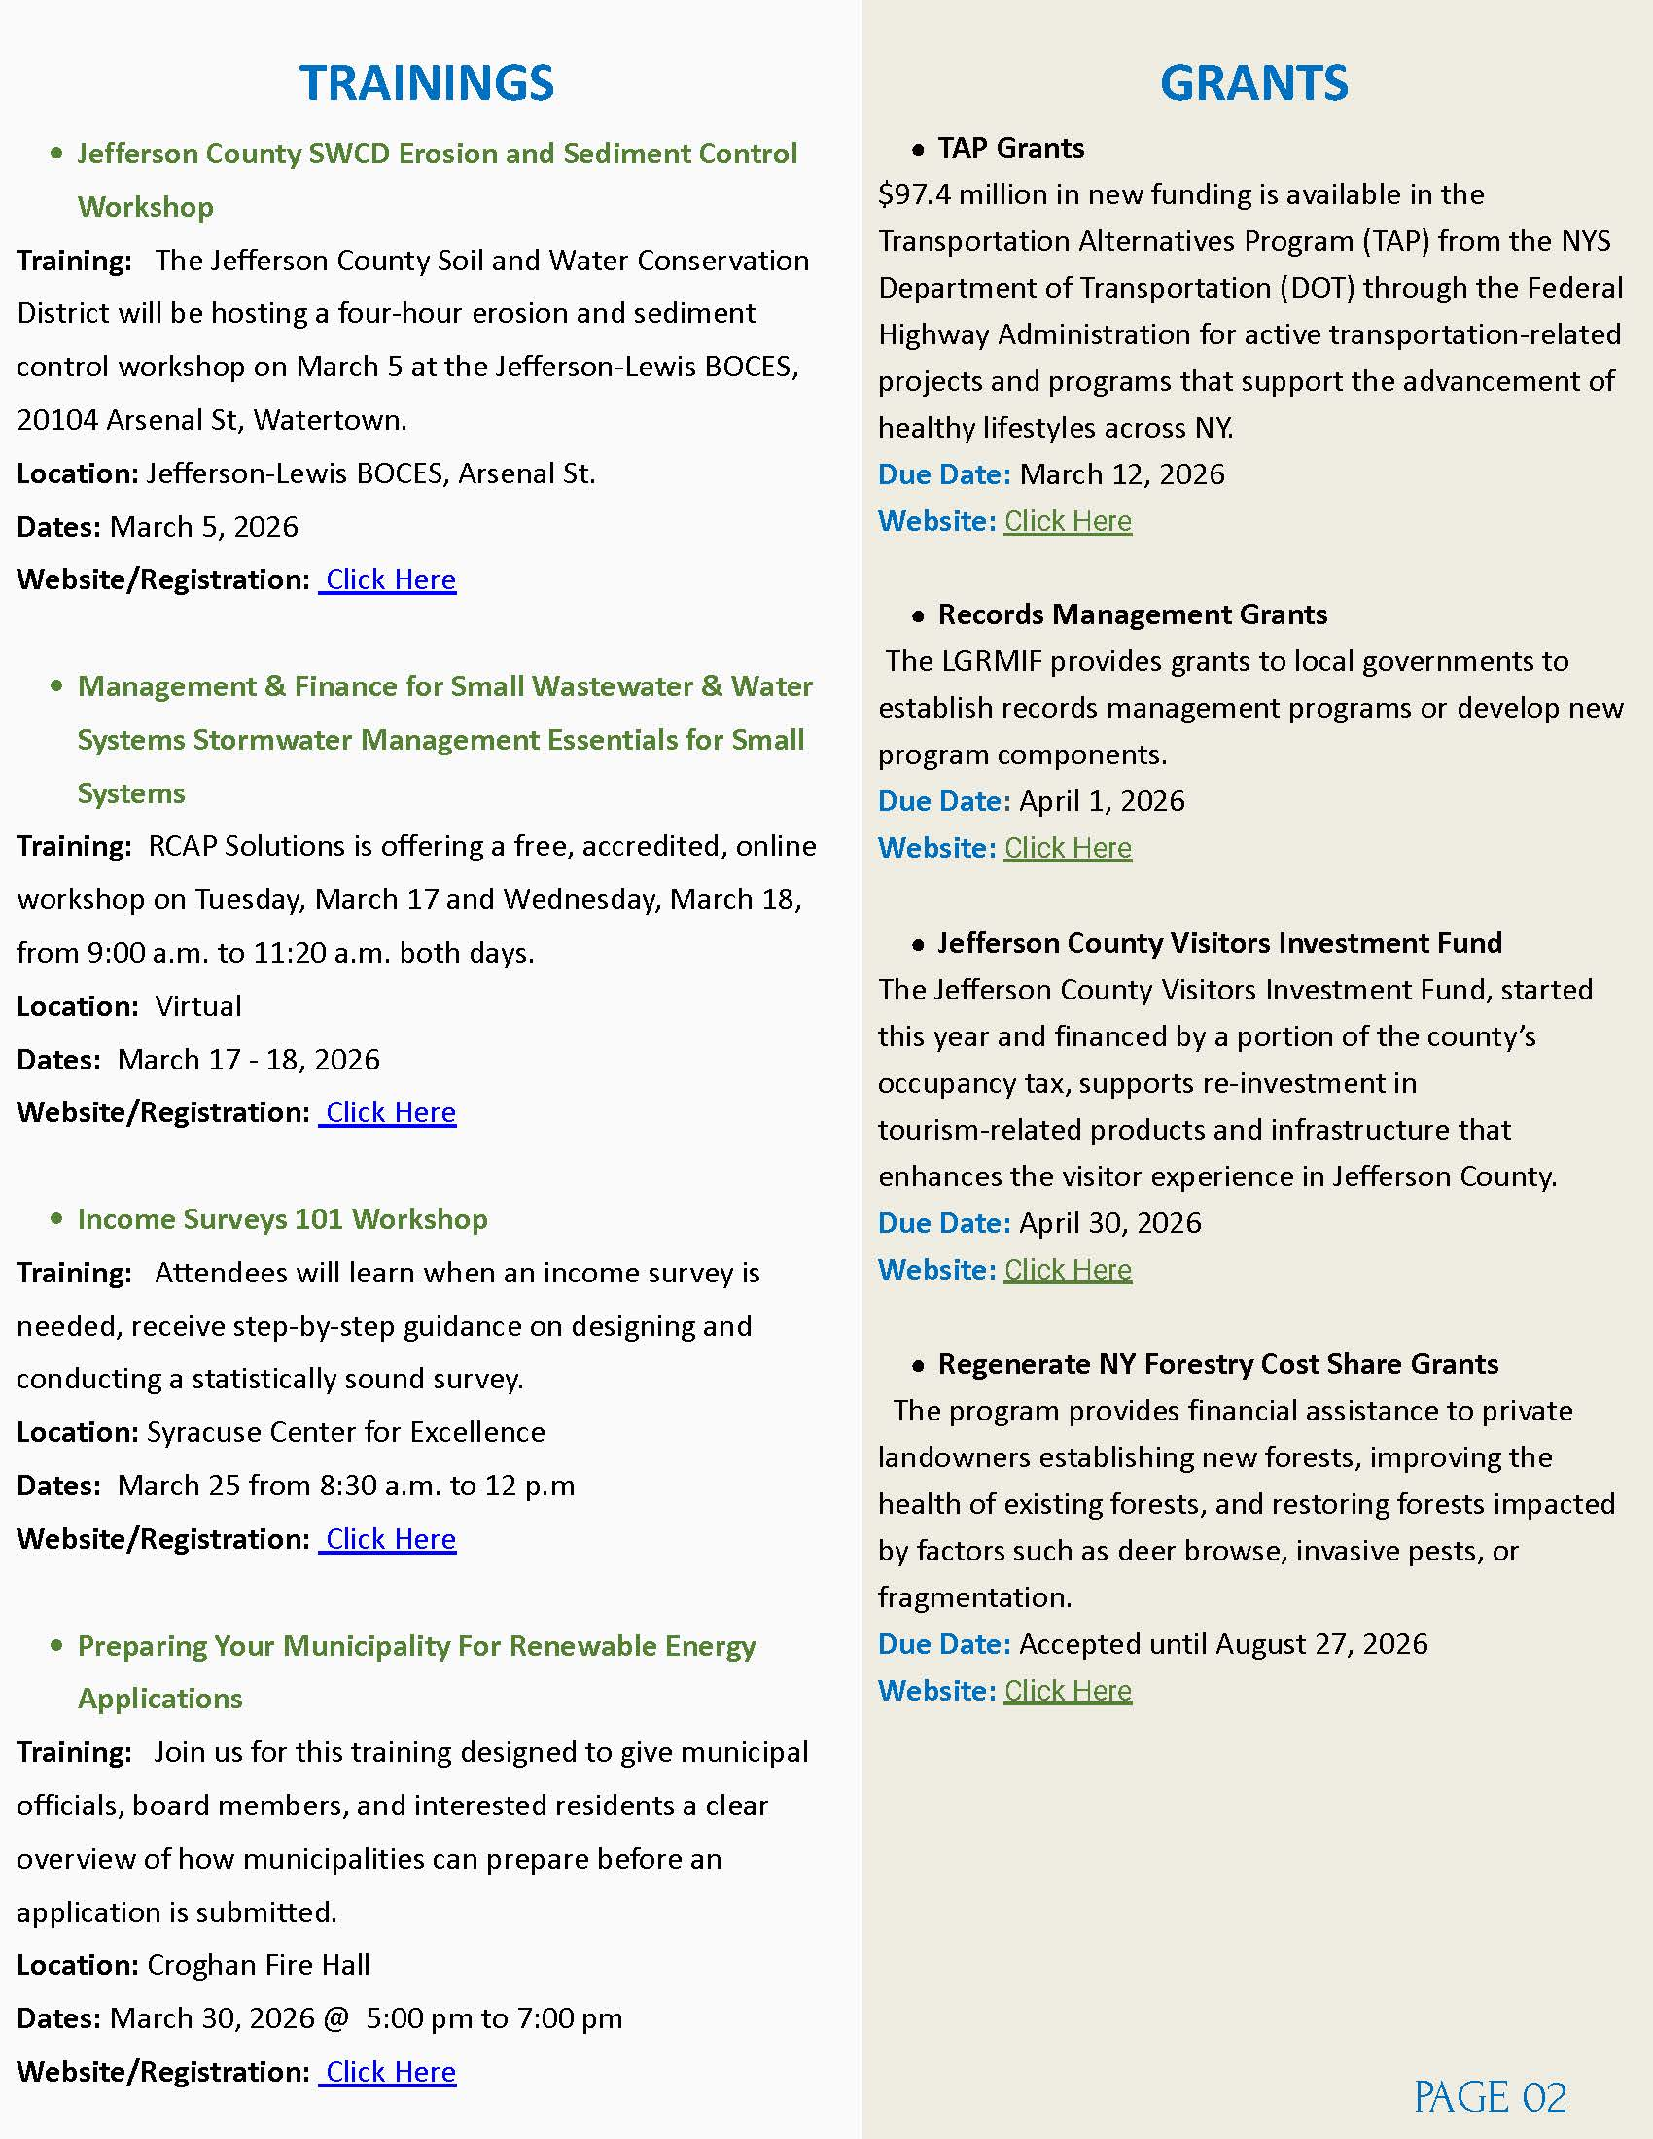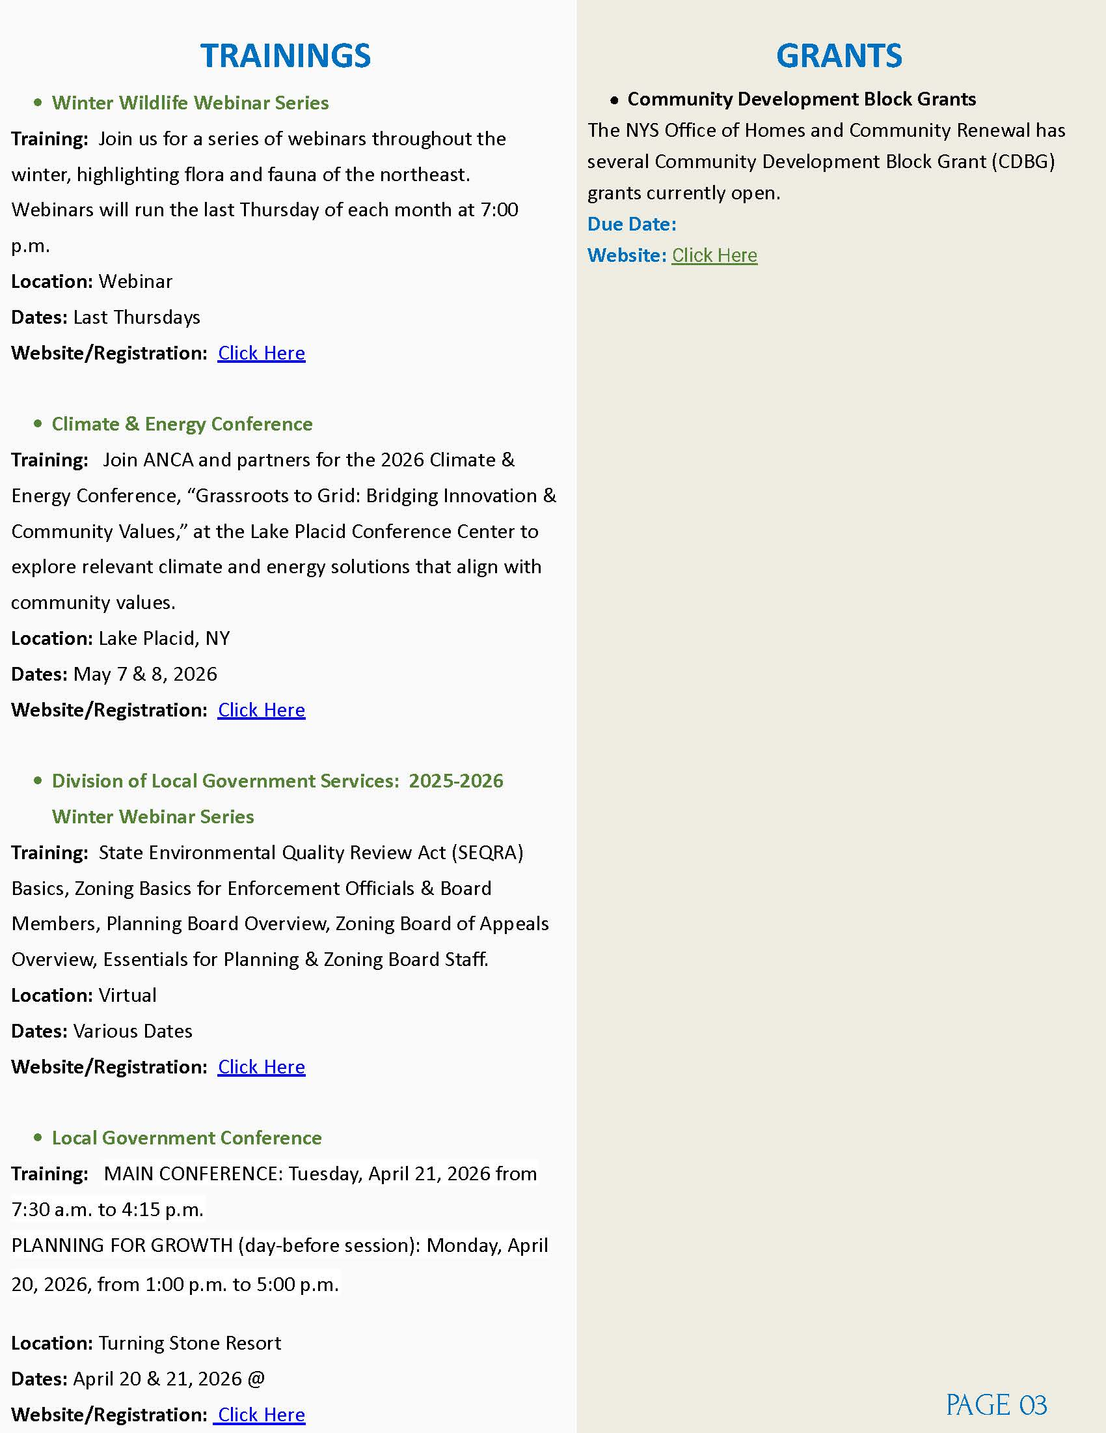

- DPW
  - PENN POWER SYSTEMS CONTRACT
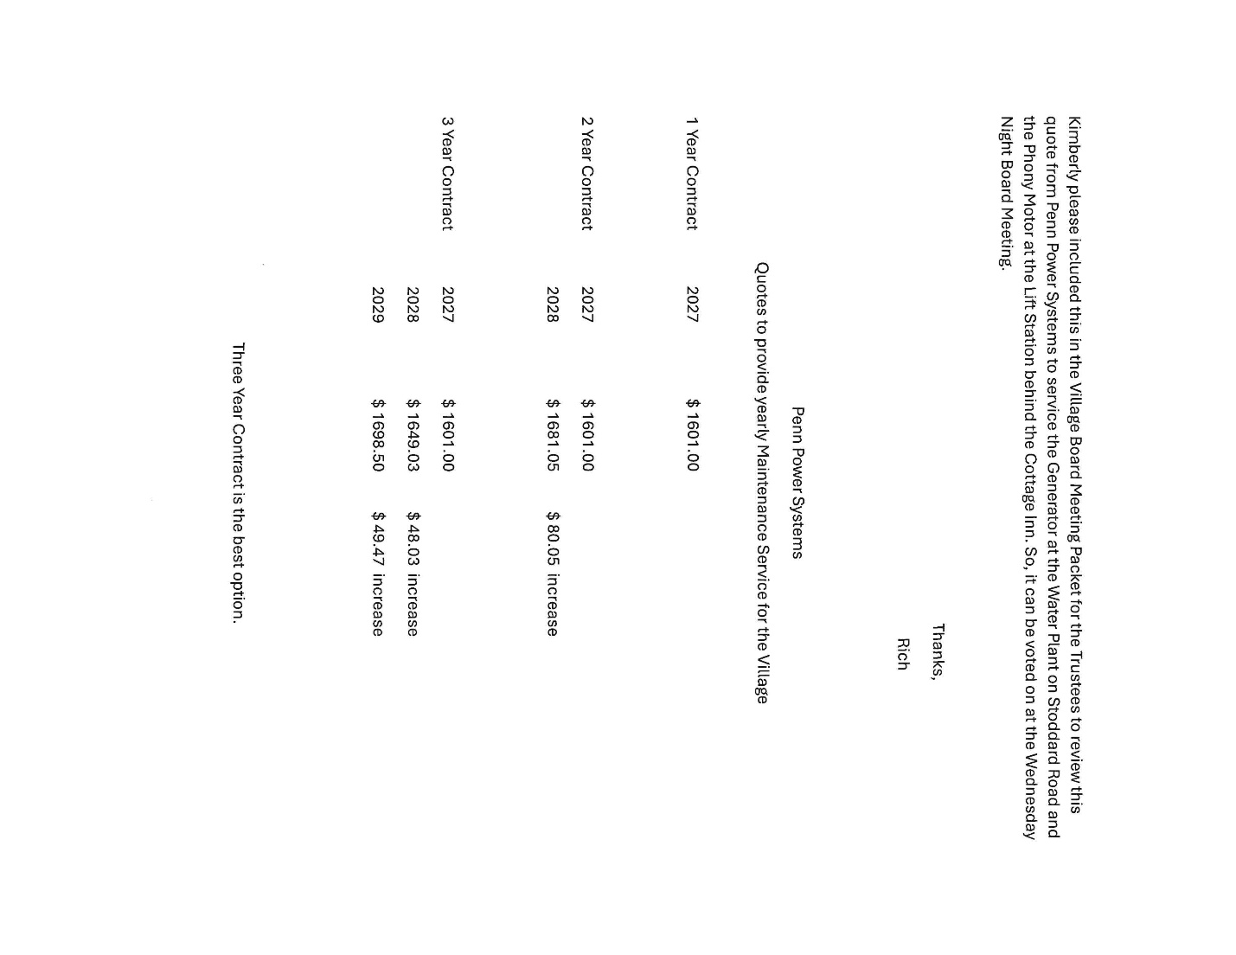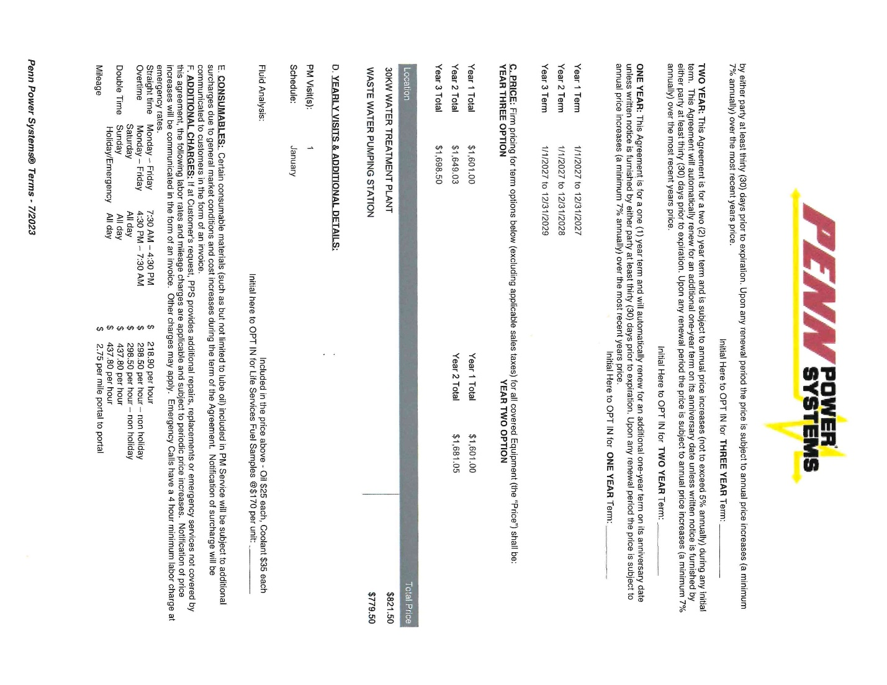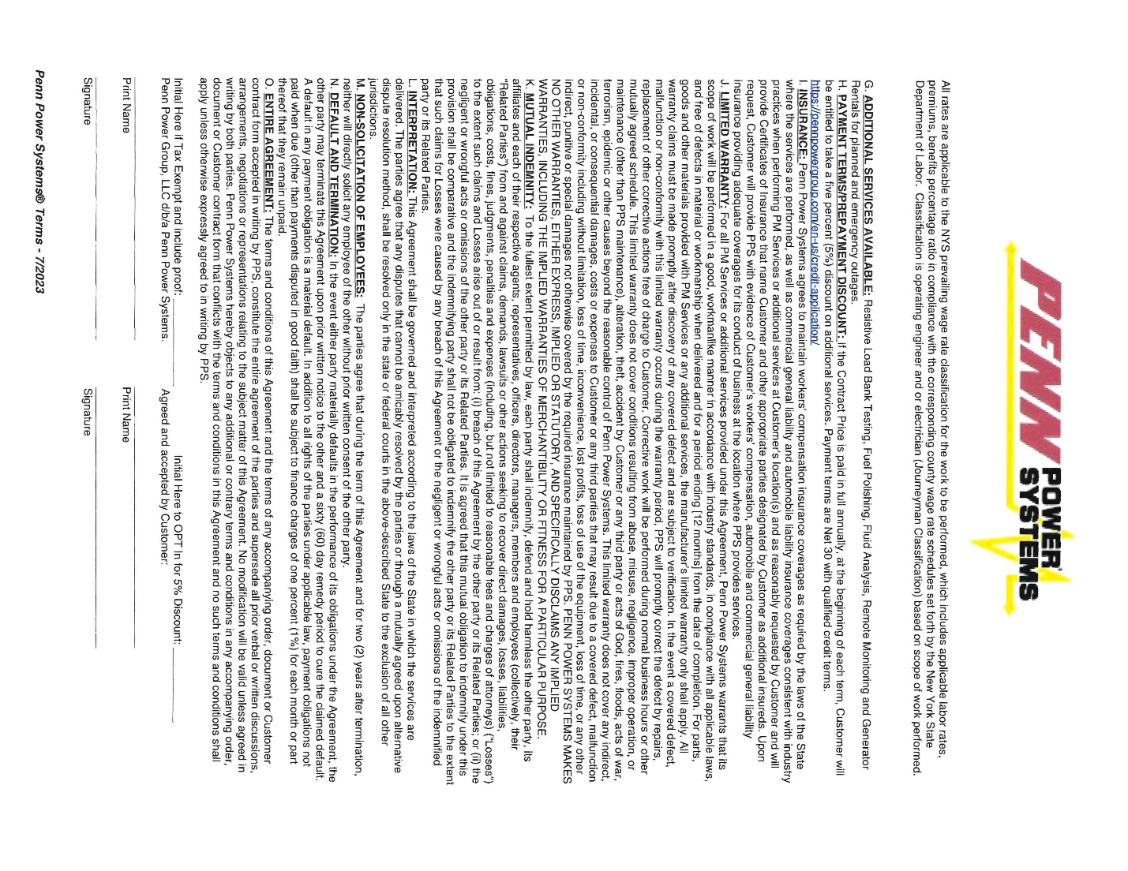
- BCA
- COPENHAGEN CARES

- PROPERTY MAINTENCE
PMO McKEEVER HAS FOLLOWED UP AGAIN WITH LEWIS COUNTY CODES, ON 10002 ST RT 12. THEY INFORMED HIM THAT THEY 150 CONDEMNED PROPERTIES, AND 10002 ST RT 12 IS PROBABLY AT THE BOTTOM.
3.3.26- CLERK REACHED OUT FOR EXACT STIPULATIONS THAT WERE PUT ON SAID PROPERTY, AT TIME OF PURCHASE. THE FOLLOWING LETTER WAS SENT BAC, THAT WAS BEING MAILING OUT SAME DAY TO OWNER OF PROPERTY.

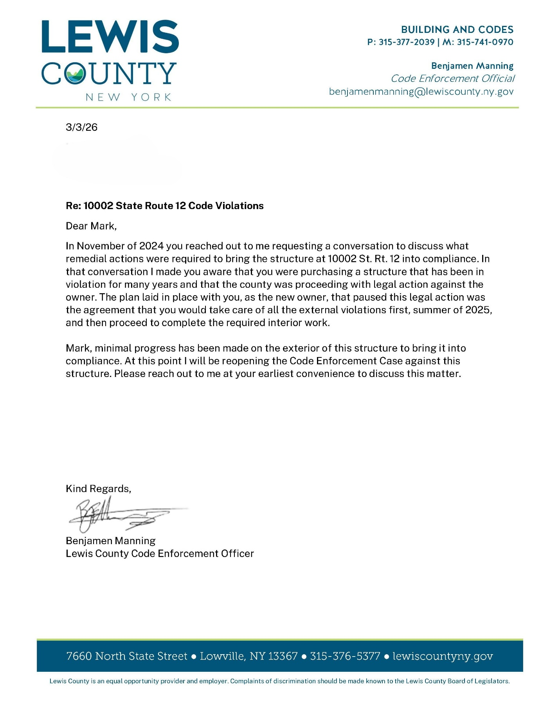

- FIRE DEPARTMENT
  - RUTLAND FIRE DEPARTMENT
  - COPENHAGEN FIRE DEPARTMENT INC.
    - NEW ATTORNEY APRROVAL

PUBLIC COMMENTS/INFORMATIONAL

OLD BUSINESS

- SEWER USE LAW-LAWYERS
- ANCA
- SHARED SERVICES WITH CASTORLAND
  - IMA WATER & SEWER
  - GARBAGE TRUCK
- LED LIGHTING BEHIND GAINES/BUSH-MUNCY
- LOUD STREET-OFFICER MONNET, SUPERINTENDENT ROSS, TRUSTEE MAHAR
- DOWNTOWN REVITILIZATION
SPRING
- CATARACT ST HYDRANT- GIVE TO POWIS
- LEWIS COUNTY DRAINAGE
- WOODBATTLE WATER PLANT- WATERMAN DEBRIS- WAITING FOR FROST TO KILL GRASS TO GET IT OUT

NEW BUSINESS

- BUDGET PROCESS
  - BY MARCH 20TH: THE MAYOR PREPARES A TENATIVE BUDGET AND GIVES COPIES TO ALL BOARD MEMBERS, AND FILES THE TENATIVE BUDGET WITH THE CLERK.
  - BY MARCH 31ST: THE BOARD HAS REVIEWED AND MADE MODIFICATIONS TO TENATIVE BUDGET.
  - BY APRIL 15TH: PUBLISH NOTICE OF PUBLIC HEARING
    - THERE HAS TO BE ATLEAST 5 DAYS BETWEEN NOTICE AND HEARING.
  - PUBLIC HEARING BY APRIL 20TH
  - BETWEEN PUBLIC HEARING AND APRIL 3OTH FINAL REVISION OF TENATIVE BUDGET.
  - BY MAY 1ST ADOPTION OF BUDGET.
- DONATING OLD OFFICE PHONES TO COPENHAGEN KINDERGARTEN/PRE-K
- ANNUAL WATER & SEWER CONTRACT WITH WILLIAMSON
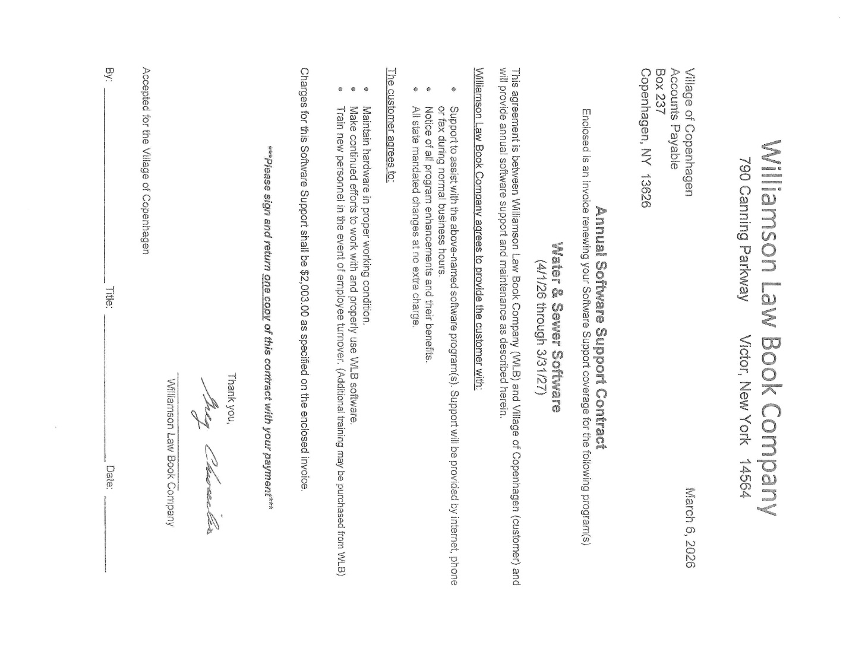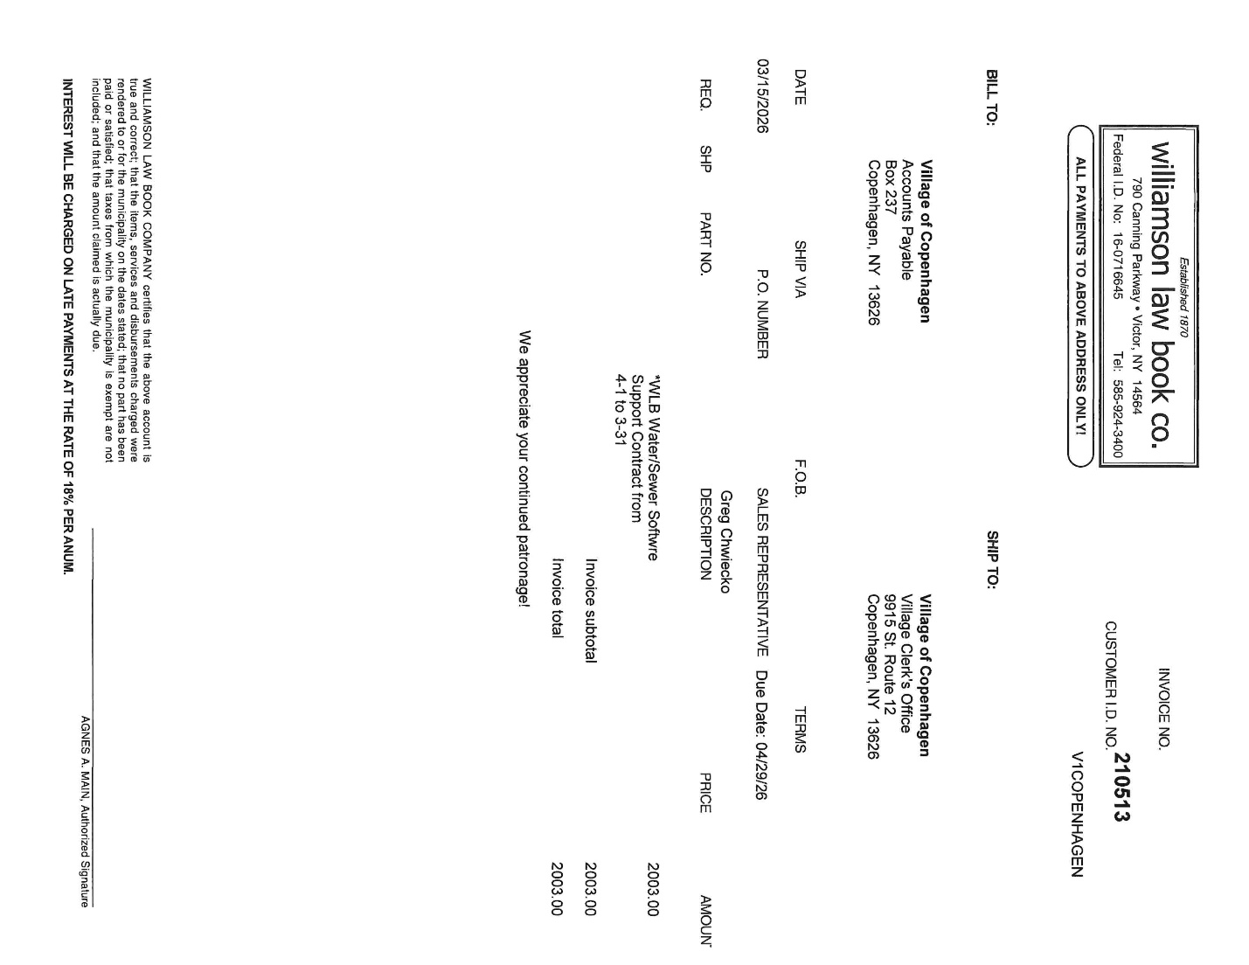

OPEN FORUM

FINANCIALS
- TREASURER REPORT
- MONTHLY ABSTRACTS
- PAY BILLS
- RESOLUTIONS TO TRANSFER FUNDS

ADJOURNMENT

NEXT MEETING APRIL 8TH
SEE YOU THERE!

